South Carolina State Council Legacy
The Super Bowl and
Knights of Columbus Connections

What is the connection between the Super Bowl and the Knights of Columbus?

The Super Bowl is huge. This year, Super Bowl LX., was the largest watched sporting event in the United States It generated over $800 million in advertising revenue and over $1 billion to the host city. The champions of the National Football Conference and the American Football Conference play for the title of “National Champions,” symbolized by the Vince Lombardi trophy.

And this is the connection. The first Super Bowl was held on January 15, 1967. Green Bay Packers defeated the Kansas City Chiefs 35-10. Super Bowl II was played on January 14, 1968. The Green Bay Packers defeated the Oakland Raiders 33-14, securing their second consecutive Super Bowl title and the final championship for head coach Vince Lombardi. Originally named the "World Professional Football Championship Trophy," the trophy was renamed the Vince Lombardi Trophy in 1970, shortly after Lombardi’s death.
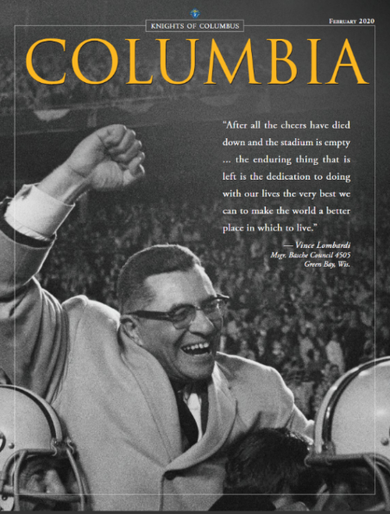
Vincent T. Lombardi was a man of strong Catholic faith and an unparalleled coaching career. Within two years of taking over the struggling Green Bay Packers in 1959, he led them to two consecutive NFL Championships. This was soon followed by a third, and as mentioned the first two Super Bowl Championships. When he retired, his career coaching record was 105 wins, 26 losses and six ties.

Being a man of deep faith, he daily attended Mass and Communion, which he considered the source of his strength. He was known to lead the Catholic players to Mass. Vince Lombardi joined the Msgr. Basche Council 4505 in Green Bay, Wis and later became a Fourth Degree Knight. (Columbia Magazine 2/20.)

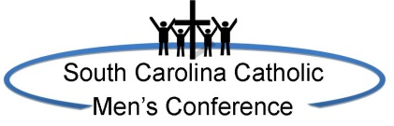
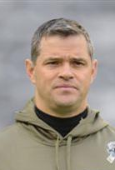
There are many other connections between the Super Bowl and Knights of Columbus member who have coached, played and refereed. But there is another major conection closer to home. From 2014 t0 2020, the South Carolina State Council conducted the South Carolina Catholic Men’s Coference for the Diocese of Charleston. The special speaker at the first conference was Joseph Lombardi, the grandson of Vince Lombardi. Joseph Lombard, himself a devout Catholic and a Knight of Columbus, played football for the US Airforce Academy. After fulfilling his military duty, he went on to coach in various capacities for the Alanta Falcons, New Orleans Saints, Detroit Lions and presently the Offensive Coordinator for the Denver Broncos. While the Quarterback Coach for the New Orleans Saints in 2010, he proudly held the Vince Lombardi Trophy when the New Orlean Saints won Super Bowl XLIV.

Thomas M. Monahon
South Carllina State Council Historian

South Carolina Council Milestones during the 2025-2026 Fiscal Year.

Council | Name | City | Charter Date | Years | Charter Grand Knight | Charter Chaplain
2207 | Bishop Henry P. Northrop | Sumter | 10/3/1920 | 105 | P. Gallagher | Rev. J. F. Mahoney
5026 | Michael O’Connor | Beaufort | 8/20/1960 | 65 | Francis Pulliam | Rev. Creston J. Tawes
5086 | Fr. Anthony Montisinos | Myrtle Beach | 2/1/1961 | 65 | John Wahler | Rev. Albert Fasse
6250 | Saint John XXIII | James Island | 9/12/1970 | 55 | William Kanapaux | Msgr. Thomas Duffy
6726 | Donald J. Godfrey | Hanahan/ Goose Creek | 11/20/1975 | 50 | George Williams | Rev. St. John Patat
6756 | St Anne-Oratory | Rock Hill | 2/8/1976 | 50 | Henry Pekketier | Rev. Edward Wahl
8980 | St. Michaels | Garden City | 4/30/1985 | 40 | R. Colucci | Rt. Rev. Edmund McCaffery
9184 | Prince of Peace Foothills | Taylors | 11/26/1985 | 40 | Dom Cipollone | Rev. Paul Seitz

Congratulations to these Councils. If your Council wrote a history of your council, please send a copy to the State Historian Tom Monahon at tmonahon@atlanticbb.net.

Real Knights of Columbus Family
Presenting their family to the Church
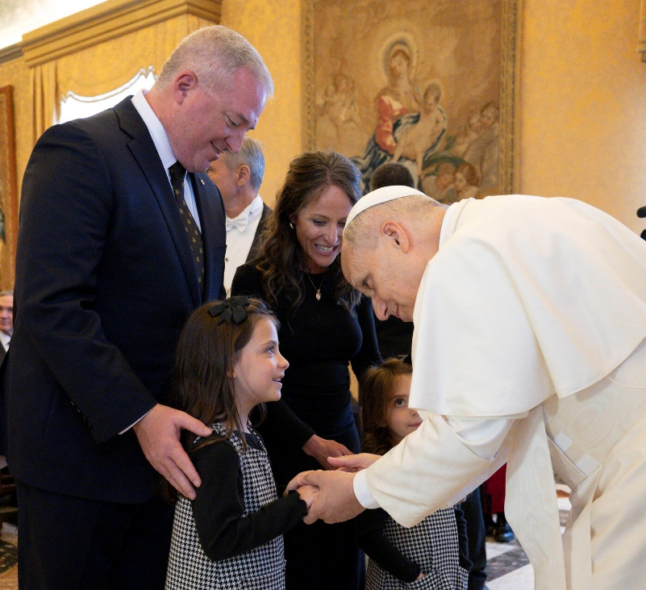

On October 6, 2025, Supreme Director Deputy Jeff Crouch and his wife Rebecca met with Pope Leo XIV and present their children Edith and Helen to him. What a great moment. What a notable example of a Knights of Columbus Family. Jeff is the South Carlina State Council Immediate Past Deputy and the first Knight from South Carolina ever to serve as a Supreme Director.

