SD Jeff Crouch Family Meet Pope Leo

Real Knights of Columbus Family
Presenting their family to the Church
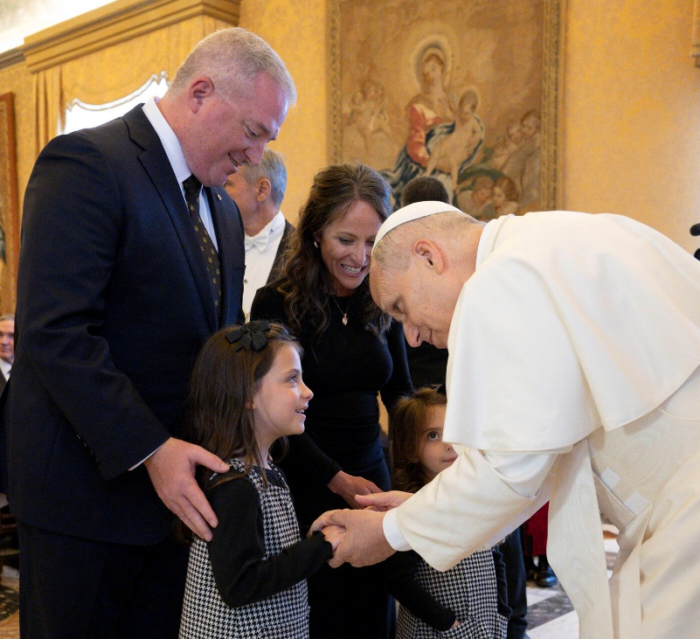

On October 6, 2025, Supreme Director Deputy Jeff Crouch and his wife Rebecca met with Pope Leo XIV and present their children Edith and Helen to him. What a great moment. What a notable example of a Knights of Columbus Family. Jeff is the South Carlina State Council Immediate Past Deputy and the first Knight from South Carolina ever to serve as a Supreme Director.
Thomas M. Monahon, PSD, FVSM
SC State Council Historian
December 12, 2025

