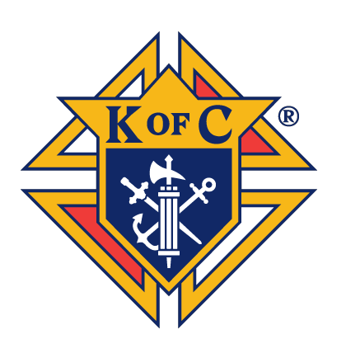

2026 SCHOLARSHIP ESSAY QUESTION: Discuss the challenges you have faced in integrating your faith into everyday life and what specific techniques you have used to overcome them,

Knights of Columbus Council 8182 is pleased to announce the winners of the 2026 Scholarship Essay Competition. After thoughtful review and prayerful consideration, the Scholarship Awards Committee selected these outstanding young individuals whose essays reflected both intellectual strength and deep spiritual conviction. Their writings eloquently conveyed their personal faith journeys and commitment to the teachings of the Catholic Church.
Each recipient stands as a reflection of not only their own character but also the love, values, and faith instilled in them by their families. We are proud to recognize both the students and the devoted parents and grandparents who have nurtured them along the way.
Listed alphabetically, the 2026 Scholarship Award recipients, along with their college of choice and proud family members, are:

- Erin Rita Barnette – Landers University – Granddaughter of Chuck & Nancy Cendrowski
- Luke Wesley Bynum – University of South Carolina - Son of Rusty and Joelie Bynum
- Evan M Cooper – Elon University – Grandson of Bob and Lyndsie Cooper
- Luka Kucinic – Clemson University – Son of Frank and Robin Kucinic
- Sylvia Kucinic – Clemson University – Daughter of Frank and Robin Kucinic
- Alondra Olvera – University of South Carolina - Daughter of Juan and Marbella Olvera
- Kirsten Lanza – Loyola University - Granddaughter of Mike & Mary Kirst
- Lillian Williams – College of Charleston - Daughter of David and Janie Williams
Please join us in congratulating these remarkable young men and women. They represent the future of our Church and community, and we are inspired by their faith, character, and academic aspirations. Should you see them at Mass or in the community, we encourage you to take a moment to acknowledge their achievements and offer your blessings as they embark on the next chapter of their lives.

SCHOLARSHIP AWARDS COMMITTEE CHAIRMAN
BROTHER WILLIAM WILLETTE

