Everybody Welcome, Everything Free
Knight of Columbus during WWI

What a great Catholic American legacy we have – both as Catholics and as Knights of Columbus. Just over one hundred years ago, this nation was thrust in to “the World War.” Our grandfathers’ response is one we should be proud of. This is the story of the Catholic Church, The Knights of Columbus, and of Catholic population in the United States.

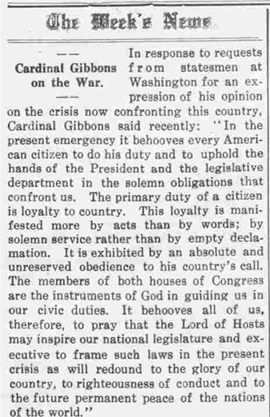
On April 2, 1917, President Woodrow Wilson addressed a joint session of Congress calling for a declaration of war against Germany. He cited Germany’s resumption of unrestricted submarine warfare. He framed the war as a struggle for democracy and a way to make the world safe for it, emphasizing the threat to international law and human rights posed by the German actions. The resulting congressional vote on April 6, brought the United States into “The World War.” Having congress approval, President Woodrow Wilson declared war on April 7, 1917.
The Sacred Heard Review
April 21, 1917, Vol. 57 - No. 19

The Church
On April 18, while meeting as the trustees of Catholic University (CU), James Cardinal Gibbons of Baltimore, and William Henery Cardinal O’Connell of Boston and six Archbishops signed a letter which was delivered to President Wilson by James Cardinal Gibbons. In the most effusively patriotic language possible, it promised all out support of U.S. Catholics for President Wilson and the war.
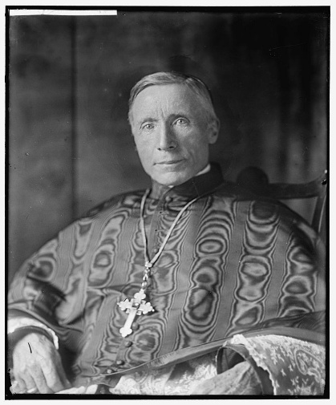
​
James Cardinal Gibbons
1834 - 1923

That promise was kept. Three cardinals, including Gibbons, set up a general “Convention” of Catholics which took place at Catholic University in Washington, DC on August 11-12. “Present were official representatives, clerical and lay, from sixty-eight dioceses...twenty-seven national Catholic organizations and of the entire Catholic press. In November, the Archbishops of the United States constituted themselves the National Catholic War Council (NCWC.) The NCWC purpose was to coordinate Catholic efforts in support of the military, demonstrate Catholic patriotism and unity, address the needs of soldiers and war workers, and promote the Americanization of immigrants. [Note: The NCWC is considered the predecessor of today’s United States Conference of Catholic Bishops (USCCB).] The Church's involvement in World War I was marked by a commitment to both the spiritual and material support of the war effort.

Before the NCWC, individual Catholic dioceses sent priests to minister to Catholic soldiers and sailors on the battlefield without any central organizational structure. When the United States entered WWI there were 25 Catholic military chaplains.

To organize these efforts and establish jurisdiction, Pope Benedict XV in November 1917 erected a military diocese of the American armed forces. He appointed Auxiliary Bishop Patrick Hayes of the Archdiocese of New York as bishop of this new diocese. Hayes received the position because New York was the primary port of embarkation for U.S. troops leaving for France and was therefore a convenient contact point for Catholic chaplains accompanying them. During the war, Hayes established four vicariates within the United States and one for troops in Europe. By the end of the war, there were over 1,000 catholic chaplains. [Note: The military vicariate eventually became the present-day Archdiocese for the Military Services, USA.]

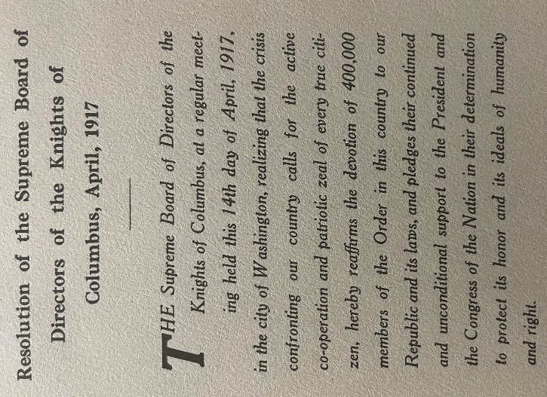
The Knights of Columbus
The Knights of Columbus also responded quickly and dynamically.

On April 14, 1917, the Knights of Columbus Board of Directors (BOD) passed a resolution pledging the devotion and unconditional support of the 400,000 members of the Order in this country to our Republic.

On April 16, the BOD removed the provision from all life insurance policies that voided payment for deaths resulting from acts of war. This removed any insurance deterrent for members wanting to fight for their country.

On April 17, Supreme Knight James Flaherty informed President Wilson of the BOD resolution of unconditional support.

On June 13, by recommendation of the Supreme Officers, the Supreme Knight notifies the U. S. War Department of the Knights of Columbus’ plan to provide facilities (KC Huts) to provide for the social and moral welfare of Catholic in the military.
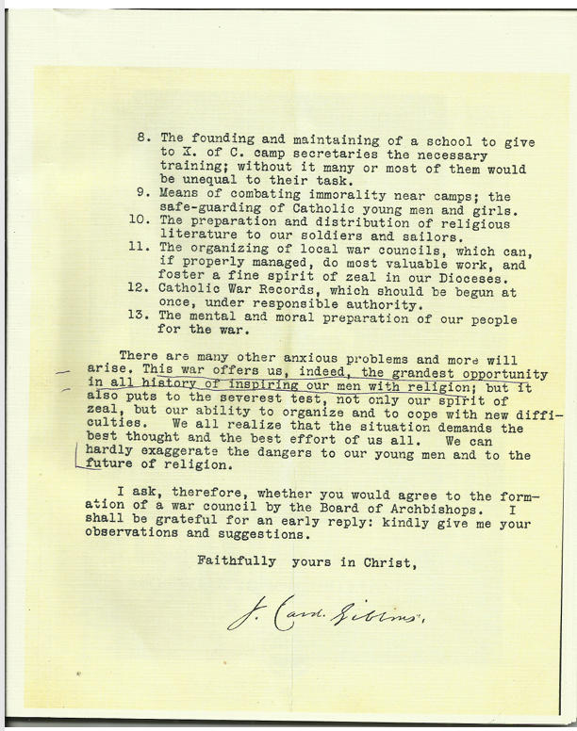
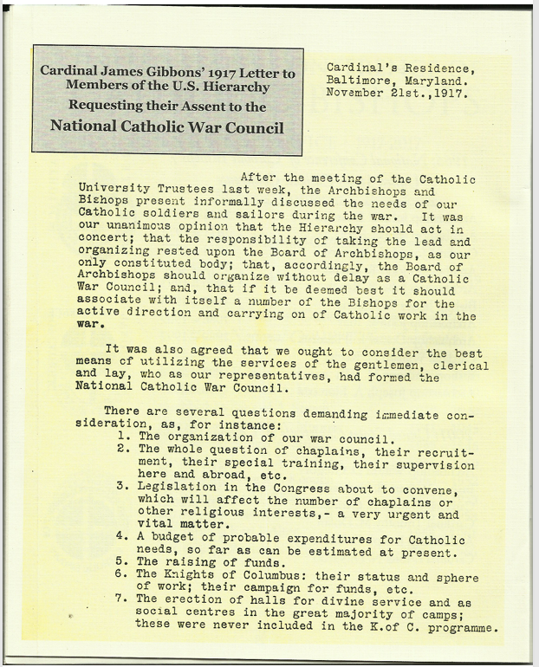
On June 21, the War Department’s Commission on Training Activities notified the Knights of Columbus of the War Departments acceptance and appreciation of the Knights “generous offer.” This commission had full control over all welfare work other than the Red Cross. Thus, the Knights of Columbus was officially recognized by the government as an agency for war relief work.

On June 25, the BOD meeting in Detroit, voted:
- The establishment of $1,000,000 Knights of Columbus War Camp Fund
- To levy a $2 per capita tax on their 400,000 members to be paid by all members to their council within 30 days, and for each council to be paid within 40 days.
- Directs all GKs to appoint committees to solicit all Catholics (in addition to the $2) for donations.

The Knights of Columbus war support had started.

And on November 20, 1917, General Pershing issued General Order #63 which put the Knights of Columbus on equal footing with the Red Cross and Y. M. C. A. for War Relief Work.

The Prelude: Between the summer of 1913 and Spring of 1917, the U. S. was forced to deployed 250,000 men (Army and National Guards) along the Mexican border in Texas, Arizona, and New Mexico. This military force, under General Pershing, purpose was to protect Americans living close to the border from raids by Poncho Villa. This sometimes required expeditions into Mexico to rescue Americans troops and prisoners.

To their credit, the Y. M. C. A. established recreation facilities for the social and moral relief of military personnel. These facilities offered a place for recreation, writing home, reading, and other social activities. This included non-Catholic services. While these facilities were open to men of all denominations, they were not Catholic friendly and were not open to allow priest to hold Catholic Mass or support.

The Knights of Columbus sent agents to survey the needs of Catholics soldiers on the border. Out of their own operating funds, the Knights of Columbus established the Mexican Border Works. Working with local councils, nineteen (19) Recreations “Centers” were built. The word “center” includes buildings, tents, or other structures and were manned by civilian volunteers- many from the local council. Following the model of the YMCA, these centers were open to all the military. This offered a place for priests to say Mass and provide the sacraments. The centers organized baseball, football, boxing, and other sporting events. They offered reading rooms and places for service men to write home. They provided, where possible, movies, dance floors, pool tables, and ice water.

From this experience, the Knights of Columbus knew what was needed going into WWI.

The Casey Huts: Over by the summer of 1917, the Knights of Columbus set up similar rest and recreation facilities as they had done at the Mexican border at training camps and behind the lines of battle. These K of C huts became known as KC or Casey Huts. They provided social services to Allied service men of all faiths. K of C Huts provided religious services, supplies, and recreation. To those in service, these were homes away from home. The motto: “Everybody Welcome, Everything Free.” meant everybody, regardless of race or creed – truly unique for that day and age.
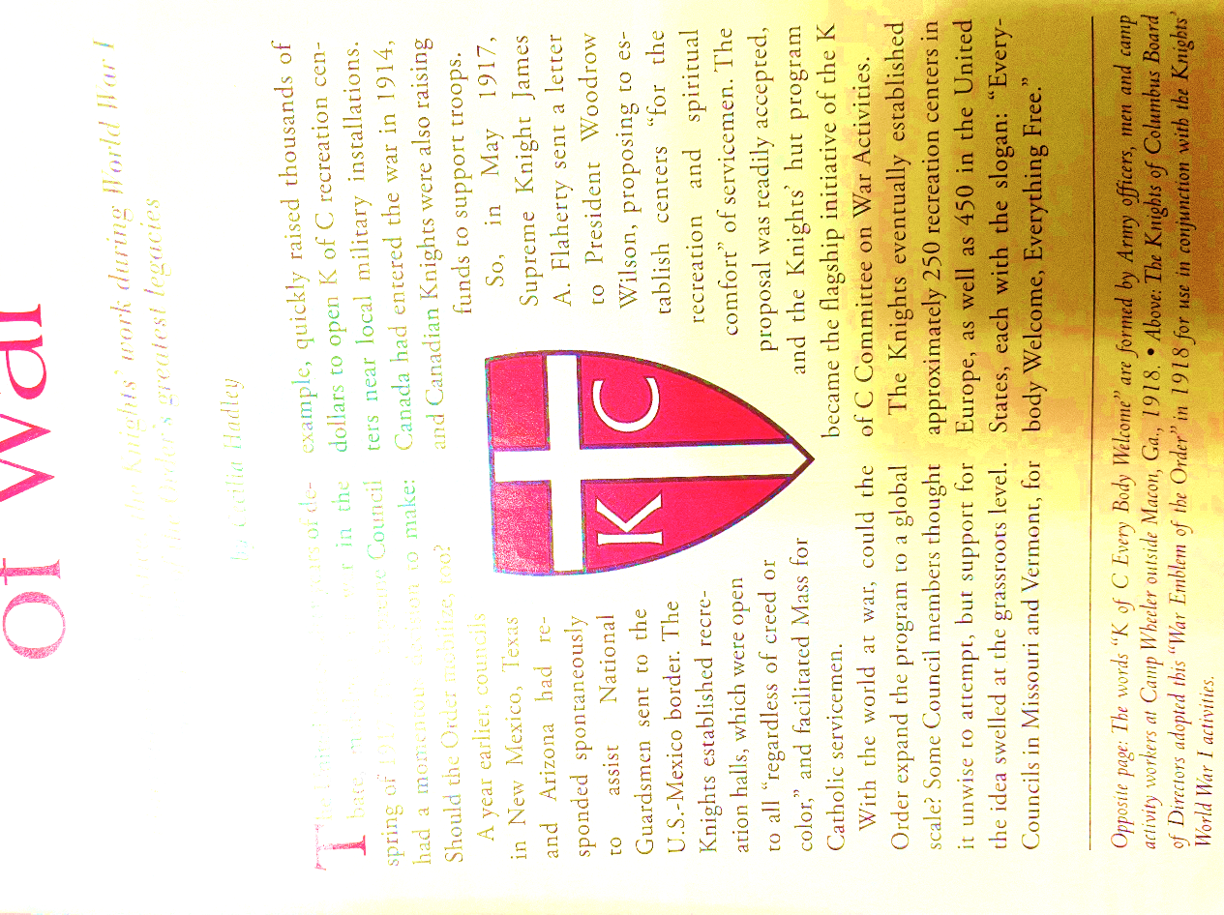
War Emblem of the Order
The Knights of Columbus employed men titled as “Secretaries” to operate these huts. Naturally, secretaries quickly got the nickname “Casey.” These men were hand chosen to be men of high Catholic morality. Most were past military age. The Order prided itself on not claiming service exemptions for its workforce and valued the fatherly approach of relatively older men. Their uniforms were like the U.S. Army’s but with “KC” on their shoulder badge and buttons. There work sometime consisted of writing letters and finding a priest for dying men.

Accomplishments include:
- More than 1100 Caseys served at over 250 Casey huts assisting service men “over there.”
- In addition, nearly 2000 Caseys served at 450 huts for the troops at home.
- 100 priests served as chaplain. (This is in addition to the 1000 active priests serving in the military.)
- During the first month overseas, the Casey huts had freely distributed 15,000 baseballs, 1500 footballs and 2200 boxing gloves.
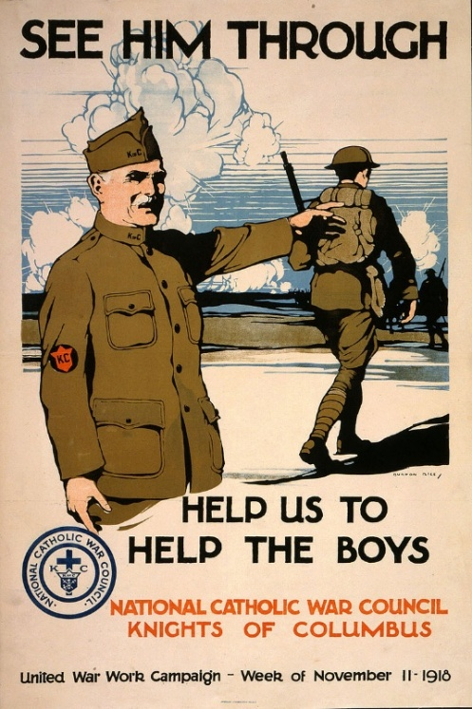
Fund Raising: In addition to the $2 per capita tax, many councils actively raised funds through donations from their members and local parishes.
- By August. 1917, the Knights of Columbus War Camp Fund had achieved its $1M pledge.
- By late Autumn, 1917, the councils of the Order had raised over $3M.

As the movement progressed, further success brought the Knights of Columbus to the attention of thousands of benefactors.
- Many large cities had raised War Relief Funds to support their boys in the military.
- There were concerts by celebrities, and generous donations from other denominations and civic organizations
- By the end of the war, the Knights of Columbus War Camp Fund had raised over $14M. (approximately $200M today,)

After the Armistice: The first World War ended on 11/11/18 at 11:00 AM. This was followed by the military occupation of Germany to restore order. And the months of effort to return the American forces home. Therefore, the Casey Huts continued to operate for over a year after the war was over.
- 420+ Caseys moved with Army of Occupation into Germany. One Casey Hut in Coblenz Germany made 40-60,000 doughnuts per day – all free.
- Over 199 huts and 150 Caseys moved to ports of embarkment. Tobacco, shaving kits, and other comforts were provided for those embarking. And while waiting for embarkment, soldiers were provided at the Casey Huts a K of C card. The card had a place for the soldiers to write their home address. and had a single printed sentence that stated, “I am safe and sound.”

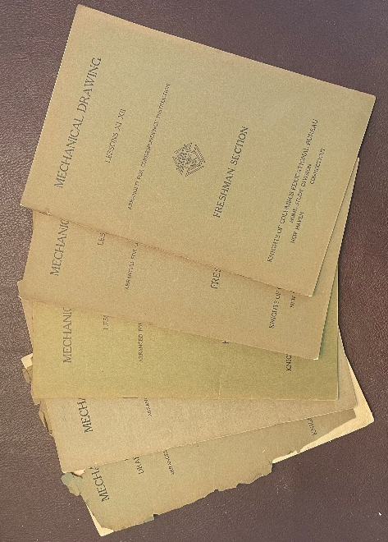
When Back Home: The Knights of Columbus was there to help assimilate the 2,000,000 returning soldiers. The Knights of Columbus established a viable employment campaign and educational programs
- Over 1700 councils became defacto employment agencies
- By 1921 – 300,000 veterans found jobs through these councils
- Until 1926, over 150 evening schools were established. More than 50,000 students are enrolled in K of C-sponsored evening school programs across the United States and Canada.
- And Supreme established correspondence courses covering eighty-five subjects. This program was offered until the late 1950s.

The American Catholic Laity
James Cardinal Gibbons. In the most effusively patriotic language possible, delivered a letter to President Woodrow Wilson promising all out support of U.S. Catholics for Wilson and the war within days of America’s declaration of war. The American Catholic’s response was overwhelming by contributing to the war effort through various means including fundraising, volunteering, and providing medica aid. But none so much as those valiant Catholic American men willing to risk their lives to support the United States.
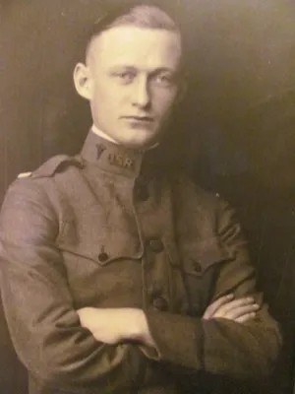
- During WWI, Catholics made up approximately 15% of the population of the United States. During WWI, 1,000,000 Catholics served in the military. This was nearly 35% of the Army and 50% of the Navy. This is over twice the population’s numerical proportion.
Lt. William T. Fitzsimons
- By the end of the war in November 1918, more than 116,500 American men and approximately 60,000 Canadians had died in the conflict (including combat, diseases, and other causes.) Among them were 1,500 members of the Knights of Columbus from the United States and approximately 120 Knights from Canada.
- Lieutenant William T. Fitzsimons, a medical officer, was the first American Expeditionary Forces (AEF) officer killed in action in World War I. He died on September 4, 1917, from wounds received when bombs fell on Base Hospital No. 5 near Dannes-Camiers in Pas-de-Calais, France. While other Americans died earlier in the war, including some serving in foreign forces, Fitzsimons was the first American officer in the AEF to be killed in action. Lt. Fitzsimmons was a member of Kansas City Council #527.
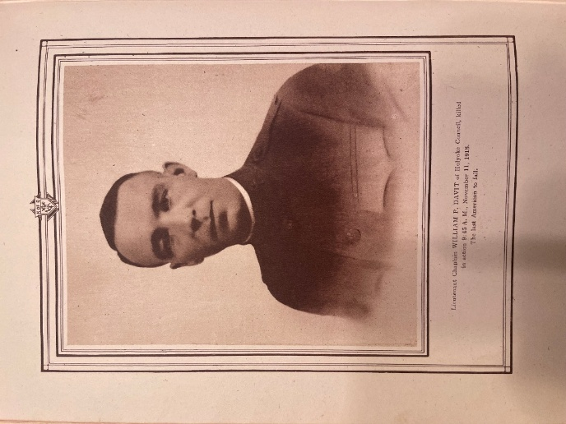
- Father William F. Davitt, a Catholic chaplain and 1st Lt. with the American Expeditionary Force in World War I, was killed in action at 9:45 AM on November 11, 1918, just one hour and fifteen minutes before the armistice went into effect. He was the last American officer to die in the war. Davitt was struck by shrapnel from an artillery shell while attempting to raise an American flag to mark the armistice. Fr. Davitt was a member of Holyoke (Mass.) Council #90.
Fr. William F. Davitt
[Note: During the summer of 1918, Rev. Davitt lead a group of volunteers to rescue forty wounded American soldiers cut off and pinned down by enemy fire. Under heavy enemy fire, Rev. Davitt rescued all forty soldiers without incurring a single casualty. For his gallantry in action, Rev. Davitt was awarded the French Croix De Guerre and the American Distinguished Service Cross.]
- Henry Nicholas John Gunther (June 6, 1895 – November 11, 1918) was an American soldier and possibly the last soldier of any of the belligerents to be killed during World War I. He was killed at 10:59 a.m., about one minute before the Armistice was to take effect at 11:00 a.m. He joined the Knights of Columbus, in 1915.

South Carolina Knights of Columbus Answers the Call.
During World War I, Carolina Jurisdiction included both South Carolina and North Carolina. South Carolina first State Historian SK Phillip Hugh Morgan, worked at Camp Jackson in Columbia from June 1919 until July 1920 and wrote that he was “well acquainted” with the KC Huts. In 1920 a School for Veteran was established in Columbia, SC, where Phillip worked teaching English, History and Salesmanship.

In the book, Knights of Columbus in Peace and War by Maurice Francis Egan and John B. Kennedy, Volume 2 (published by the Knights of Columbus – 1920) lists those Knights of Columbus members who subsequently served in World War I. The list of South Carolina Knights is shown in Attachment 2.

Most noteworthy on the list are:
- T. A. Albenesius (Council #704) – Wounded in action.
- Hugh L. M. Degnan (Council #724) – Died in Service.
- Thomas Walsh (Council #724) – Died in Service.
- Alexander C. Dohl (Council #724) – Promoted from rank to commission.
- Basil Kerr (Council #704) – Served as South Carolina 5th State Deputy in 1931-1933.

Attachment #1
James Cardinal Gibbin’s letter to the U. S. Hierarchy
Regarding the National Catholic War Council

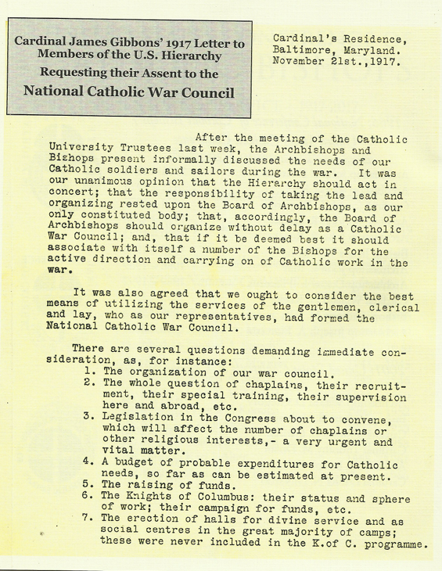
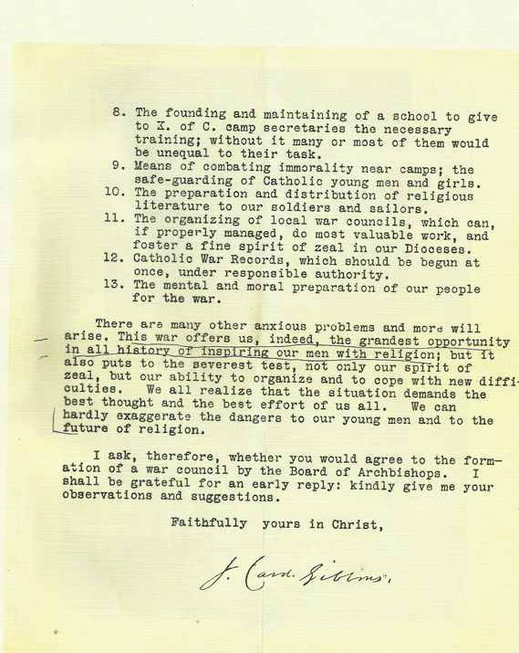

Attachment #2
South Carolina Knights of Columbus Roll of Honor
