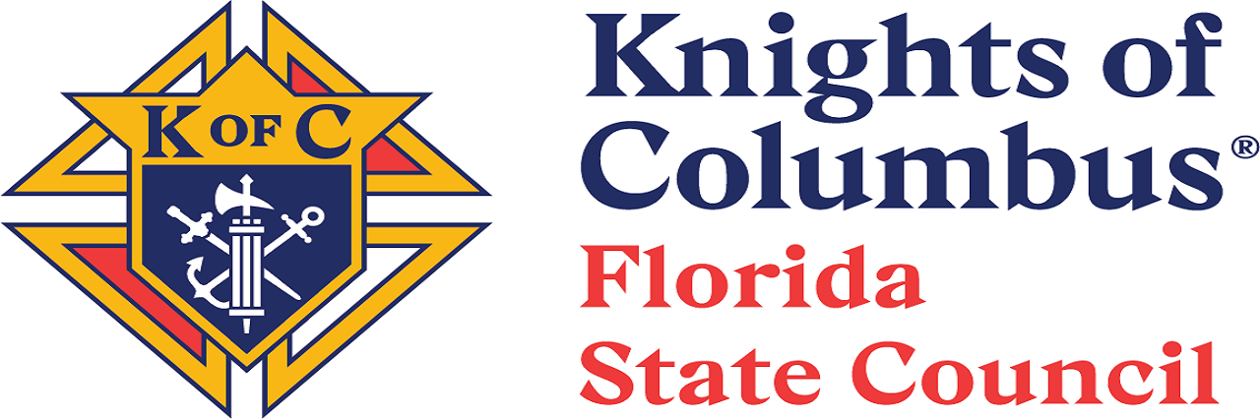
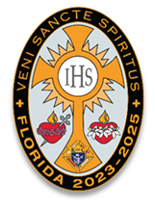

February 10, 2025,

Re: 2025 Florida State Council Convention Advertising and Sponsorship Solicitations
Worthy State Officers, Directors, Chairmen, Regional Directors, District Deputies, Grand Knights, General Agents and Brother Knights,
As you may already know, the 121st Florida State Convention will take place May 23-25, 2025, at the Hyatt Regency Jacksonville, 225 East Coastline Drive Jacksonville, FL 32202.
The Florida State Council requests every Brother Knight to be involved with the 2025 Knights of Columbus Florida State Council Convention Advertising and Sponsorship solicitation effort.
It is imperative that we act now and submit the appropriate forms for Convention Ad submissions. Deadline is May 1st, 2025.
All District Deputies are respectfully requested to place a $500 full page ad in the Program Book. This is accomplished by soliciting each of your Councils and Assemblies for their proportional share. In addition, all Brother Knights, especially our State, Regional, and District Leadership, are requested to help find commercial and business advertising for the Program Book as well as key sponsorships for the State Convention.
DISTRICT AD PROCEDURE:

First DDs - Fill out the Program Ad order form in a Word document using Arial 12 font with your District Council & Assembly information in the following format:
- Council # and name
- GK name
- FS name
- Chaplain name
- Same information is needed for Assemblies and Columbiettes.

Then DDs – will send Weldon O. Watkins III your Program Ad form and a check made payable to: Florida State Council

MAIL TO:
Weldon O. Watkins III
C/O FSC Knights of Columbus
4783 NW 45th Ct
Ocala FL 34482
Request that Regional Administrators assist in stressing the urgency to get these forms in early and with payment.

ADVERTISING OBJECTIVE - offset convention costs and present a better convention experience offer to all attendees whether in-person or virtual.

BUSINESS ADVERTISING AND SPONSORSHIPS

All Brother Knights are encouraged to solicit and promote their businesses, commercial businesses, and related organizations for the purpose of partnering with the Florida Knights on the following,
- Program Book Advertisement
- Sponsorship of Key Convention Events
- Exhibit Tables for the Convention Trade Show
- Donation of Promotional Items.
Review the offerings and present them to everyone you know - Brother Knights, Brother Knight business owner, Commercial Business Owners with affinity for our principles, Non-Profit Corporations that do similar work and Service Providers in other fields of endeavor aligned with Knights of Columbus.
A sponsor vetting process will be conducted by the Marketing committee along with the State Advocate for each business entry.
All forms will be available on the website with open access. Let’s do it! – Our State Goal is $50,000.
Vivat Jesús,
Weldon O. Watkins III
State Marketing and Brands Director
Advertising@floridakofc.org & Kofctuewowiii@gmail.com
352-229-4501

