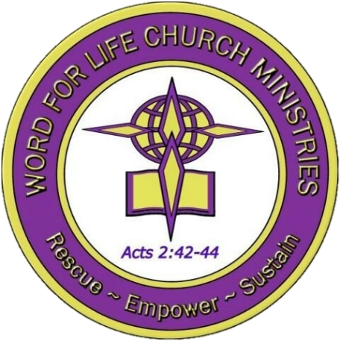

WORD For Life Church Ministries

in CHRIST: BELIEVING AND LIVING BECAUSE OF JESUS
a study of Ephesians

Spring 2024

Rev. Larrin Robertson
Pastor-Teacher

Ephesians 1:1-23
As we examine the opening chapter of this correspondence with believers in Ephesus, keep in mind the primary theme under consideration:

In Christ: Believing and Living Because of Jesus

With this in mind, we can better appreciate the nuances present in what seems to be one of Paul’s standard greetings. Several key points are raised that will help our understanding of what it means to be a believer living in the various contexts of their secular society. Importantly, as we uncover meaning for them, we will also be able to discern meaning for our contemporary contexts as well.

Chapter Theme: Alive in Christ.
God’s grace brings new life to anyone who believes in Jesus Christ for salvation.

Reflection Question: Have you place any limits on God’s limitless grace?

Key Terms
- Saint: one who has been set apart, which relates to the word “sanctified.” Such are ones who receive salvation through Jesus Christ and remain “in the world” but are no longer “of the world.”
- Grace: used as a standard greeting of goodwill (v.1) but carries the connotation of gratitude, kindness, or favor toward another.
- Chosen: (v. 4) means to select, pick out for oneself, elect. The idea is that someone has chosen, selected, picked out, or elected another for the purpose(s) of the one with the ability to choose.
- Predestined: (v. 5) [pro (before/ahead of) and horizo (establish boundaries, limits)] the compound word is pre-horizon, and it has a literal meaning of pre-established boundaries, i.e., before creation.
- Adoption: (v. 5) to place, as a child, into the divine family; the term is often referred to as sonship, or legally made a son.
- Redemption: (v. 7, 14) ransom in full, a release made possible because a payment has been made; similar to the idea of deliverance. It literally means to “buy back from” or re-purchase what (or whom) had been previously enslaved.

Chapter Outline (adapted from Warren Wiersbe. Exposition Commentary, New Testament, Vol. II, Ephesians – Revelation, p. 8-10)

- Ephesians 1:1-3
Introduction: The writing of Ephesus is approximated to AD 62. This timing seems to coincide with Paul’s imprisonment in Rome, a time when he also wrote a general letter to believers in Colossae (Colossians) and a pastoral letter to a wealthy believer named Philemon (Philemon). For more on Paul’s relationship with believers in Ephesus, read Acts 19:1-41 and 20:17-38.
  - Author (1a) _______________________________________________________
_________________________________________________________________
  - Audience (1b-2)
By way of Paul’s naming of the intended readers, we might identify the audience in the following ways:
- They are _________.
- They live in/around _________.
- They are striving to remain _________.
  - Aim (3)
With this one verse, Paul centers God as the source of blessings for the believer and as the One who determines the range within which these blessings may be found. Paul’s theology and doctrinal teaching for the church, and the aim of this letter, are underscored here: God is the Sovereign and has made new life possible in, through, and because of Jesus Christ.
    - The _________ of blessings
    - The _________ of blessings
    - The _________ of blessings
________________________________________________________________________
________________________________________________________________________
________________________________________________________________________

- Ephesians 1:4-14
Because Jesus “paid it all” believers are no longer obligated to, nor bound by, the debt caused by sin. As debt cancellation causes the world to rejoice, how much more ought believers rejoice by our release from spiritual debt that we could never repay? This is how believers become rich in God by faith in Christ Jesus our Lord. The opulence of the temple of Diana as a center of idolatrous worship and the commercial transactions that occurred there, Ephesus was not short on wealth. The question becomes: how have you been made rich?
  - Blessings from God the Father (4-6)
    - God _________ us. It is God’s grace—as evidenced in the act of election—by which we have the ability to say yes to God’s choosing.
    - God _________ us. Regeneration is the basis upon which we get into God’s family. It is God’s act of making us immediately able to claim our inheritance.
    - God _________ us. We are accepted by God when we receive God’s grace through Jesus Christ.
  - Blessings from God the Son (7-12)
    - Jesus _________ us (7a).
    - Jesus _________ us (7b).
    - Jesus ____________________ to us (8-10).
    - Jesus ____________________ for us (11-12).
  - Blessings from God the Holy Spirit (13-14)
    - The Holy Spirit _________ us.
    - The Holy Spirit has given us an _________, or deposit.
________________________________________________________________________
________________________________________________________________________
________________________________________________________________________

- Ephesians 1:15-23
Surface-level knowledge or understanding may be enough to get by. But what if there was more to uncover and benefit from by going deeper? The good news is that when we continue in the faith, we learn more about God by virtue of what God has called us to and the power we have to fulfill our calling.

  - To know God
    - By Faith and Love (15-17)
      - Faith in God
      - Love for one another
    - God’s Call (18)
    - God’s Power (19-23)

________________________________________________________________________
________________________________________________________________________
________________________________________________________________________

