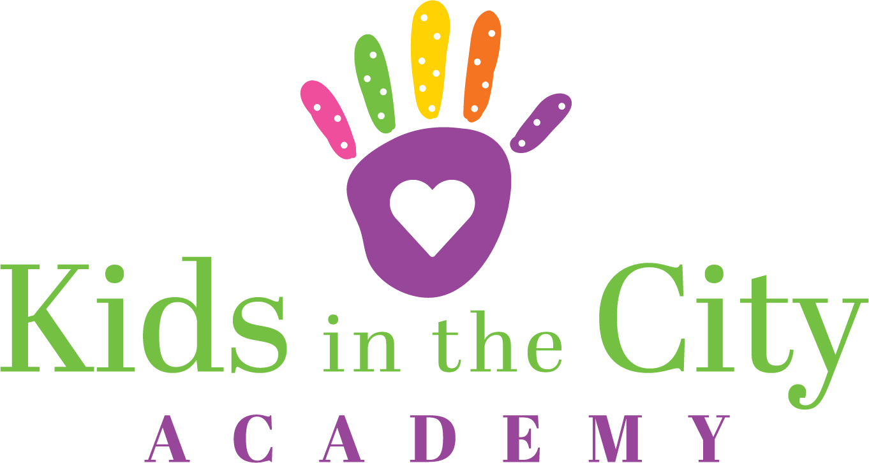

VPK Scholars Supply List

- 1 pencil box
- 1 box of crayons (24 pack)
- 1 box of washable markers
- 2 containers of Playdoh (any color)
- 2 trays of watercolor paints
- 2 bottles of School Glue
- 2 packages of Glue sticks
- 1 pack of copy paper
- 1 pack of white card stock
- 1 pair of child scissors
- 1 pack of dry erase markers
- 1 pack of assorted colors construction paper
- 1 box of gallon size Ziploc bags
- 1 small pack of baby wipes
- Treasure box toys
- 1 box of paper clips
- 2 boxes of Kleenex/tissue
- Family photo for classroom family tree
- Child's photo for cubby
- 2 sets of clothing, labeled with first and last name, placed in cubby

The teachers may be asking for other items during the school year to help with specific projects.

Thank you in advance for your help!

