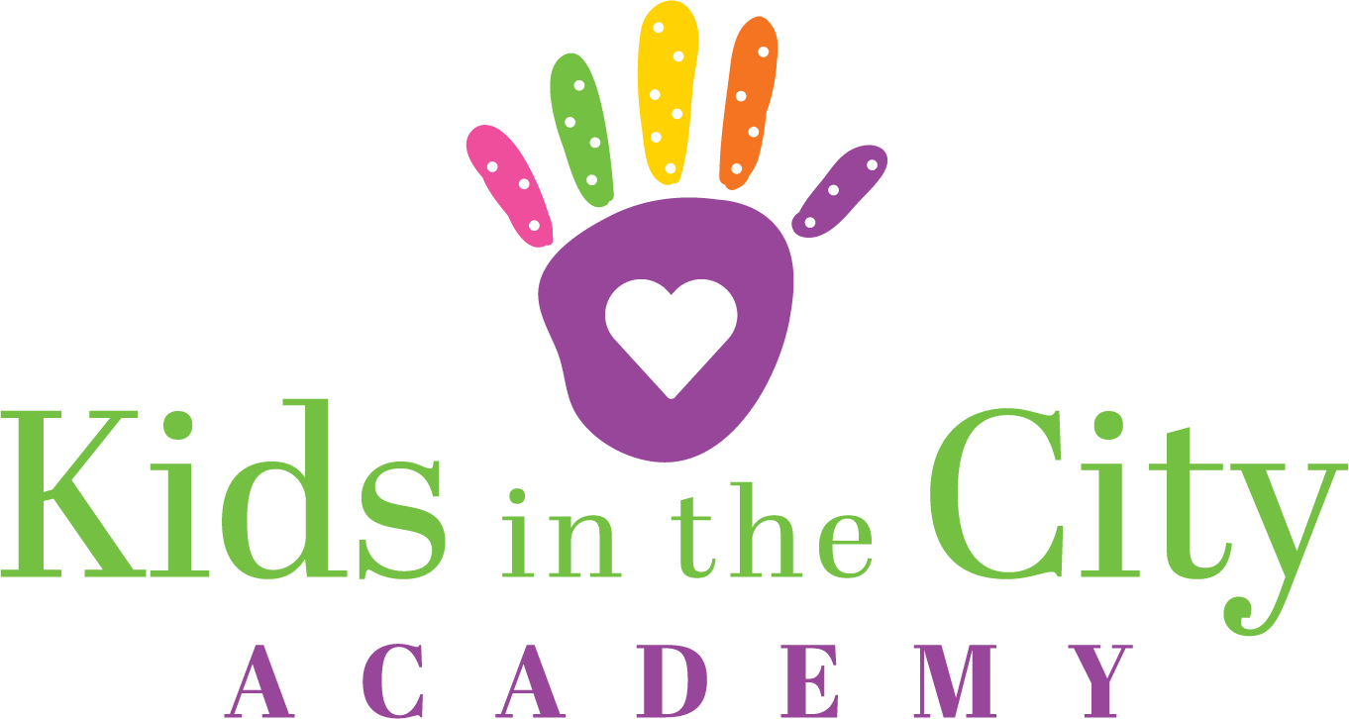

Adventurers: Three-Year Olds Supply List
- 1 pencil box
- 1 box of jumbo crayons (24 pack)
- 1 box of washable markers
- 2 containers of playdoh (any color)
- 1 pack of copy paper
- 1 pack of assorted colors card stock
- 1 pack of assorted colors construction paper
- 1 pack of expo thin markers & dry eraser
- 1 pair of child scissors
- 1 pack of colored pencils
- 2 trays of watercolor paints
- 1 bottle of school glue
- 2 packs of glue sticks
- 1 box of Kleenex
- 1 package of baby wipes
- 1 water cup
- 1 bag of cotton balls
- 1 bottle of hand sanitizer
- 1 blanket
- 1 fitted sheet for cot
- 1 can of shaving cream
- Family photo for classroom family tree
- Child's photo for cubby
- Complete set of clothing labeled with first and last name, placed in cubby
*The teachers may be asking for other items during the school year to help with specific projects.
*Please label all school supplies with your child's name.

