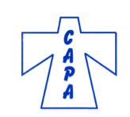
Colorado Activity Professionals Association’s
36th Annual Conference

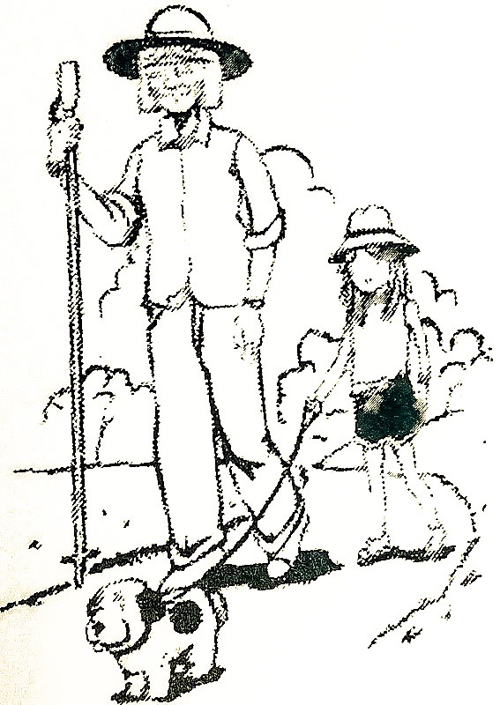

“Honoring Life Journeys”

October 3 - 6, 2023
Grand Junction, Colorado
The Courtyard Grand Junction

To register, complete the enclosed registration form or register online at thecapa.org under “Upcoming CAPA Events.” You can pay online or make checks out to CAPA and mail to: Ginger Clark, 4902 Herndon Circle, Colorado Springs, CO 80920. On-time registrations must include a registration form and payment prior to the deadline.
Conference Information

Full Conference Registration Includes:
- All Educational Sessions
- Choice of Break-out Sessions
- Wednesday Awards Theme Dinner
- Luncheon on Thursday
- Networking and Free Time

Deadline for Early-bird Registrations is Monday, September 11, 2023.

Cancellation Policy
Cancellations must be postmarked or called in by September 11, 2023, for a full refund. After that date, a 10% fee will be deducted for all cancelled registrations. A 50% fee will be assessed for all cancellations after October 1, 2023. No refunds for no-shows!

Continuing Education Credits Available 20.5 hrs Total
Tuesday Evening 1.5 hrs
Wednesday Only 8.5 hrs
Thursday Only 7.5 hrs
Friday Morning 3.0 hrs

Dress
Business casual is appropriate. Dress in layers as meeting rooms can be chilly. Masks are personal preference this year. Please bring a costume to dress up as your childhood dream job on Wednesday evening.

If you are interested in sharing a room or have questions or concerns about the conference,
contact Ginger at 719-661-7855.
Hotel Information
The Courtyard Grand Junction
765 Horizon Drive, Grand Junction, CO 81506
If web-based the online booking link is: Book your group rate for Colorado Activity Professionals Association
If Print based the online-booking instructions would be: www.marriott.com/GJTCY
Use Group Code: CAPCAPA for Single King Room or CAPCAPB for a room with 2 Queen Beds
For call-in reservations either format (Web or Print):
Call the hotel at (970) 263-4414 or (800) 935-4176. Be sure to mention the CAPA Group Rate or Group Code CAPC
Mention CAPA and make your reservation by September 11th. Reservations made after September 12th might be the regular room rate, based on availability. Hotel room rates for CAPA are $117 plus taxes.
Make your hotel reservation directly with the hotel. Special Accommodations Needed? Please call the hotel directly.

Tuesday, October 3rd
2023 Conference Agenda

4:00pm – 6:00pm
State Executive Board Meeting
5:00pm – 7:00pm
Registration Open
7:00pm – 8:30pm GROUP SESSION
Alisa Tagg (The State of NAAP Address)
8:30pm – 9:30pm
Opportunity for Networking

Wednesday, October 4th
7:30am – 8:30am
Registration Open
Display Tables & Silent Auction Open

8:15am – 8:30am
Welcome & Introductions

8:30am – 10:00am KEYNOTE ADDRESS:
Alisa Tagg (The Importance of You: The Activity Professional)

10:00am – 10:15am BREAK

10:15am – 11:45am SESSION
- Alisa Tagg (Effective Resident Councils)
- Breanna Isringhausen (Art for Everyone)
11:45am – 1:30pm LUNCH on your own
Display Tables & Silent Auction Open

1:30pm – 3:00pm BREAKOUT SESSIONS
1. Alisa Tagg (Creating Culture Within the Social
Model of Care)
2. Ginger Clark (Programming 101)
3:00pm – 3:15pm BREAK
3:15pm – 4:45pm BREAKOUT SESSIONS
1. Chad Federwitz (Spiritual Dementia Care)
2. Debby Holmes (Music and Motion)

4:45pm – 5:30pm Break to prepare for Dinner
5:30pm – 7:00pm Theme Night & Awards Ceremony
(Dinner included with CAPA Registration)
7:00pm – 7:15pm BREAK
7:15pm – 8:45 pm Breanna Isringhausen & Carl Gibbs (Karaoke Groups ~ How To Facilitate Them)

Thursday, October 5th
7:30am – 8:30am Registration Open
Display Tables & Silent Auction Open
8:30am – 10:00am SESSION
- Alzheimer’s Association Virtual Session
10:00am – 10:15am BREAK
10:15am – 11:45am BREAKOUT SESSIONS
- Tana Dell (Dementia Training)
- Linda Janicki (Reviving Bingo)
11:45am – 12:00pm BREAK
12:00pm – 1:30pm CAPA BUSINESS
MEETING, LUNCHEON, & AUCTION
Lunch is included with your conference fee.
Silent Auction Closing & Door Prize Drawings

1:30pm – 3:00pm BREAKOUT SESSIONS
- Maureen Lutz (How To Plan & Implement a Successful Sensory Program)
- Carl Gibbs (COVID: Exploring the Paradigm Shift in Senior Care Activities)

3:00pm – 3:15pm BREAK
3:15pm – 4:45pm BREAKOUT SESSIONS
1. Lisa Curtis (Creating Custom Care Plans)
2. Robert MacLennan (Honoring Mothers Who
Made Our Life Journey)
4:45pm – 6:30pm BREAK
Dinner is on your own tonight.
6:30pm – 8:00pm Mark Brown (Can We Talk Here?!)

Friday, October 6th
8:30am – 10:00am GROUP SESSION
Robert MacLennan (State of CAPA Address)

10:00am – 10:15am BREAK
10:15am – 11:45am END NOTE SESSION
Mark Brown (We Crawl – We Walk – We Run)
Have a Safe Trip Home!

Join CAPA by going to
www.thecapa.org

Benefits of Membership
- Peer Support through regularly-scheduled chapter meetings including educational sessions
- Discounts on workshops, NAP Day, and Annual Conference
- Membership card, membership listing, access to the member’s only section of the CAPA website
- Memberships pins after one year of active service
- Annual CAPA Conference and other periodic workshops offering educational opportunities
Things to Remember
- Networking with others in the field.
- Bring business cards and calendars to trade.
- Bring money for the auction (cash, check, and credit card).
- Dress is business casual. Masks are personal preference; not required.
- Dress in layers as meeting rooms can be chilly.
- Bring a costume for Wednesday evening (childhood dream job).

Session Synopses

The State of the National Association of Activity Professionals
Alisa Tagg, MS, ACC/EDU, CADDCT, CDP, CDCS, DCS
Whether you are a NAAP member or not, you won’t want to miss this informative session. You will hear how NAAP is working to enhance your ability to become certified, retain your certification and how they are working with our government to give our residents the best quality of life/care possible.

KEYNOTE: The Importance of You: The Activity Professional
Alisa Tagg, MS, ACC/EDU, CADDCT, CDP, CDCS, DCS
We will focus on the important role that you, the Activity Professional, play in your community. We will also review the role of professionalism you play, how you enhance quality of life, and gain more confidence about who you are.

Effective Resident Councils Alisa Tagg, MA, ACC/EDU, CADDCT, CDP, CDCS, DCS
Resident Councils play a crucial role in communities ~ residents can voice concerns request improvements, support new residents, support community efforts to make care and life in the community the best it can be. This session will give guidelines and supportive measures on how to organize and hold effective resident council meetings. The participant will
also understand the beneficial relationship between Resident Council and Quality Assurance reporting.

Art for Everyone: How to Incorporate Art with a Variety of Residents Breanna Isringhausen, AAP-BC
I need your paragraph please…

Creating Culture within the Social Model of Care Alisa Tagg, MA, ACC/EDU, CADDCT, CDP, CDCS, DCS
In this session, the participant will learn how to create culturally competent communities through recognizing the need for diversity and humility. We will review the positive takeaways of engagement and how social engagement will change the way that we provide quality of life.

Programming 101: Maximizing Your Calendar Ginger Clark, BMT, BME, ADC, AAP-BC
Bring your calendar and six different colored highlighters/markers. In this session, you will learn how to create a well-rounded calendar, sure to please both residents and state surveyors! This is for people who are new to the position or just want a refresher course.

Spiritual Dementia Care Chad Federwitz, MA MA
Research and empirical evidence support the importance of spiritual care for people with Alzheimer’s or other dementias. This session will give examples of spiritual care for those with memory loss, some current practices to fill gaps, and results when this care is provided.

Music and Motion Debby Holmes, AAP-BC, ADC, other stuff
I need your paragraph please…

Karaoke Groups ~ How To Facilitate Them Breanna Isringhausen, AAP-BC & Carl Gibbs, ADC
We will structure our presentation from set up to song selection. We also will explain the importance of this group by setting examples of what will enrich the lives of ALL residents. Resources will be discussed for karaoke programming and we will share ideas for participation, to not only enjoy the music, but benefit physically and emotionally.
There will be a giveaway at the end of the session.

Alzheimer’s Association Panel Discussion Angel Hoffman, MA; Lisa Steffen, BFA, MA; Kelly Osthoff, MA
We will have a Zoom call with three of the local Alzheimer’s Associations staff members discussing “Dementia Education and Effective Communication Strategies” (Angel Hoffman), “Art and Dementia” (Lisa Steffen), and “Programs and Services (Kelly Osthoff).

Dementia Training Tana Dell, LCSW, NHA
I need a paragraph please…

Reviving Bingo Linda Janicki
In this session, Linda will provide new ideas for an old standard. Come with us and join in the fun!

How To Plan and Implement a Successful Sensory Program Maureen Lutz, RMT, ADC
In this interactive session, you will learn how to use items and activities that will provide a sensory experience for your participants. Ideas for sensory boxes and where to obtain items will be given as well as an opportunity to network with others about their own ideas. Be prepared to have fun!

COVID: Exploring the Paradigm Shift in Senior Care Activities Carl Gibbs, ADC
Activities and methods of person-centered care have undergone a significant paradigm shift since 2020 in senior care. Let’s explore the landscape of activities in skilled nursing and how Activity Directors adapted their programs over the course of the COVID pandemic. We will discuss regulation changes from the beginning of the pandemic to our current rules and regulations, leading us to an insight into the variety of successful current activities and the nature of future activities in a safe senior care environment.

Creating Custom Care Plans; Unique Interventions for Unique Individuals Lisa Curtis
Create care plans that eliminate stock interventions, review pertinent information, and how to utilize other disciplines to make Activity Care plans a unique, well-rounded snapshot that explains more of the “Why” in their life story and preferences.

Honoring Mothers Who Made Our Journey Possible Robert MacLennan, ADC
Honoring the mothers at any care community in the state is essential for all Activity Professionals. This session will provide information to design and create corsages to honor mothers on this very special day of the year.

Can We Talk Here?! Mark Brown, Ph.D.
At the CAPA Conference in 2022, Mark had a session planned and then a question turned the talk into a very therapeutic session, dealing with all of the stress and frustrations that Activity Professionals have endured during COVID. This session will be an open discussion about whatever the participants want to bring up. Just remember: “What happens in Grand Junction, stays in Grand Junction!”

The State of CAPA Address Robert MacLennan, ADC
The President of the CAPA State Executive Board, Robert MacLennan, will discuss current membership, the website, the Facebook page and much more. Please plan to attend this informative session.

We Crawl – We Walk – We Run Mark Brown, Ph.D.
An old Oriental proverb asks the question: What animal walks on four legs in the morning, two legs in the afternoon and three legs in the evening? We know this to be a very puzzling question. But, if we think, the answer will come to us from our lifespan and how we live our life. Join Dr. Mark as he takes you through the steps of these three different forms of animal, and answer the question of our life’s journey: how we live, how we thrive, how we reach our success as we come to the end of this journey. Let’s remember to Honor each and every Life’s Journey. Oh… and remember… The Journey never ends!

COLORADO ACTIVITY PROFESSIONALS’ ASSOCIATION CONFERENCE – October 3 - 6, 2023
Conference Registration
To register, complete the enclosed registration form or register online at thecapa.org under “Upcoming CAPA Events.” You can pay online or make checks out to CAPA and mail to: Ginger Clark, 4902 Herndon Circle, Colorado Springs, CO 80920. Registrations must include registration form and payment prior to the deadline to be considered “Early” or “On-time.” Each attendee must complete a registration form.

Name _________________________________________ Chapter ______________________
Facility ________________________________________ First Conference? Yes ____ No ____
Mailing Address ________________________________________________________________
_____________________________________________Circle all applicable: SNF/MC/AL/IL/Day
Home Phone _____________________________ Cell Phone _____________________________
Email __________________________________________ Add me to email list: Yes / No
Special Dietary Needs ___________________________________________________________

CAPA Members
Full Early-bird Registration by Sept 11th $225
Full Registration after September 11th $245
One-Day Early-bird Registration by Sept 11th $140
One-Day Registration after Sept 11th $150
Wednesday Only or Thursday Only (Circle one)

Non-Members
Full Early-bird Registration by Sept 11th $270
Full Registration after Sept 11th $290
One-Day Early-bird Registration by Sept 11th $180
One-Day Registration after Sept 11h $190
Wednesday Only or Thursday Only (Circle one)

Payment Method ____________
CAPA Membership ($50) ____________
(if needed; not required)
Total Amount Enclosed ____________

Note: If you wish to pay by credit/debit card, please go to www.thecapa.org under “Upcoming CAPA Events” then “2023 CAPA Conference”

*After September 11th, contact Ginger Clark at emtclark@aol.com or 719-661-7855 for Special Consideration.
Please Note: Late Registrations will not guarantee meal and special diets.

Will you be attending the Friday morning sessions? Yes___ No___

You are responsible for your hotel reservation. The cost is NOT included in the Conference Registration. Call The Courtyard Grand Junction at 970-263-4414 and mention CAPA Group Rate.

Colorado Activity Professionals’ Association
2023 Conference

“Honoring Life Journeys”
October 3 – 6, 2023
Grand Junction, Colorado

CAPA
c/o GINGER CLARK
4902 HERNDON CIRCLE
COLORADO SPRINGS, CO 80920

