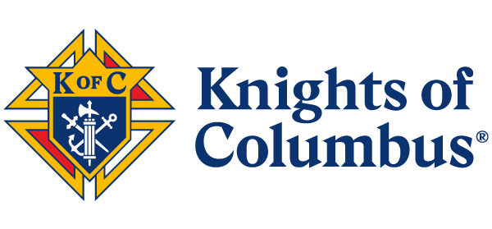

**FRATERNAL BENEFIT EVENT**

**PULPIT ANNOUNCEMENT**

**OPTION 1** [190 words]

Hello. My name is [NAME] and I am honored to be a member of your local Knights of Columbus council. Many of you know the great work we do in the parish and community, but what you might not know is that the Knights of Columbus has been helping provide financial security for Catholic families for generations. The Knights of Columbus was founded by Blessed Michael McGivney to support Catholic families. Today, our Order continues this tradition of protecting families, proclaiming the faith, and helping those most in need in this community and across the world. Through the good work of the Order and its array of insurance products you can address your family's insurance needs while supporting an organization that contributes to charities that align with our shared Catholic faith.

On [DATE], [TIME], at [LOCATION], we invite all of you to join us for a Fraternal Benefit Event to learn more about the financial services and fraternal benefits offered by the Knights of Columbus, led by local agent, [AGENT}. [*when applicable*: Details are also included in this week’s bulletin.]

**OPTION 2** [142 words]

Hello. My name is [NAME] and I am honored to be a member of your local Knights of Columbus council. Many of you know the great work we do in the parish and community, but what you might not know is that Knights of Columbus has been helping provide financial security for Catholic families for generations. For more than 140 years, the Knights has been protecting families, proclaiming the faith, and helping those most in need in this community and across the world. Today many Catholics are turning to the Knights of Columbus for its array of insurance products.

Join us on [DATE], at [TIME] for a Fraternal Benefit Event to learn more about the financial services and fraternal benefits offered by the Knights of Columbus, led by local agent, [AGENT}. [when applicable: Details are also included in this week’s bulletin.]

3-2023 1-23