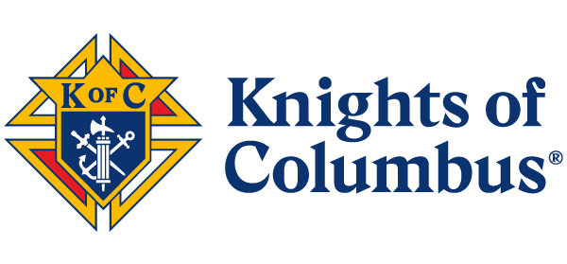

**FRATERNAL BENEFIT EVENT**

**BULLETIN TEXT**

**OPTION 1** [78 words]

Learn how Knights of Columbus can help you protect your family and plan for your retirement, while supporting an organization that contributes to important charitable causes aligned with your Catholic values. You are invited to join us for a Fraternal Benefit Event to learn more about the financial services and fraternal benefits offered by the Knights of Columbus. [DATE], [TIME], at [LOCATION]. Please reach out to [NAME OF AGENT & CONTACT INFO] [or visit LINK] to register.

*Knights of Columbus One Columbus Plaza New Haven, CT 06510*

**OPTION 2** [83 words]

Learn how the Knights of Columbus helps protect Catholic families, proclaims the faith, and helps those most in need in local communities and across the world. With the Knights you can address your family's insurance needs while supporting an organization that contributes to charities that align with our shared Catholic faith. Everyone is invited to join us for a Fraternal Benefit Event on [DATE], [TIME], at [LOCATION]. Please reach out to [NAME OF AGENT & CONTACT INFO] [or visit LINK] to register.

*Knights of Columbus One Columbus Plaza New Haven, CT 06510*

1-2023 1-23