WELCOME TO CALVARY CHRISTIAN SCHOOL

The Calvary Christian School Administration and Faculty are excited to serve parents who want a Christ-centered education for the children. Whether you have been at Calvary Christian School for many years or are just considering enrollment at the school, it is important that clear and concise information be available to you. We hope that this student handbook provides that insight into the policies of the school and how it operates. While we know that this tool will be very useful in allowing you to develop a concept of what our school is about on a day to day basis, we also know that it will not convey the passion held by faculty, administration and parents for the work that goes on at our school. This passion is rooted in a deep love for God, and it rests on His Word as a foundation. It is our deepest desire to show the love of God to each student, parent and faculty member who call Calvary Christian School home.

We seek to provide a practical, Bible-based education that touches each child’s heart, mind, and spirit. You will be pleased when your child sits in classrooms that provide one of the finest educations in the Northern Virginia area. Our composite test scores are among the highest in the area at most grade levels. You will be pleased when your child comes home with songs they have learned during their daily Bible class. You will be pleased when you see your child responding to the balanced approach we maintain between love and discipline; between God’s grace and God’s truth.

It is difficult for me to express what a special place our school has become without sounding self-serving, but this is the Lord’s school. What happens here is because of Him. I can say this: the care, love, concern, and attention your child will receive at this school represent the faculty’s efforts to be the hands, ears, mouth, and feet of our Lord. Yes, Calvary Christian School is a safe place for children in today’s reckless and dangerous world. Yes, it provides a fine education for children that will equip them for the internationally competitive world in the workplace. Yes, we seek to meet each child’s spiritual, physical and emotional needs when the culture is sending all the wrong messages to undermine patents who want a Biblical lifestyle for the child. Ultimately, this school becomes faculty, parents and students working together to create an environment that honors God, which leads to each individual growing closer to the Lord while taking on the character traits of our Lord and developing their God-given talents and gifts.

I would like to thank the parents, alumni, and friends of CCS who have supported this ministry for many years. I would be pleased to meet with new parents who want what we have at Calvary Christian School. We need new parents and students to join with us as we work to provide an education that meets today’s needs while at the same time reaching the hearts and minds of students for Christ.

Because Christ Lives and Reigns,

John R. Wallace, Jr.
Senior Administrator

Table of Contents

Page
DIRECTIONS TO CALVARY CHRISTIAN SCHOOL
From Stafford
From Woodbridge/Dumfries via US 1
From I-95 North or South
From Quantico

MAP TO CALVARY CHRISTIAN SCHOOL

OUR MISSION

STATEMENT OF FAITH

GOALS AND OBJECTIVES FOR OUR STUDENTS
Spiritual Objectives
Social-Personal Objectives
Academic Objectives

CALVARY CHRISTIAN SCHOOL CLASSROOMS

GUIDELINES FOR OUR BIBLE TEACHING

CURRICULUM
Four-Year-Old Transition Kindergarten Program (K4T)
Four-Year-Old Kindergarten Program
Five-Year-Old Kindergarten Program
1st Grade Program
2nd Grade Program
3rd Grade Program
4th Grade Program
5th Grade Program
6th Grade Program
7th Grade Program
8th Grade Program
CCS High School Graduation Requirements
9th Grade Program Sample
10th Grade Program Sample
11th Grade Program Sample
12th Grade Program Sample

GENERAL INFORMATION
Quarterly Life Skills Classes
Quarterly Life Skills Classes
Middle and High School International Missions Trip
Field Trips
Snow Policy and Holidays
Lunch and Fruit Break
Lunch Venders
Supplies
Sick Students
Policy on Contagious Symptoms
Immunization Record Requirement
Testing Program
Prayer
Parent-Teacher Communication
Parent-School Communication
Parent Involvement
Transportation
Hours of Operation of Calvary Christian School
Before and After School Childcare
Drop Off and Pick Up of Daycare Students
Homework
Report Cards and Interim Reports
Attendance

SAMPLE OF INTERIM REPORT for 1st-6th Grade

SAMPLE OF INTERIM REPORT for 7th-12th Grade

SAMPLE OF TRANSITION FOUR (K4T) PROGRESS REPORT

SAMPLE OF KINDERGARTEN REPORT CARD

SAMPLE OF ELEMENTARY REPORT CARD

SAMPLE OF MIDDLE AND HIGH SCHOOL REPORT CARD

SAMPLE OF THE OFFICIAL HIGH SCHOOL TRANSCRIPT

UNIFORM CODE FOR CALVARY CHRISTIAN SCHOOL KINDERGARTEN &
ELEMENTARY STUDENTS

UNIFORM CODE FOR CALVARY CHRISTIAN SCHOOL MIDDLE SCHOOL
STUDENTS

UNIFORM CODE FOR CALVARY CHRISTIAN SCHOOL HIGH SCHOOL
STUDENTS

FLYNN & O’HARA UNIFORM COMPANY OF VIRGINIA

Table of Contents
(Continued)

Page
KINDERGARTEN AND ELEMENTARY DISCIPLINE POLICY OF CALVARY
CHRISTIAN SCHOOL
Reward System
Tally System

CALVARY CHRISTIAN SCHOOL MIDDLE AND HIGH SCHOOL DISCIPLINE
POLICY
Reward System and Positive School/Class Culture
Derogatory Reports (D.R.’s)/Detention
Honor Roll
Middle and High School Student Pledge (6th-12th Grades)

STAFFING OF CALVARY CHRISTIAN SCHOOL
Class Size Breakdown

ADMISSION TO CALVARY CHRISTIAN SCHOOL
Readmission
Application
Non-Discriminatory Policy
Records

FINANCIAL INFORMATION
First
Second
Administrative Charges
Sample Automatic Draft Form (ACH)
Notice Regarding Cash Payments
Notice Regarding Daycare Charges
Notice Regarding Daily Lunch Charges
Notice Regarding Late Fees
Notice Regarding Past Due Accounts
Notice Regarding Missed Days of School
Double Budget Process

CALVARY CHRISTIAN SCHOOL FEES AND TUITION 2013-2014 WORKSHEET

VERY IMPORTANT WAYS YOU CAN HELP CALVARY CHRISTIAN SCHOOL
Table of Contents
(Continued)

Page
THE ADMISSION PROCESS

A FINAL NOTE FROM THE CALVARY CHRISTIAN SCHOOL ADMINISTRATOR

ADDENDUM
Emergency Plan for Calvary Christian School
Contact Information for Calvary Christian School

DIRECTIONS TO CALVARY CHRISTIAN SCHOOL

From Stafford: Take Rt. 1 to the light at Rt. 1 and Joplin Road by the Iwo Jima
Memorial. Take a left and then make a quick right onto Inn Street. Inn Street makes a sharp left; follow it for about one-half mile to Triangle Baptist Church. Park and enter at the school's entrance at the far end of the facility by the playground.

From Woodbridge/Dumfries via US 1: Take Rt. 1 to the intersection of Rt. 1 and Joplin Road by the Iwo Jima Memorial. Take right at light and then make another quick right onto Inn Street. Inn Street makes a quick left; follow it for about one-half mile to Triangle Baptist Church. Park and enter at the school's entrance at the far end of the facility by the playground.

From I-95 North or South: Go to the Quantico/Triangle exit. Go toward Triangle, but take the first left before you get to the stop light at Rt. 1. This looks like you are going into a hotel lot. Make another quick left onto Inn Street. Follow Inn Street for about one-half mile to Triangle Baptist Church. Park and enter at the school's entrance at the far end of the facility by the playground.

From Quantico: Exit main gate of Quantico. Go across Rt.1, but be prepared to take the first right onto Inn Street. This looks like you are going into a hotel lot. Make another quick left; go about one-half mile, you will find Triangle Baptist Church. Park and enter at the school's entrance at the far end of the facility by the playground.

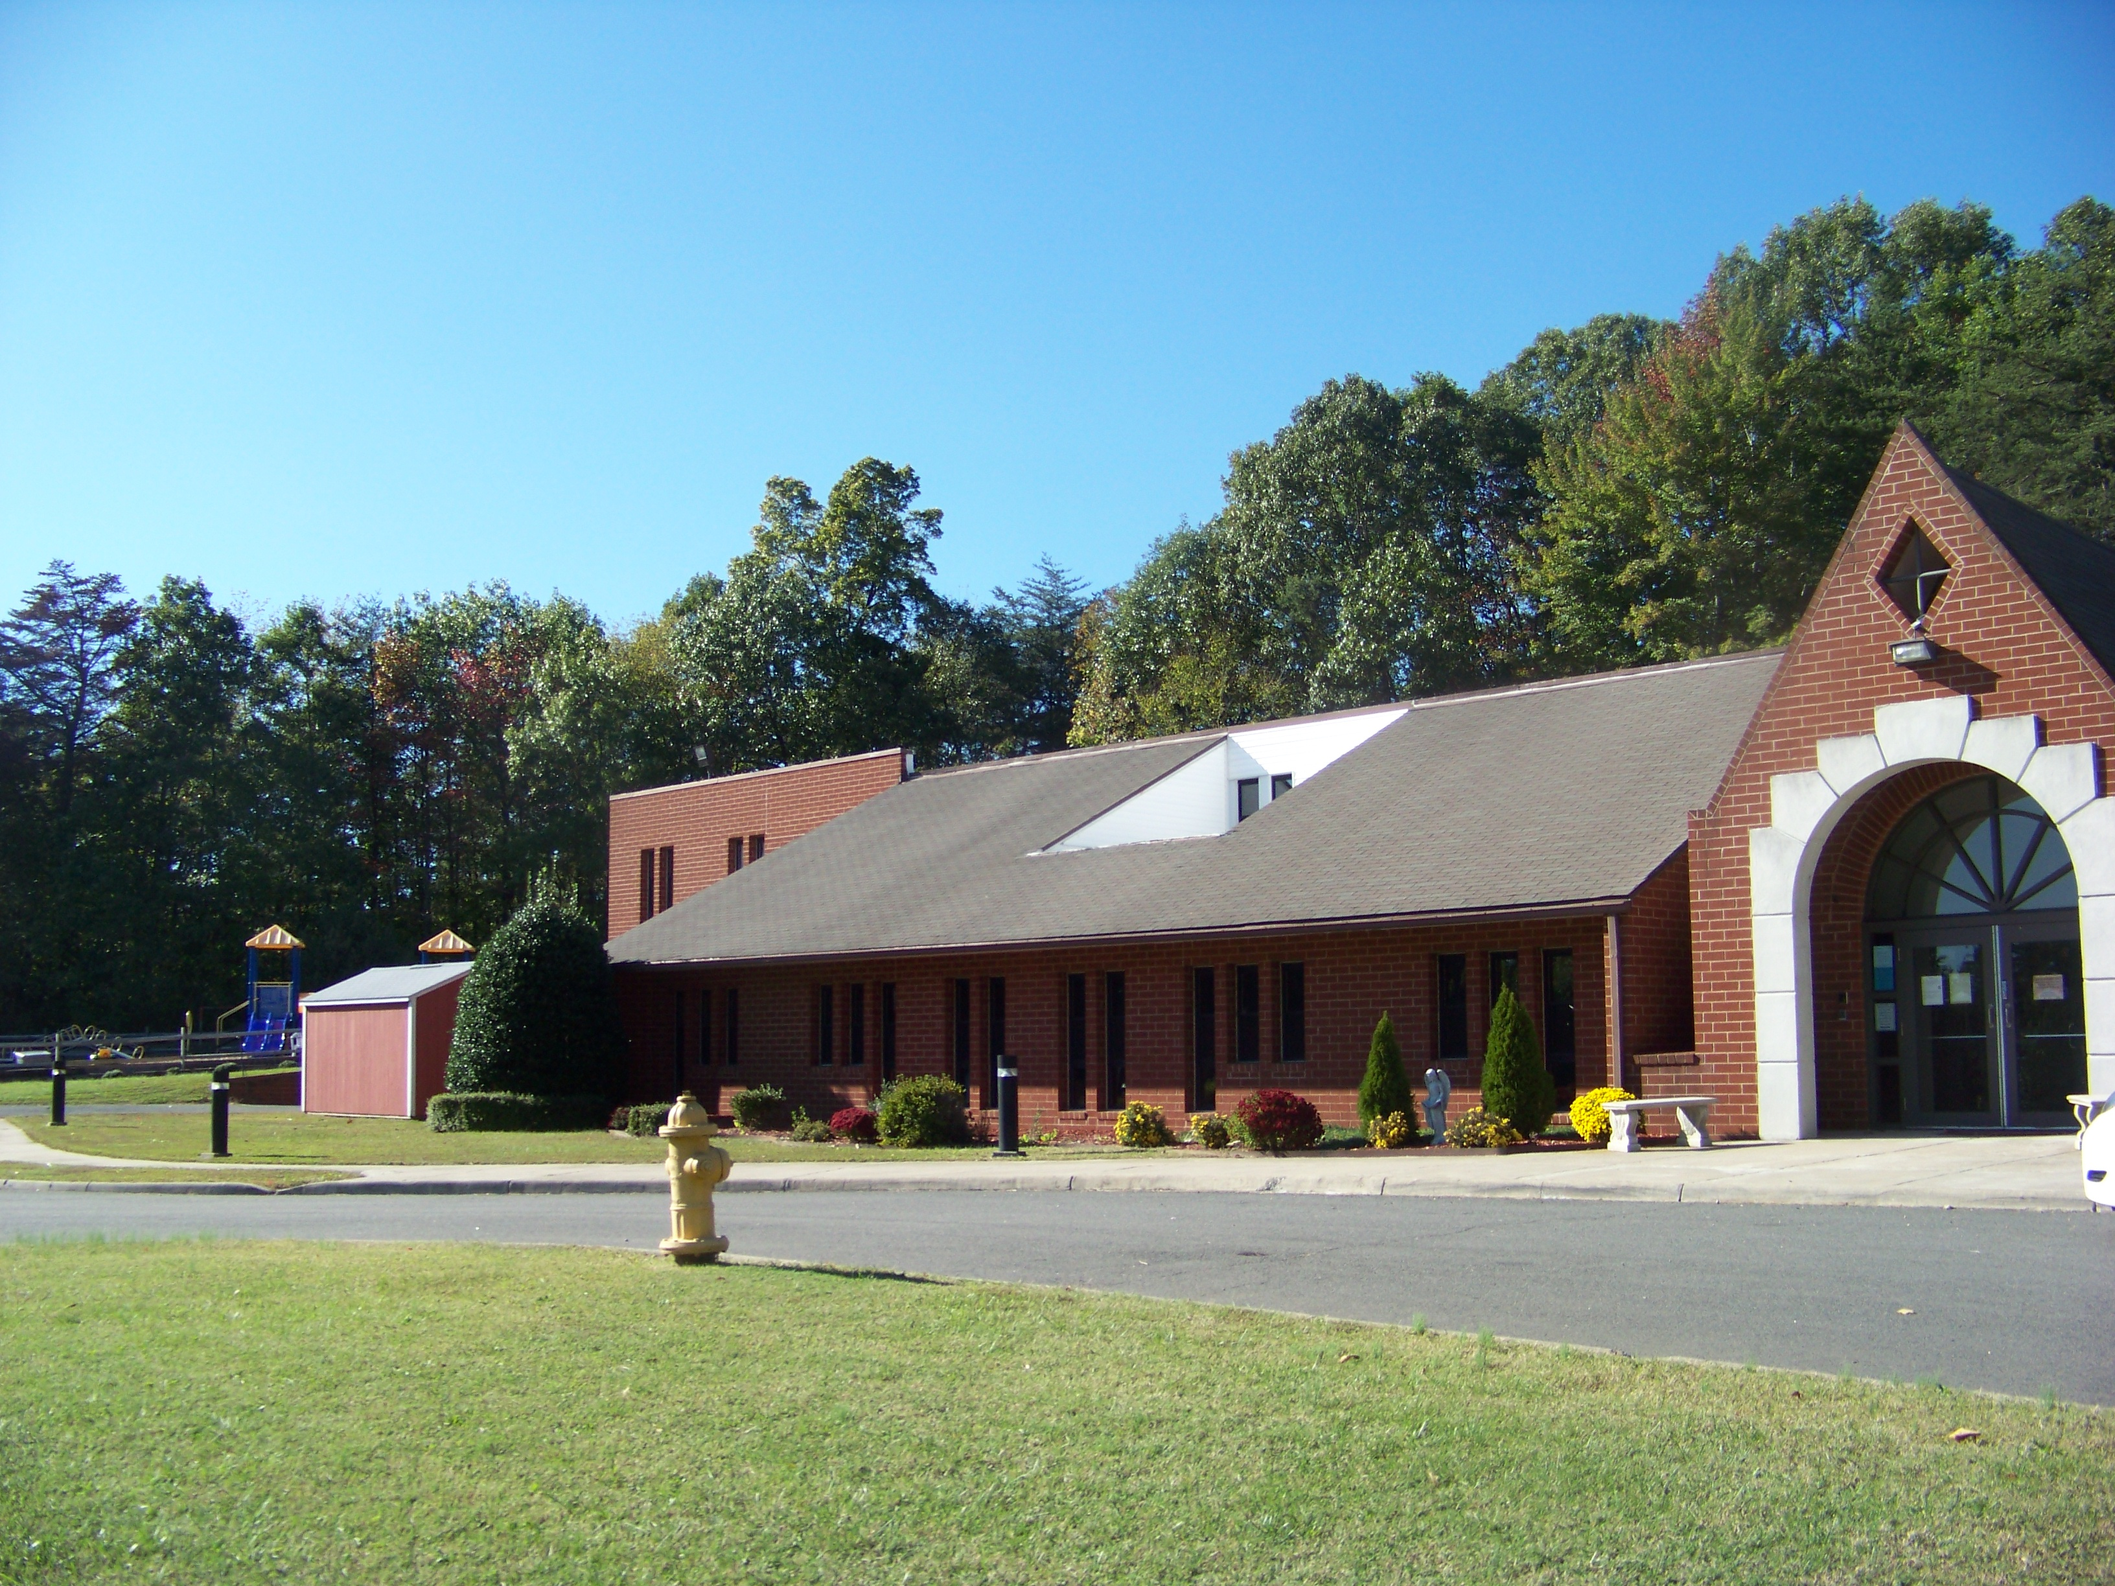

OUR MISSION

The mission of Calvary Christian School is to establish a true partnership with Christian parents to provide for their kindergarten, elementary, middle school, and high school students’ an outstanding Christian education. The school endeavors to develop a Christian world view in the student through an integrated curriculum of Biblical truth as the foundation for all academic instruction, extra-curricular activities, and social interaction. Emphasis is given to each student’s total development, including their personal commitment and service to Jesus Christ, encouraging the students to allow their character to conform to the character of Christ, and helping the student achieve academic excellence. It is in using this foundation that we hope each student will impact this world for the cause of Christ.

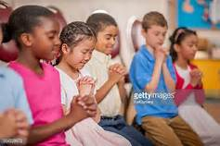

“Linking the head and the heart, the home and the school, the child and God.”
STATEMENT OF FAITH

The basis of all areas of operation of Calvary Christian School will be the Word of God as interpreted by the following statement of faith:

1. We believe the Bible to be inspired and the only infallible, authoritative, written Word of God.

2. We believe that there is one God, eternally existent in three Persons: God the Father, God the Son, and God the Holy Spirit.

3. We believe in the deity of our Lord Jesus Christ, in His virgin birth, in His sinless life, in His miracles, in His vicarious and atoning death, in His bodily resurrection, in His ascension to the right hand of the Father, and in His personal future return to this earth in power and glory to rule a thousand years.

4. We believe in the Blessed Hope - the rapture of the Church at Christ's coming.

5. We believe the only means of being cleansed from sin is through repentance and faith in the precious blood of Christ.

6. We believe that acceptance of Jesus Christ as Lord and Savior is absolutely essential for personal salvation.

7. We believe the redemptive work of Christ on the cross provides healing of the human body in answer to believing prayer.

8. We believe the baptism of the Holy Spirit, according to Acts 2:4, is given to believers who ask for it.

9. We believe in the sanctifying power of the Holy Spirit by whose indwelling the Christian is enabled to live a holy life.

10. We believe in the resurrection of both the saved and the lost, the one to everlasting life and the other to everlasting damnation.
GOALS AND OBJECTIVES FOR OUR STUDENTS

SPIRITUAL OBJECTIVES

1. To teach the Bible as God's inspired Word and as completely true.

2. To win students to a saving knowledge of Christ as Savior and Lord.

3. To develop a respect for God's authority and the authority of parents in students' lives.

4. To develop a desire to know what the Bible teaches and to develop a spirit of obedience.

5. To help each student to establish the habit of daily devotions.

6. To assist students in beginning to integrate Biblical truth into each academic area and eventually into each area of their lives, so that they become sensitive to God’s will for their lives and develop a willingness to follow it.

SOCIAL-PERSONAL OBJECTIVES

1. To enable each student to see himself as a unique, very special creation of the Lord, with gifts and abilities which He desires to be developed and used to the fullest for His glory.

2. To help students understand that God is at work in the lives of believers, to conform them to the image of His Son, and to develop Christ-like character.

3. To develop the concept that we are one in the Spirit with other believers and to instill the desire to maintain that oneness.

4. To teach that our responsibility is to love others in word and deed because "God first loved us," understanding that our lives are a witness to those around us.

5. To develop proper attitudes toward siblings and parents, and commitment to eventually establish God-centered homes.

6. To develop good habits of politeness and courtesy toward others.

7. To teach the responsibilities of living in a democratic society, contributing to others with a servant-spirit, and being good stewards of all that God has given us.

8. To encourage physical fitness, good health habits, and wise use of our bodies as temples of God.

ACADEMIC OBJECTIVES

1. To tailor instruction realistically to the academic level on which each student is functioning and to help the student progress as far as his God-given abilities will carry him.

2. To provide an environment conducive to learning and excellence.

3. To give particular attention to language arts skills so that students can read and communicate well.

4. To teach an appreciation of God's world for the wonder and care of His natural creation and a deep interest in and love for the people and different cultures of the world.

5. To teach critical thinking skills so that students can evaluate, discern, problem solve, and make wise Biblical judgments.

6. To develop creative abilities and love of the fine arts.

7. To develop disciplined study habits and a desire to continue learning all through life.

8. To help students appreciate God's Word as their most basic "life textbook."

These three sets of goals and objectives establish the ideal toward which we will work, allowing God to mold the students, faculty, and parents into His image.

Classrooms at Calvary Christian School
While classrooms look different each school year, the following pictures should provide an idea of the classroom surroundings that students will experience each day while that are in school.

The Classrooms of the Calvary Christian School
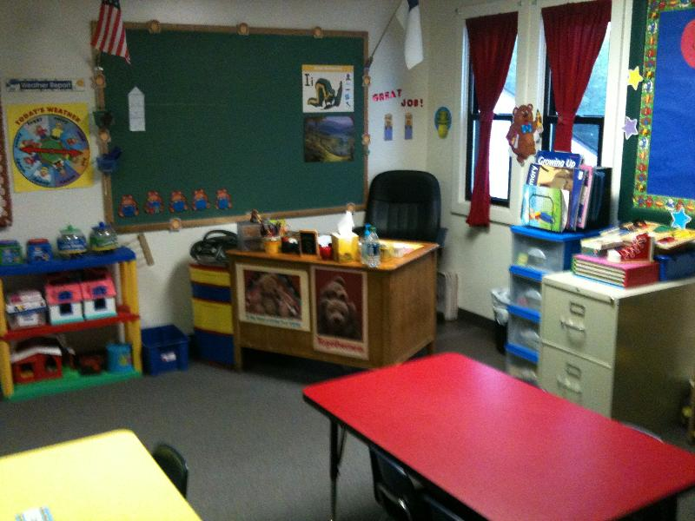
K4T View 1

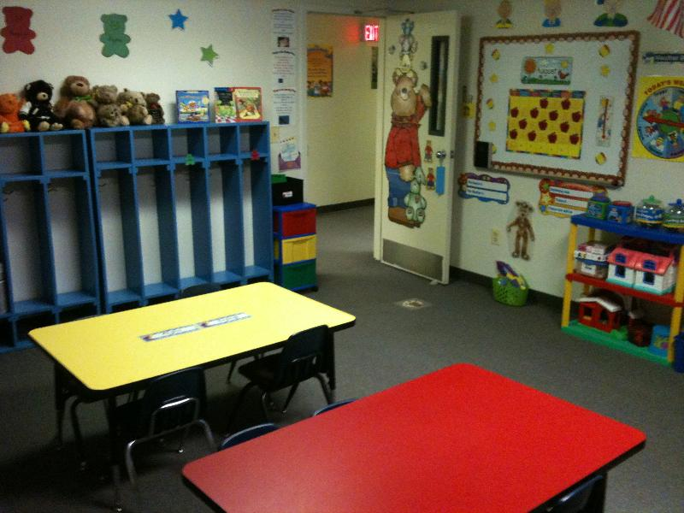
K4T View 2

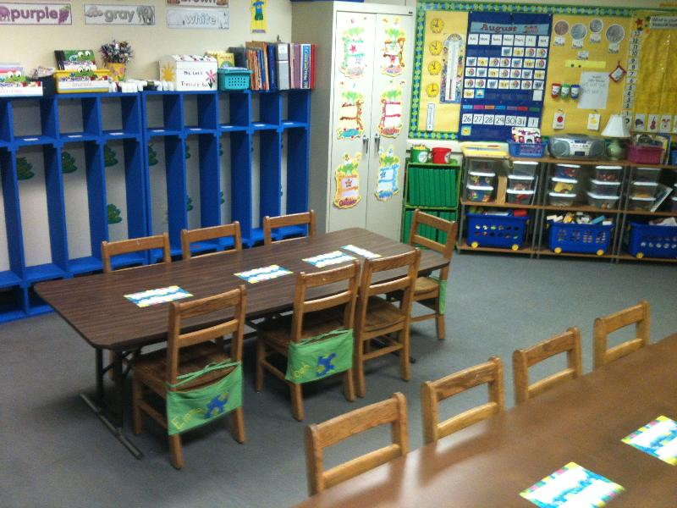
K4 Room View 1

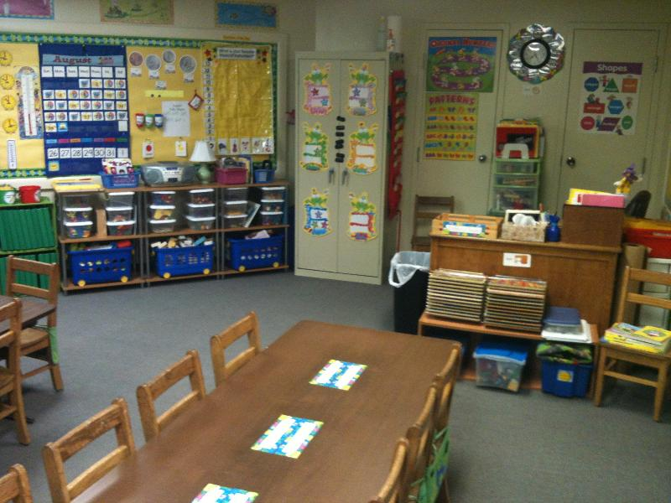
K4 Room View 2

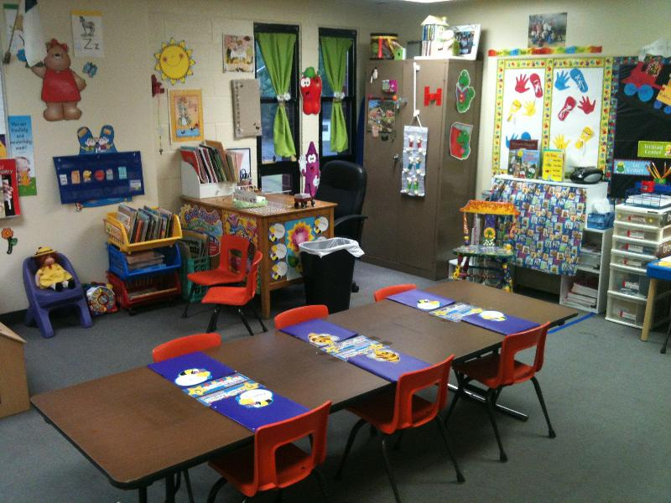
K5 Classroom

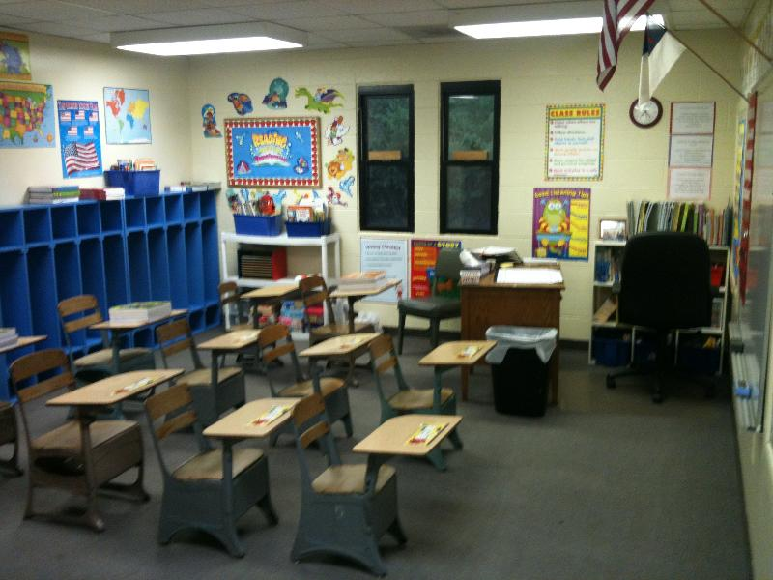
1st/2nd Classroom

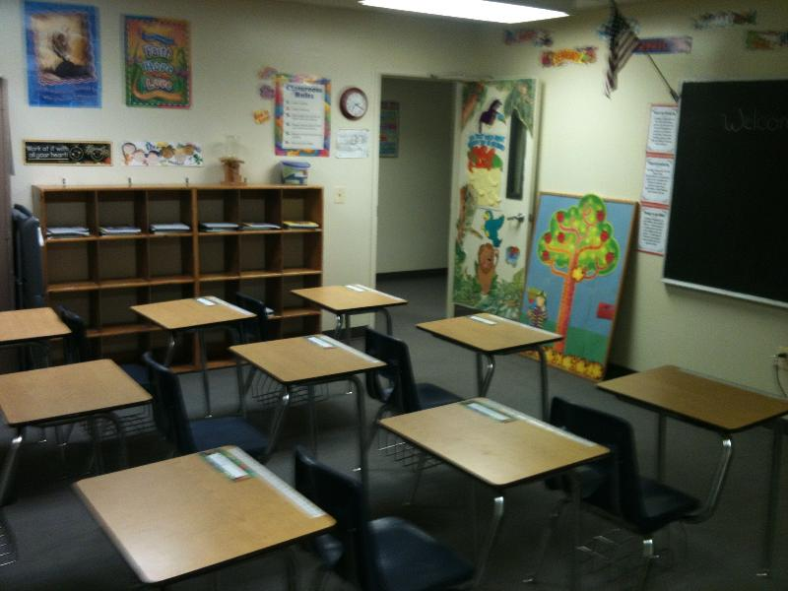
3rd/4th Room View 1

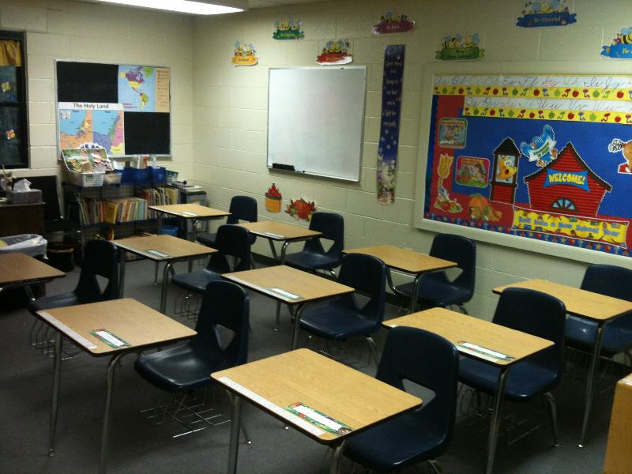
3rd/4th Room View 2

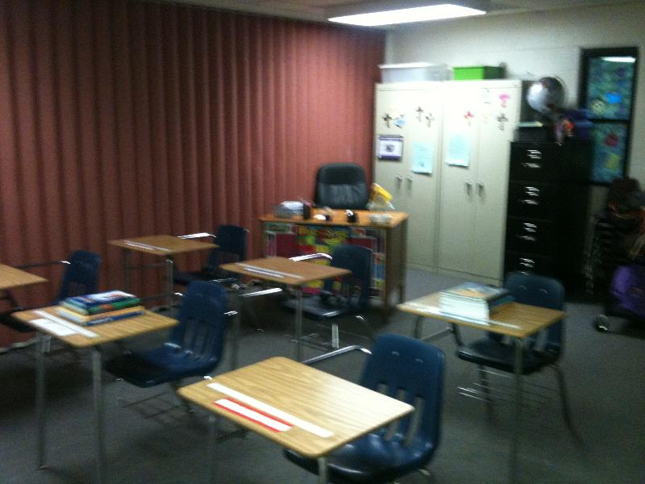
5th/6th Grade Classroom

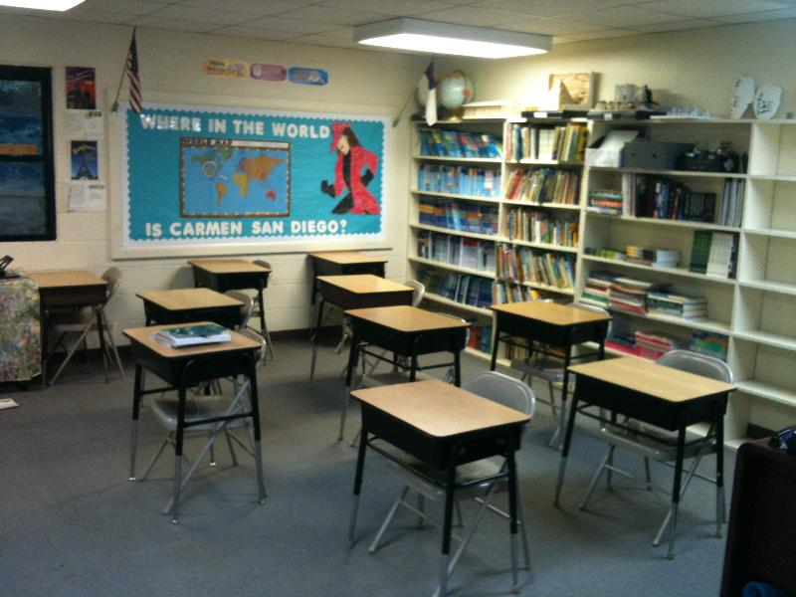
Middle School Classroom

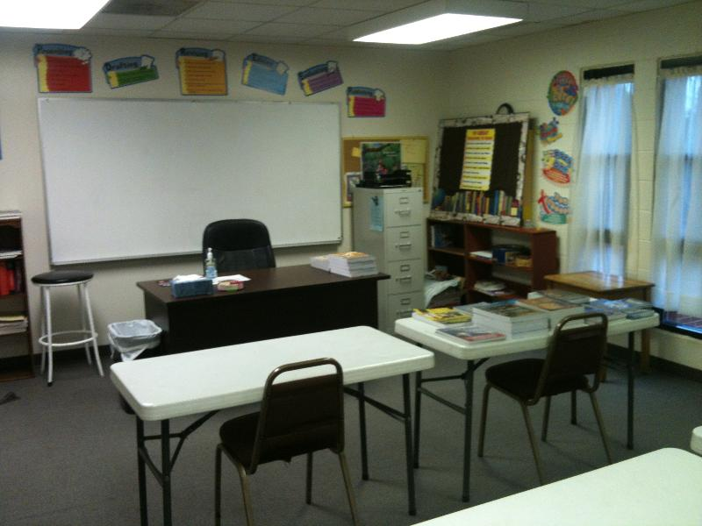
High School Classroom

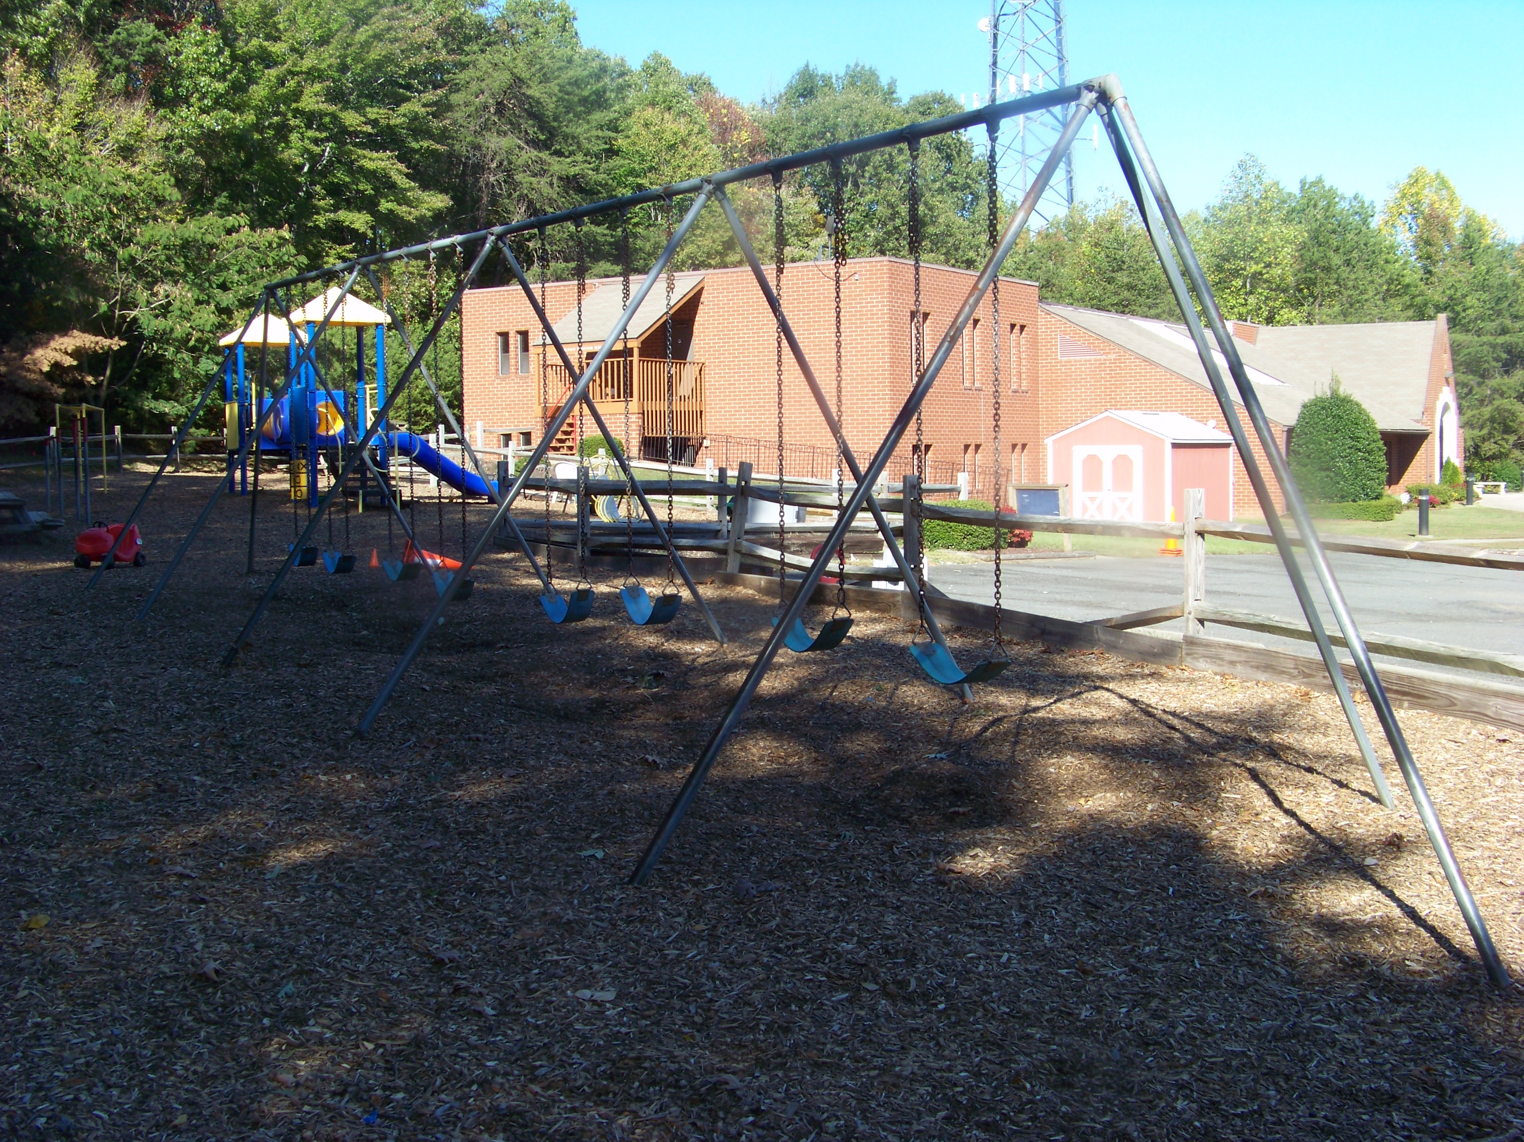
CCS Playground Area
GUIDELINES FOR OUR BIBLE TEACHING

Our goal, as we teach Bible, is to create a thirst for the Word of God - the Living Word, the Lord Jesus Christ, and the written Word, the Bible. The following guidelines will help us as we teach in our classrooms:

1. Present the major indisputable doctrines of the Bible boldly; e.g., sin, salvation, and the deity of Christ.

2. When subject questions arise on which born-again believers differ (such as modes of baptism, tongues, baptism of the Holy Spirit, healing, etc.), we are certain to explain that various views exist. Rather than presenting our own personal convictions on the matter, we let the Scriptures speak for themselves and encourage students to study what the Bible says about the matter. We pray that the Holy Spirit will give them understanding according to His perfect timing.

3. We remember that as teach your student(s), it is the Holy Spirit's job to actually do the teaching. The Holy Spirit is truly at work when Jesus Christ is exalted (John 16:3, 14). We want to center on the person, ministry, and work of Christ.

We thank God that during our first twenty-five years of operation, doctrine has not become a divisive issue. We wait under the Lordship of Christ, allowing His Spirit to lead us in the area of Bible teaching. With over twenty churches represented at Calvary Christian School, this is essential to show the unity of Christ's body of believers.

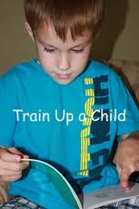

“Train up a child in the way he should go; and when he is old,
he will not depart from it.” Proverbs 22:6
CURRICULUM

Calvary Christian School uses the Abeka Curriculum as its basic outline of study as the backbone for study. This curriculum has been developed, refined, and used in Christian schools for the last fifty years. Because of its long history, the Abeka material has set the standard for excellence within Christian education across the country. Because all curriculum has strengths and weaknesses, we supplement this program with other teaching curriculum such as Bob Jones and The Association of Christian School International, when we see that an individual, class, or subject area need a change from ABeka. Colorful workbooks and textbooks bring learning alive to the students that attend Calvary Christian School. If you have specific questions regarding the material used for instruction, please be sure to bring it up at your initial interview for admission.

Our curriculum provides for a traditional classroom setting. Table and chairs are used in the kindergartens, and one-piece desks or tables and chairs are used in the elementary grades, middle, and high school.

Our three and a half, four, and five-year-old kindergarten reading program is phonics-based. By learning the sound that each letter makes, students have a strong basis for reading by the end of their four-year old kindergarten year. Basic counting, number recognition, and math skills are also taught to the three and a half and four-year-old students. The five-year old program reinforces the material taught in the four's program, and then extends it in both the phonics and numbers areas. A detailed breakdown of the areas covered in our kindergarten program is included on the following pages. It is our goal to have each student reading by the time he or she leaves the four or five-year- old program.

Our elementary curriculum (1st-6th) is very aggressive in the areas of math and language skills. We feel that these two areas are extremely important for our students' future academic success, as well as success after leaving school. Drill and detailed study are required in each subject area. The science and history books are oriented to the Word of God - something missing from secular text books.

Our middle school (7th-8th) program is designed to provide our teachers with flexible class scheduling, and to teach students the skills needed to be successful high school and college students. At this level, it is especially important for the faculty and parents to help develop a very positive Spiritual environment on campus. It is from the foundation that strong social and academics will flow. We use the ABeka Curriculum for most major subject areas. These years of school serve to prepare the students as excellent readers with refined study skills and strong communicators, both through writing and verbal presentation. We also seek to develop strong over-all math conceptualization understanding which is accompanied by exceptional computational and problem-solving skills. Students in 8th grade may be recommended for high school level mat: Algebra 1 and earn high school course credit. Our Domestic or International Mission and Cultural Studies Courses (DMCS or IMCS) are available for 8th grade students who participate in the Calvary’s Impact Mission Program and who meet the additional requirements of the course which are established at the beginning of the trip preparation.

The Calvary Christian School High School represents a very special place for preparation for the student’s life after high school. The curriculum is a college preparatory program of study. The courses offered and required for graduation are based on the Prince William County Schools guidelines for graduation plus up to five additional credits. Please see the “High School Graduation Requirements” section of this book for exact details. The curriculum used at the high school level includes Abeka, Bob Jones, Apologia, and outside text material. The level of expectation in high school is far greater than in middle school. Students are expected to take personal responsibility for their engagement in the learning process with diligent study and class preparation. While academic study is important to post-high school success, a direct focus on spiritual and social growth is equally important. This means that these areas will be equally addressed as part of the high school process and program.

An individual high school program of study will be developed with the parents and student upon admission to Calvary Christian School. The program will outline the classes that must be completed each year prior to graduation which generally follows Prince William County requirements, but also includes four years of Bible credits. It will also plan the extra “resume builders” that college and university admission officers are seeking to provide admission. These may include church leadership, volunteer work, scouting, missions work such as the school’s Calvary’s Impact International and Domestic Missions Programs, internships, summer camp work, employment, sports, church work, and college summer attendance.

Calvary Christian School is pleased to work with Northern Virginia Community College, as well as other well-known universities, to provide joint high school/college credit to our juniors and seniors when classes are taken at the NOVA or online. For juniors and seniors who have successfully met admission screening and who area approved by the Calvary Christian School’s administration and their chosen school of higher learning, Calvary Christian School will pay $200 per course for up to two courses in the junior year and four courses the senior year of high school. This program is intended to meet the needs of the most outstanding students at Calvary Christian School. Using this program will help transition our high school students from a high school environment to a college environment. While the program is optional, students who use the full program will graduate from Calvary Christian School with their first full semester of college completed. Parents are responsible for all book fees and tuition above the amount that is reimbursed for college courses. Transportation will be coordinated on a case by case basis.

Art, Music, P.E. and Computer will be taught as “Life Skills” courses on a quarterly basis to all students K4, K5, and 1st-12th grade.

A detailed listing of objectives for your student's grade level (K4, K5, 1st-12th grades), by subject, is included in the following pages. It is our belief that the Abeka course of study, properly supplemented, places our students in an ideal position to excel after leaving Calvary Christian School. Please note that the listing below is the back-bone of study. Each teacher adds substantial amounts of additional material to supplement to education of the students in their class. We suggest that each family review the complete course of study that is listed on the school’s website. The following outline is a brief summary of each grade levels educational outline.

Scope and Sequence of ABeka Curriculum

K4T Three and a Half-Year-Old Kindergarten
Language Arts
Phonics and Reading and Manuscript Writing
• Recognition each letters shape and sound. Be able to write each letter.

Numbers
• Counting and number recognition from 1-30 • Number concepts 1-15
• Numbers before and after 1-20 • Number Sequencing

Bible
• Hymns/choruses • Lessons such as Genesis, Life of Christ,
• Memory verses Salvation Series
• Bible doctrine

K4 Four-Year-Old Kindergarten
Language Arts
Phonics and Reading Manuscript Writing
• Recognition of name, sound, and picture of • Formation of letters and sentences
blends, words, long and short vowels & • Writing of first name
consonants.
• Sounding of blends and one- and two-vowel words
• Reading of sentences and stories with one-
and two-vowel words

Numbers
• Number recognition and counting 1-100 • Numbers largest and smallest 1-20
• Number concepts 1-20 • Numbers before and after 1-20
• Addition facts: 1+1, 1+2, 1+3, 1+4, 1+5, 1+6, 1+7, 1+8, 1+9

Bible
• Hymns/choruses • Lessons such as Genesis, Life of Christ,
• Memory verses Salvation Series
• Bible doctrine

K5 Five-Year-Old Kindergarten
Language Arts
Phonics and Reading Manuscript Writing
• Recognition of name, sound, and picture of • Letters, blends, words,
long and short vowels & consonants and sentences
• Sounding of blends and one- and two-vowel • First and last name
words, and consonant blend words Language
• Beginning phonics rules and spellings • Recognition of sentences by capital
• Reading sentences and stories with one- letters and periods
and two-vowel words, consonant blends, and
special sounds words from nine books

Science
Plants Health and Human Biology
• God's Plan for Seeds • God's Plan for Me
Animals Earth and Space
• God's Plan for Animals • God's Plan for Weather
• God's Plan for the Seashore • God's Plan for Seasons

Arithmetic
• Number recognition, counting & writing 1-100 • Counting and writing by fives to 100
• Number concepts 1-100 • Counting and writing by twos to 100
• Numbers before and after 1-100 • Using number words 1-10
• Numbers largest to smallest 1-100 • Value of penny and dime
• Counting and writing by tens to 100 • Telling time
• Addition facts through 10
Bible
• Hymns/choruses • Bible doctrine
• Memory verses • Lessons such as Salvation Series, Genesis, Life
of Christ

1st First Grade
Language Arts
Phonics and Reading Language
• Review of vowels, consonants, blends, • Capitalization of first word in a sentence, days
one-and two-vowel words, consonant blends of the week, and months of the year
• Recognition and use of all phonics rules in • Recognition of complete sentences
reading • Correct punctuation at the ends of sentences
• Spelling rules: doubling consonants, dropping Manuscript Writing
silent e, changing y to i • Review of letter formation three spaces high
• Words using suffixes, prefixes, • Beginning of cursive writing
syllables, and contractions Spelling
• Same meaning words, compound words, • Weekly phonics-based word list
rhyming words, opposite words • Weekly test with phonics
• Daily seat-work practice in all academic areas • Reinforcement activities
• Oral reading

History and Geography
• This Is My America • My America Grows
• My America's Flag • My America Talks
• My America's Freedoms • My America Travels
• Symbols of My America • My America Is Beautiful
• Great People of America • My America Sings

Science
Plants Health and Human Biology
• Discovering Plants • Discovering Myself
Animals Energy
• Discovering Animals • Discovering My Toys
• Discovering Insects

Health, Safety, Manners
Health Safety
• Eating good foods • At home and away from home
• Exercising • On streets, playgrounds, water
• Rest Manners
• Posture • At home, school, church, public
• Care of body, clothes, home

Arithmetic
• Number recognition, counting, and writing 1-350 • Place value in ones, tens, and hundreds
• Numbers largest and smallest 1-250 • Simple fractions
• Counting and writing by tens to 200, • Using a thermometer
fives to 200, twos to 150, and threes to 99 • Addition facts through 13 and three-digit addition
• Number sequences by one, two, tens with carrying
• Numbers before and after by ones, twos, tens 1-250 • Subtraction facts through 10 and two-digit subtraction
• Value and handling of penny, dime, nickel, • Story problems in addition and subtraction
quarter, and half dollar • Multiplication facts by twos, fives, and tens
• Multiple combinations with four numbers in • Telling time
addition and subtraction • Simple measures

Bible
• Hymns/choruses • Bible doctrine
• Memory verses • Lessons such as Salvation Series, Genesis, Life of Christ, Paul

2nd Second Grade
Language Arts
Phonics and Reading Language
• Review of vowels, consonants, blends, one-and • Capitalization of first word in a sentence
two-vowel words, consonant blends days of the week, months of the year, and
• Recognition and use of all phonics rules in reading holidays
and writing • Correct punctuation at the ends of
• Spelling rules: doubling consonants, dropping sentences
silent e, changing y to i • Complete sentences, questions, and
• Words using suffixes, prefixes, syllables and exclamations
accents, abbreviations, compound words, • Word usage rules
rhyming words, opposite words, same meaning
words, singular and plural words, singular possessive
words, and contractions
• Oral reading
Cursive Writing
• Cursive writing in lower and upper case in three • Writing of complete sentences, questions
spaces exclamations, and short stories
• Introduction to one-line high cursive writing • Daily seat work practice in all academic
• Creative writing areas
Spelling
• Weekly phonics-based word list
• Vocabulary words and definitions second semester
• Reinforcement activities

History and Geography
• America, Our Home • The People Who Built America
• Our Flag • The Separatists
• Our Patriotic Holidays • America's Indians
• Our Songs • The Colonists
• America's Pioneers • America's Cowboys
• The New Americans • Tomorrow's America

Science
Plants Matter
• Enjoy the Plant World • Enjoying the Air Around Us
Animals Energy
• Enjoy the Animal World • Enjoying Things That Move
Health and Human Biology Conservation
• Enjoying Myself and Others • Enjoying Things That Work Together

Health, Safety, Manners
Health Safety Manners
• Posture • At home and away • Politeness
• Nutrition • from home • Thoughtfulness
• Exercise • On streets • Kindness
• Rest • Around water • Thankfulness
• Cheerfulness
• Patience
• Respect
• Table and Telephone
Manners

Arithmetic
• Number recognition, counting, and writing 1-500 • Roman numerals 1-20
• Numbers largest and smallest 1-300 • Simple graphs
• Counting an writing by tens to 300, twos to 300, • Addition facts through 18, column threes
to 102, fours to 100, & fives to 300 addition, four-digit addition with carrying,
• Number before and after by one, twos, threes, addition terminology
fours, fives, and tens • Value and handling of money
• Subtraction facts through 17, four-digit subtraction • Telling time
with borrowing, subtraction terminology • Multiplication facts by twos, three, fives,
• Simple measures tens
• Place value to thousands • Division facts by twos, fives, tens
• Simple fractions • Story problems in addition and
• Using a thermometer subtraction
• Multiple combinations with five numbers in
addition and subtraction

Bible
• Hymns/choruses • Lessons such as Salvation Series, Life
• Memory verses of Moses, Joshua, Tabernacle,
• Bible doctrine Judges, Ruth, Jonah

3rd Third Grade

Language Arts
Reading Language
• Review of all phonics rules Writing Process
• Oral reading • Complete sentences
• Reading comprehension • Punctuation and capitalization rules
Cursive Writing • Creative writing, friendly letters
• Review of cursive writing formation one space high Grammar
• Introduction to 3/4 space writing • Recognition of simple nouns, subject,
• Creative writing verbs, adjectives
Spelling • Word usage
• Weekly phonics-based word list with vocabulary • Forming plurals and common contractions
• Sentence dictation using spelling words • Recognition of antonyms, homonyms,
• Reinforcement activities synonyms
• Dictionary skills

History and Geography
• Continents and oceans of the world • Thomas Jefferson
• Study of world geography • Daniel Boone
• States of the United States • Noah Webster
• Study of our American heritage through the lives • John Greenleaf Whittier
of great people • Robert E. Lee
• Columbus • Abraham Lincoln
• John Smith • Clara Barton
• Miles Standish • Louisa May Alcott
• Squanto • Booker T. Washington
• William Penn • George Washington Carver
• Ben Franklin • Laura Ingalls Wilder
• George Washington • Billy Sunday

Science
Plants Earth and Space
• Exploring the Plant World • Exploring the Ocean
Animals • Exploring the Weather
• Exploring the World of Vertebrates Conservation
• Exploring the World of Invertebrates • Exploring the Desert, the Ocean, the Pond,
Health and Human Biology the Forest, the Farmer's Field
• Wonderfully Made

Health, Safety, Manners
Health Safety Manners
• Posture, Exercise • Fire, Water safety • Hospitality
• Nutrition, Diet • Home, Play safety • Proper introductions
• Cleanliness • Street safety • Telephone manners
• Fighting disease • First Aid • Courtesy and respect

Arithmetic
• Recognition of the place value of numbers •Solving story problems with up to four steps
• Addition facts and checking addition problems • Recognizing and solving simple equations
with carrying • Converting measures and solving
• Subtraction facts and checking subtraction measurement equations
problems with borrowing • Recognizing and working with greater than
• Multiplication tables 0-12 and multiplication (>) and less than (<)
problems with carrying • Counting money and solving money
• How to show a multiplication fact six ways problems
using the decimal point correctly • Division tables 2-12 and working and checking
Arithmetic Cont.
• Solving problems containing parentheses a division problem
• Fraction terminology and basic • Terminology for four processes
understanding of fractions • English and metric measures
• Averaging numbers • Telling time
• Reading a thermometer • Roman numerals 1-1,000
• Recognizing geometric shapes

Bible
• Hymns/choruses • Bible doctrine
• Memory verses • Lessons such as Salvation Series, Parables, Samuel, David, Elijah, Elisha, Daniel

4th Fourth Grade

Language Arts
Reading Language
• Oral reading Writing Process
• Reading comprehension • Sentence structure, Kinds of sentences
• Speed reading • Punctuation; Capitalization facts
• Vocabulary building • Abbreviations, Possessive words
Penmanship • Letters - business, friendly, post cards,
• Review of cursive writing formation through skill thank you notes
practice, word games, spelling words, • Gathering information
original composition, & sentence dictation • Writing with detail
Spelling • Writing encyclopedia and book reports
• Weekly word lists based on phonics rules, • Creative writing
challenging words, and vocabulary • Dictionary skills
• Reinforcement activities
Grammar
• Recognizing and using all eight parts of speech
• Diagraming verbs, nouns, pronouns, adjectives, adverbs

History and Geography
• Map study • French and Indian War
• State history for six weeks • American War for Independence
• Eight documents memorized • Building a New Nation
• Our Nation Grows • Years of Conquest
• Civil War • The First Americans
• New Frontiers • The English Come to America
• An Age of Progress • New England Colonies
• Beyond Our Boundaries • Middle and Southern Colonies
• World Wars • A Picture of Colonial Life
• Today's Effort, Tomorrow's Challenges • Great Awakening

Science
Plants Energy
• Plants: Provision for Man and Beast Energy: Sound and Hearing
Animals Earth and Space
• Insects: Miniature Marvels of Creation • Geology: Planet Earth
• Birds: Winged Wonders • Oceanography: The Ocean World
Matter • Astronomy: Consider the Heavens
• Let's Find Out
• Matter: Water, Air, and Weather

Health
Physical Fitness Personal Hygiene
• Your Body's Framework • A Winning Smile
• Muscle Builder • Your Body's Cover
• Your Breathing Machine • Keys to Good Grooming
• Interpersonal Relationships • A Healthier You

Arithmetic
• Place value of whole numbers and decimals • Addition, subtraction, and multiplication
• Mastery of fundamental operations involving fractions
• Story problems • Factoring
• Estimating answers • Divisibility rules
• English and metric measures • Introduction to decimals
• Converting measures within the same system and • Making change
solving measurement equations • Reading a thermometer
• Roman numerals • Equation solving
• Graphs and scale drawing • Basic geometric shapes
• Perimeter and area

Bible
(See Textbook Series)

5th Fifth Grade

Language
Reading Language
• Oral reading Writing Process
• Reading comprehension • Sentences and Sentence parts
• Speed reading • Punctuation, capitalization, and quotation facts
• Vocabulary building • Synonyms, antonyms, homonyms
Penmanship • Dictionary, Thesaurus skills
• Review of cursive writing formation through • Letters - business, friendly, post cards, thank you
skill practice, word exercise, original notes
composition, and sentence dictation • Making an outline
Spelling • Writing a library research paper and book reports
• Weekly word lists on various categories • Creative writing
and vocabulary study Grammar
• Recognizing and diagramming all eight parts of speech
• Recognizing and diagramming complements
• Word usage

History and Geography
• Eight documents memorized • Greece: Home of Beauty
• Geography facts memorized: terms, rivers, • Rome: Ruler of the Ancient World
capitals, mountains, climate, deserts • Christianity: The Greatest Force in History
• Fertile Crescent: Cradle of Civilization • Nations of Europe
• Egypt: The Gift of the Nile • England and the British Isles
• Kingdoms and Empires • Asia: The Largest Continent
• Middle East: Ancient and Modern • Africa: Continent of Natural Wonders
• Continent of Europe • Australia, Oceania, and Antarctica

Science
Animals Matter
• Amazing Mammals • Water, Air, Weather
• A Variety of Vertebrates Earth and Space
Energy • Geology: Treasures of the Earth
• Force and motion • Oceanography: The Living Sea
• Electricity and magnetism • Astronomy: The Nine Planets, Star, Moon, Sun
• Engines: steam, internal combustion, jet propulsion, • Conservation: Preserving the Sea
rocket engines
• Light

Health
Circulatory System Digestive System
• Life in the Blood • Digestion Begins in the Mouth
• Your Hardy Heart • Through the Esophagus, Stomach, Small
• Pathways through Your Body Intestine, Liver, Pancreas
Nutrition • Absorbing Digested foods
• A Balanced Diet Interpersonal Relationships
• Daily Food Guide • Social Acceptance
• Maintaining Your Proper Weight • Mental Awareness
• Raising Your Rate of Metabolism • Spiritual Warfare
• Physical Fitness

Arithmetic
• Place value of whole numbers and decimals • Divisibility rules
• Mastery of fundamental operations • Addition, subtraction, multiplication, and
• Story problems division involving decimals
• Roman numerals • Reading a thermometer
• Rounding off • Converting from a Celsius scale to a Fahrenheit
• English and metric measures scale and from a Fahrenheit scale to a Celsius scale
• Converting measures within the same system and • Equation solving
solving measurement equations involving fractions • Addition, subtraction, multiplication, and division
• Graphs and scale drawings • Basic geometric shapes
• Factoring • Perimeter and area

Bible
• Hymns/choruses • Lessons such as Salvation Series, Life of
• Memory verses Moses, Tabernacle, Joshua, Judges

6th Sixth Grade
Language Arts
Reading Language
• Oral reading Writing Process
• Reading comprehension • Writing, comparison/contrasts, poetry,
• Speed reading outlines, library research paper,
• Vocabulary building narration, and journal
Penmanship • Sentences and Sentence parts
• Review of cursive writing formation • Fragments, Run-ons
• Practice penmanship through creative writing • Punctuation and capitalization rules
and word exercises • Dictionary, Thesaurus and Library skills
Spelling • Student Writers' Handbook
• Weekly word lists by prefixes, suffixes, and Grammar
root words • Recognizing, diagramming and using all
• Vocabulary study from the word lists eight parts of speech

History and Geography
• Advanced map studies • Middle America: Land of Discoveries
• Geography facts memorized • South America: Continent of Natural Resources
• Eight documents memorized • United States History: The Colonial Heritage,
• Exploring the New World: Land, Wildlife, and • New World's First Republic, U.S. in the
• Early People Twentieth Century
• Canada

Science
• Invertebrates • Space Science
• Plants • Materials and Matter
• Earth Science • Physical Science

Health
• Safety and First Aid • Anatomy
• Growth and Fitness • Endocrine System
• Disease and Your Defenses • Circulatory System
• Your Body and Drugs • Respiratory System
• Muscular System • Skeletal System
• Lymphatic System • Nervous System
• Skin

Arithmetic
• Place value of whole numbers and decimals • Percent
• Maintaining skills in fundamental operations • Graphs and scale drawing
• Story problems • Basic geometric shapes
• Roman numerals • Perimeter, area, and circumference
• Rounding off • Bisecting angles
• English and metric measures • Reading thermometers
• Converting measures within the same system and • Converting Celsius to Fahrenheit and Fahrenheit
solving measurement equations to Celsius
• Adding, subtracting, and multiplying measures • Equation solving
• Prime factoring • Latitude, longitude, and time zones
• Fundamental operations involving fractions and • Banking, find interest, and installment buying
decimals • Reading electric and gas meters
• Ratios and proportion

Bible
• Hymns/choruses • Lessons such as Salvation Seris, Parables,
• Memory verses Elijah, Elisha, Daniel, Ezra/Nehemiah,
Esther, Life of Christ 7th Seventh Grade
Language Arts
Grammar Research paper
• Capitalization rules • Writing style
• Punctuation rules • Letter writing
• Kinds of sentences and diagramming Vocabulary, Spelling, Poetry
• Eight parts of speech and their uses • Vocabulary lessons
• Diagramming eight parts of speech • Weekly spelling lessons
• Grammar court during second semester • Eight poems memorized
• Sentence structure Literature
Composition • Reading for enjoyment stories and poems by such
• Outlining authors as Frost, Dickinson, Kipling,
• Summaries Bunyan, Alcott, Luther, Dickens, Defore
• Book Reports

History and Geography
• The Beginning • Voltaire's France and Wesley's England: A Tale
• From Sumer to Canaan of Two Countries
• Down to Egypt • The New World of Industry and Technology
• Israel and Its Land • England's Age of Progress
• According to His Will • Unbelief and Revolution in Nineteenth-Century
• Greece: A Drama in Two Acts Europe
• Rome before Christ • War and Revolution: The Twentieth Century
• Rome after Christ and Early Church History Toward the End
• The Dark Age: Religion and politics in an Age • World Geography
of Works • Parliamentary procedure
• The Protestant Reformation and the Modern Age • Current events

Science
• Invitation to Science • Knowing the Weather
• Plants: Provision for Life • The Science of Classification
• Your Wonderful Body • Through the Microscope
• Introduction to Physical Science • Science and Creation
• The Amazing Atmosphere • Insects and Other Arthropods

Health
• The New You: Social and Mental Health • Drug Abuse: It's Deadly
• Personal Appearance: An Expression • Spiritual Fitness: It’s Your Choice
of the Real You

Sex Education from the Bible
• Morality • Dating and Marriage
• Sins such as adultery, fornication, & homosexuality

Mathematics
• Maintaining skills in fundamental operations • Basic geometric concepts
(from grades 4th - 6th) • Development and use of formulas
• Fractions and decimals • Reading and constructing graphs
• Ratio and proportions • Negative numbers
• Application of percent • Powers and roots
• Personal finances • Time zones, latitude, and longitude
• Metric system • Introduction to plane and solid geometry

Bible
• Hymns • Study Series: Exodus, Life of Christ
• Memory verses

8th Eighth Grade
Language Arts
Grammar Descriptions
Capitalization rules The library and research paper
Punctuation rules Outline
Kinds of sentences and diagramming Improving writing style
Eight parts of speech and their uses Vocabulary, Spelling, Poetry
Diagramming eight parts of speech Vocabulary lessons
Grammar court during second semester Weekly spelling lessons
Sentence structure Eleven poems memorized
Composition Literature
Manuscript form Reading for enjoyment stories and poems by such
Summaries authors as Stuart, Whittier, Longfellow,
Book reports Rawlings, Burns, Browning, Hawthorne,
Paragraphs and Sandburg

History
A New World to Explore Pioneer Families Move West
England, Jamestown, and the Pilgrim Fathers Statehood for California and Texas
New Colonies A Time of Testing
Life in the English Colonies The Age of American Initiative and Enterprise
Preparation for Independence Heroes of the Faith
Home of the Brave Growing into Greatness
Land of the Free Our Country, Our Families, Our Promise,
Elbowroom! From the Appalachians to Our Faith
the Rockies Depression and War
A Time for Statesmen Time for Freedom and Responsibility
The Blessings of Technology What It All Means
The Second Great Awakening Current events
Education and Culture State history for three weeks
To All The World

Science
Consider the Heavens Physics of Heat
Through the Telescope Birds: Efficiency in Motion
Science versus Evolution Magnets and Magnetism
Matter in Motion Electrons and Electricity

Health
Physical Fitness: The Active Life Safety First: Then Basic Aid
Good Nutrition: Eating for Energy Spiritual Growth: A Personal Challenge
Disease: Today's Battle Against It Sex Education from the Bible (see seventh grade)

Mathematics
Maintaining skills in fundamental operations Earning income
(from grades 4th - 7th) Banking
Principles of mathematics Preparing income tax return forms
English and metric measures Stocks and bonds
Introduction to algebra Insurance
Signed numbers Introduction to geometry
Powers and roots Properties of geometric figures
Like and unlike terms Constructing geometric figures
Multiplying and dividing monomials Perimeter, area, surface area, and volume
Word problems solved algebraically Pythagorean rule
Reading and constructing graphs Sine, cosine, and tangent
Statistics and probability Scientific notation
Introduction to business math

Bible
Hymns and Memory verses Study Series: Journeys of Paul, Joshua, Judges

CALVARY CHRISTIAN HIGH SCHOOL GRADUATION REQUIREMENTS
STUDENT:_______________________________

Graduation Requirements Advanced Standard Special Notes
Bible 1-4 Credits 1-4 Credits (1 Credit per Year at CCS)
English 4 Credits 4 Credits
Mathematics 4 Credits 3 Credits (Advanced–Alg I, II, Geo)
Science 4 Credits 3 Credits
Social Studies 4 Credits 3 Credits
Foreign Language 3/4 Credits 0 Credits (3 Yrs of 1 or 2 Years of 2)
Physical Education & Health 2 Credits 2 Credits
Fine or Practical Arts 1 Credit 1 Credit

Electives, Life Skills, IMCS 1/2 Credits 6 Credits (Sr Semr is reqd- 1 credit)

Total Credits Needed: 24 Credits 22 Credits

STUDENT RECORD BY YEAR, GRADE, AND CREDIT
Mathematics English Literature and Grammar
________ ________ ____ Algebra I ________ ________ ____ English 9
________ ________ ____ Algebra II ________ ________ ____ English 10
________ ________ ____ Geometry ________ ________ ____ English 11
________ ________ ____ _____________ ________ ________ ____ English 12
(Pre-Calculus, Business, Statistics, Computer)

Science Social Studies
________ ________ ____ Physical Science 9 ________ ________ ____ Wld Geog 9
________ ________ ____ Biology 10 ________ ________ ____ Wld History 10
________ ________ ____ Chemistry 11 ________ ________ ____ U.S. History 11
________ ________ ____ _____________ ________ ________ ____ Amer Govt. 12
(Marine Biology or Physics)

Foreign Language Physical Education
________ ________ ____ Spanish I ________ ________ ____ P.E. I
________ ________ ____ Spanish II ________ ________ ____ P.E. II
________ ________ ____ Spanish III
________ ________ ____ ______________

Bible Classes (Required While at CCS) Domestic or International Missions & Cultural Studies
________ ________ ____ Bible 9 ________ ________ ____ DMCS1/IMCS I
________ ________ ____ Bible 10 ________ ________ ____ DMCS 2/IMCS II
________ ________ ____ Bible 11 ________ ________ ____ DMCS3/IMCS III
________ ________ ____ Bible 12 ________ ________ ____ DMCS4/IMCS IV
________ ________ ____ Senior Seminar

Life Skills (½ Credit Each), Fine or Practical Arts, and Other Electives
________ ________ ____ Computer I ________ ________ ____ Music II
________ ________ ____ Computer II ________ ________ ____ __________
________ ________ ____ Art I ________ ________ ____ __________
________ ________ ____ Art II ________ ________ ____ __________
________ ________ ____ Music I ________ ________ ____ __________
CALVARY CHRISTIAN HIGH SCHOOL SAMPLE
ADVANCED DIPLOMA COURSE PLAN

9th Grade: Bible 9, Algebra 1, Language Arts 9, World Geography, Applied Earth Science, Spanish 1, PE, Life Skills (1/2 credit), Possible International or Domestic Mission Study credit

10th Grade: Bible 10, Geometry, Language Arts 10, United States History, Biology, Spanish 2, PE, Life Skills (1/2 credit), Possible International or Domestic Mission Study credit

11th Grade: Bible 11, Algebra 2, Language Arts 11, World History, Chemistry, Spanish 3, Life Skills (1/2 credit), Elective, Possible International or Domestic Mission Study Credit

12th Grade: Bible 12, Pre-Calculus, Language Arts 12, American Government (1/2 credit), Economics (1/2 credit), Physics, Life Skills (1/2 Credit), Elective, Possible International or Domestic Mission Study credit

Variations, including course increases and reductions, may occur depending on the individual student. If Northern Virginia Community College or another school of higher learning, the joint credit may replace the high school credit.

Concerning Foreign languages: Two years of two different languages may be taken to meet the advance requirement. For example: Two years of Spanish may be taken at CCS and two years of Latin may be taken at NOVA. Students who do not have English as their first language may test out of the Foreign Language requirements but may be required to take ESL in their place.

All educational work taken outside of Calvary Christian School must be approved in advance by the school administrator. This includes work done locally through NOVA, online through various universities, and home school credits. Advance approval will avoid disappointment should the classes not be needed or not meet the curriculum and academics standards required by the school.

Diploma Type: Calvary Christian School offers advanced, standard, and modified standard diplomas. Generally, a decision is made initially upon enrollment on which type of diploma is being sought based on student and parent goals, past academic achievements, and other circumstances. Students entering Calvary Christian School in 10th grade and beyond, may have their choice of degree type more limited based upon the credits being transferred. The administration Calvary Christian School will do its best to assist students who have documented learning disabilities knowing that the Lord has a specific plan for each person.

GENERAL INFORMATION

QUARTERLY LIFE SKILLS CLASSES
All K4, K5 and 1st - 12th grade students attend “Life Skill” classes. These include Art, PE, Music, and Computer. Each student will attend approximately twenty specialized classes within each area. This will be in addition to the work done in these areas by the main classroom teacher. Our goal in the Life Skills classes is to help parents identify “gifted” areas that their child may have. Parents may then consider additional ways to develop these gifts.

MIDDLE AND HIGH SCHOOL DOMESTIC AND INTERNATIONAL MISSIONS TRIPS
Each year, Calvary Christian School sponsors mission trips for interested students who meet spiritual, discipline and academic standards. These trips provide a powerful tool that allows personal spiritual, social, and academic growth. These trips represent a cornerstone of our middle and high school programs. Students raise most of the funds for the trip through personal efforts and fund raisers. Parents of 7th -12th graders are encouraged to speak to the administration regarding these trips during the initial interview process.

FIELD TRIPS
Each class will take field trips for fun and education. We encourage parents to attend whenever possible. Parents will sign a form prior to each field trip releasing liability, and authorizing medical treatment if needed. While every effort will be made to help a student obtain a signed form, students who do not have a signed form may not attend the field trip. On occasion students that attend a field trip may be allowed to wear clothing other than their school uniform. Modesty and neatness in dress honor the Lord. Students who wear clothing that is not modest and neat will not be allowed on the field trip. If in doubt on what is appropriate, please call the school. We do not want anyone left out of a field trip because of inappropriate dress.

SNOW POLICY AND HOLIDAYS
As with any school, there will be certain days when school will not be held. These include federal holidays, Christmas and Easter vacation, and snow days. The Administration will determine when the school will be closed, and the dates will be scheduled on the annual school calendar. In the event of an emergency or weather-related situation, emails will be sent to parents, a notice will be placed on the home page of the school web site, and parents will receive a text. Please visit the section of this school handbook related to emergency response and areas of responsibility of parents and the school. If you have questions regarding the Emergency Plan of Calvary Christian School, please contact the senior administrator.

LUNCH AND FRUIT BREAK
Each morning the students have "fruit break." Each student needs to bring a piece of fruit daily. Please do not send fruit roll-ups or candy. Single serving canned fruit is acceptable if you send a plastic spoon.

Each student has a choice of bringing lunch or purchasing meals through our catering services. A monthly menu will be provided to parents. Lunches may be bought by enrolling in our annual lunch contract or by purchasing books of tickets. Books of ten tickets may be purchased in the school office for $ 45.00. No individual lunch tickets may be sold, and teachers will not be allowed to accept cash or checks when taking lunch orders in the morning. Please purchase books of tickets in our school office.

Parents may choose to allow their student(s) to have milk each day at lunch by enrolling at the beginning of the year in the school’s milk program. Current Annual Fee: $90.00

LUNCH VENDERS
All meals served at Calvary Christian School each full school day- Monday, Wednesday, and Thursday are provided by Montclair Family Restaurant located in on Dumfries Road in Dumfries, Virginia. Meals includes hamburgers, subs, chicken with mashed potatoes, pasta dishes, etc. Tuesdays the school places an order with McDonald’s , Taco Bell, or Chic-fil-a. On Friday freshly made pizza is provided from a local vendor to our students. This is served with fruit slices and juice. Our lunch program is very popular with our students.

SUPPLIES
A list of supplies that will be needed will be sent home to each family in mid-July of each school year. We ask that you keep your student well stocked all year. Teachers will send reminders home to parents from time to time.

SICK STUDENTS
Please complete the health forms carefully in the registration package. Do not send your student(s) to school if sick. We ask that all parents read the policy below on what we consider a “sick student”. We hope that the school and parents can work together to minimize the spread of illnesses at Calvary Christian School.

We also ask parents to be sure that their student(s) come to school well rested. We do not have room for multiple students to “nap” in the school office, so please watch this area carefully.

POLICY OF CONTAGIOUS SYMPTOMS
In the past, we have asked parents to keep sick students out of the classroom. This is for the protection of both other students and the faculty. Please review the following detailed outline. This should help you make the BEST possible judgment on whether to send your student to school.

The school administrator will ask students having any of these symptoms to leave school:
• A temperature over 99 F orally.
• Vomiting.
• Diarrhea. This is usually a sign of viral or bacterial infection.
• Drainage from the nose that is any color other than clear. A thick yellow or green drainage is an indication of something more than a cold.

• Deep, congestive cough. This is extremely contagious by way of saliva, and as we know, a child does not always cover his mouth.
• Conjunctivitis (“Pink Eye”). Both eyes MUST be clear of any drainage before returning to school.
• Chicken Pox. All sores must be crusted over.
• Any unexplained rash on body.

There must be two-way communication on any outbreak of lice, mumps, chicken pox, measles, or other major disease for the safety of the student body and Calvary Christian School staff. Children with fevers must stay home until the fever is normal for 24 hours.

IMMUNIZATION RECORD REQUIREMENT
Immunization requirements (excerpted from the Code of Virginia):

“No student shall be admitted by a school unless at the time of admission the student or his/her parent or guardian submits documentary proof of immunization to the admitting official of the school...”

Listed below are the required immunizations:

Diphtheria and Tetanus Toxoids and Pertussis Vaccine (DPT): For students less than seven years of age, a minimum of three doses of DPT, with one dose administered after the student’s 4th birthday (or fur doses of DPT regardless of when administered). If any of these three doses must be administered on or after the seventh birthday, Td (adult tetanus toxoid full dose and diphtheria toxoid reduced dose) should be used instead of DPT.

Poliomyelitis Vaccine: A minimum of three doses of trivalent, oral poliomyelitis vaccine (OPV), with one dose administered after the fourth birthday ® four doses of OPV regardless when administered). Four doses of inactivated poliomyelitis vaccine (OPV) shall be an acceptable alternative means of immunizing any child in whom the use of OPV is medically contraindicated.

Measles (Rubeola) Vaccine: A minimum of one dose of attenuated (live) rubeola virus vaccine administered at age twelve months or older. Any measles immunization received after 1968 should be considered to have been administered using a live virus.

German Measles (Rubella) Vaccine: A minimum of one dose of Rubella Virus vaccine administered at age twelve months or older.

Mumps Vaccine: A minimum of one dose of mumps virus vaccine administered at age 12 months or older for students entering school on or after August 1, 1981.

Parents: Please be sure that documentary proof of immunization is submitted to the School Office prior to the opening of school. Dates must be given in month, day, and year (no check marks).

TESTING PROGRAM
In addition to entrance tests, Calvary Christian School administers yearly standardized achievement tests (Stanford Achievement Test). Occasionally, other types of educational tests are used. We are always happy to share those results with you.

PRAYER
As the prayer ministry of Calvary Christian School develops, we ask you to have a vital part. Your consistent, earnest prayers for our students, our faculty, and other families will be honored by the Lord and answered according to His perfect will. Please pray for the many needs of Calvary Christian School daily!

Each week, a group of mothers gathers at the school to pray for the needs of the students, staff, churches, and families of Calvary Christian School. The ministry of this group is vital to the school as they place our needs before the Lord. You are invited to contact the school office about the time and day that the group meets each week. We will also provide the name and phone number of the mom who heads this ministry. Please strongly consider becoming involved in this ministry.

PARENT - TEACHER COMMUNICATION

We strongly believe in the need for parents and teachers to be partners in the educational process. Parents are always welcome to visit in the classroom, and we appreciate it when a parent or teacher takes the initiative to arrange a conference. It is best that both parents (if possible based on the individual circumstance) attend parent teacher conferences to assure complete communication. Parents should also note that the teachers at Calvary Christian School work in pairs with their parent conferences. This means that the teacher plus one other faculty member will be in a meeting with parents.

We ask that parents schedule meetings rather than to take morning class time with “at the door conferences”. This allows the teacher time to meet the needs of all the students in the class.

The administration of Calvary Christian School believes strongly in the biblical principles of communication as taught in Matthew 5 and 18. We are convinced that when one has been offended or has offended another, he should go immediately to the person involved to discuss that matter in love. We have seen relationships restored and new relationships develop when these precious principles are practiced between staff members, parents, and students. Our desire is that, as a school family, we would be committed to building up one another and confronting one another with a loving spirit.

A parent who has a concern about something occurring in the classroom, should go to the student’s teacher to resolve the matter first. In the event a parent believes that the administration needs to be involved, either the parent or teacher may bring an administrator into the process.

We appreciate your comments about any aspect of the school program and look forward to communicating with you often.

PARENT - SCHOOL COMMUNICATION

The administration of Calvary Christian School communicates with parents using the following methods:

- Interim Reports (1st -12th Grades, 4 times per year)
- Report Cards (K4-12th Grades, 4 times per year)
- Progress Reports (K4T only, 4 times per year)
- Tally Reports (K4-5th Grades, weekly)
- DR Reports (6th-12th Grades, weekly)
- Web-site at www.calvary-christianschool.com
- Regular email newsletter
- Regular flyers going home with each student
- Flyers and Posters which can be seen upon entering the campus
- This Student Handbook
PARENT INVOLVEMENT
We wish to work with parents who desire to be partners with the school and who want to become involved in the life of the school. Please review our Volunteer Handbook to find where you can contribute your time.

We trust that our families will commit themselves to attending our Parent-Teacher Night in the fall and other special programs throughout the year. We feel you will be stimulated and blessed as you participate, and we know you will enjoy the fellowship with our teachers and other parents!

TRANSPORTATION
Some Calvary Christian School parents use car pools with other families. We will work with you to help you locate a car pool in your area. We are extremely cautious about allowing students to ride home with anyone other than their usual car pool driver and ask that parents always send in written permission when this is necessary.

HOURS OF OPERATION OF CALVARY CHRISTIAN SCHOOL

8:30 a.m. until 3:00 p.m.

BEFORE AND AFTER SCHOOL CARE
In order that working parents can have their students attend the school, we offer before and after school care. The hours for these programs are as follows:

Before School - 6:30 a.m. until 8:15 a.m.
After School - 3:15 p.m. until 6:30 p.m.

Please keep in mind that this is not a baby-sitting service in the sense that we desire provide this care to facilitate attendance at Calvary Christian School and to help parents to eliminate a pick-up connection after school when one is not available. Thus, before and after school care is provided only to students who attend CCS. Your student(s) need you, so we ask parents to pick their student(s) up as soon as possible after work. The pricing for these services represent a fraction of what most providers charge.

Fee for this service are included on the current year’s financial rates sheet.

DROP OFF AND PICK UP OF DAYCARE STUDENTS
Daycare students may be dropped off from 6:30 AM -8:15 AM. All other non-daycare students should be dropped off after 8:15 AM but before 8:30 AM. All parents of half day students enrolled in our transition four and four-year old kindergarten program should be in the car line at 11:55 AM. All non-PM daycare students must be picked up between 3:00 and 3:15 PM by parents lining up in the car pool line. Students who remain after school past 3:15 PM are subject to after school daycare fees. Students who attend after school clubs do not accrue aftercare fees, but parents are asked to pick the student up promptly at the end of the club or event.

HOMEWORK
Homework is an essential element in the learning process. It should be a time of reinforcement of things that have been taught in class. It also serves as “study time” for subjects that require memory work such as spelling. Finally, it is a method for teaching students personal responsibility.

As our school year progresses, our K4 and K5 students’ “homework” will take the form of reading with their parents. This should be a short 15 minutes of fun for both student and parent.

The following listing is a general outline of time we believe students will need to spend on their homework (exclusive of long term projects):

1st Grade - 20-25 minutes 5th Grade - 50-55 minutes
2nd Grade - 20-30 minutes 6th Grade - 55-60 minutes
3rd Grade - 30-35 minutes 7th Grade – 60-75 minutes
4th Grade - 35-40 minutes 8th Grade – 60-75 minutes
9th-12th Grade – 75-90 minutes

Most students will require less time than the amounts above. Parents whose student consistently average more than this amount of time over a two-week period or longer should contact their student’s teacher.

Your support in this area is very important to your student’s success at Calvary Christian School.

REPORT CARDS AND INTERIM REPORTS
Report Cards will be sent home at the end of each grading period. Students' work in each subject is evaluated with both an academic grade and an effort grade. Parents are contacted when their student starts having special difficulty in a subject so that we can work together to provide needed help. Special circumstances (weather, etc.) may arise that require a teacher to average less then a full quarter of work required by our curriculum. In this event, the work excluded from one quarter’s grades will be averaged into the next quarter’s grades.

Interim Reports are sent home at the end of the fifth week of each quarter. These reports are intended to inform parents and students of weak academic areas for that academic quarter. The following grading scales are used:

99-100 = A+ 91-92 = B+ 83-84 = C+ 75-76 = D+
95-98 = A 87-90 = B 79-83 = C 71-74 = D
93-94 = A- 85-86 = B- 77-78 = C- 69-70 = D-
68 = F

ATTENDANCE
We consider good attendance and arriving on time to school extremely important. If a student must miss school for a reason other than illness, we ask that parents contact the teacher in advance. We also appreciate it when parents arrange to have schoolwork picked up for their student. Students who miss seventeen (17) school days or more may not be promoted to the next grade.

We cannot stress enough the importance of students being on time. Bible is the first subject in each class. The devotions “set the tone” for that school day. When students miss this time, it can have a negative effect on the entire class. Please note that two tardies count as a full day of absence in the “17 Day Rule.”

When a student returns to school, a note should be sent explaining the reason for his/her absence.

UNIFORM CODE FOR CALVARY CHRISTIAN SCHOOL
KINDERGARTEN & ELEMENTARY STUDENTS
(K4T, K4, K5, 1st - 5th GRADES)

Calvary Christian School students will wear a uniform based on the following code. This code will be strictly enforced. All jumpers must be bought through our uniform company. Items not purchased through our uniform company may not be acceptable and receipts should be kept.

BOYS Shirt: Powder blue short sleeve polo shirt with school logo.
Slacks: Navy blue cotton slacks.
School Jacket: These jackets come with a school logo and are optional.
Socks: Navy blue socks.
Shoes: K-4 through 1st grades : Tennis shoes may be worn at all times. 2nd through 5th grades: Black dress shoes. Tennis shoes may not be worn in the school. Tennis shoes may be worn only during outdoor time. Tennis shoes should be in book bag all other times.

GIRLS Skorts or Pants: Navy uniform skort or navy uniform slacks
Blouse: Powder blue short sleeve polo shirt with school logo.
School Jacket: These jackets come with a school logo and are optional.
Socks: White or Navy knee socks.
Shoes: K-4 through 1st grades: Tennis shoes may be worn at all times.
2nd through 5th grades: Black/White Saddle Oxfords or Black dress shoes. Tennis shoes
may not be worn in the school. Tennis shoes may be worn only during outdoor time.
Tennis shoes should be in book bag all other times.

UNIFORM CODE FOR CALVARY CHRISTIAN SCHOOL
MIDDLE AND HIGH SCHOOL STUDENTS
(6th - 12th Grades)

Calvary Christian Middle School students will wear a uniform based on the following code. This code will be strictly enforced. Items purchased at vendors other than our uniform company may not be acceptable. Please save your receipts so you may return them if needed.

BOYS Shirt: Maroon short sleeve polo shirt with school logo.
Slacks: Gray knit slacks.
School Jacket: These maroon jackets come with a school logo and are optional.
Socks: Black or gray socks.
Shoes: Black dress shoes. Tennis shoes may not be worn in the school. Tennis shoes
may be worn only during outdoor time. Tennis shoes should be in book bag or
locker all other times.

GIRLS Slacks or Kilt: Gray knit slacks OR Maroon, yellow, white and gray uniform Kilt
Shirt: Maroon short sleeve polo shirt with school logo.
School Jacket: These maroon jackets come with a school logo and are optional.
Socks: Black or gray socks.
Shoes: Black dress shoes. Tennis shoes may not be worn in the school. Tennis shoes
may be worn only during outdoor time. Tennis shoes should be in book bag or
locker all other times.

This uniform code will be strictly enforced. Parents are asked to help us maintain high standards regarding uniforms. Only uniforms provided by Flynn and O’Hare may be worn by students to avoid a color code and variations in cut and style of those colors.

Students are expected to come to school clean and in proper uniform each school day. Uniforms that are damaged or have holes must be replaced.

In the event a student comes to school out of uniform, in a partial uniform, or in a nonconforming uniform, an "Out of Uniform" notice will be sent home with the student at the end of the day. In the event the student repeatedly comes to school out of uniform, the parents will be called to bring the appropriate clothing or pick up the student.

Additionally, boys will not be allowed to wear any jewelry except a watch, and must have neat collar-length hair or shorter. No "rat-tails", "exotic haircuts" or colors will be allowed. Jean-jackets are discouraged. Girls must use modesty in use of jewelry. No makeup 6th grade or below. Modest use is permitted 7th grade and above. Girls will not be allowed to wear “exotic haircuts” or die their hair bright colors.

Please note that the school’s administration is aware that the Lord looks on the heart of a man rather than the exterior. The exterior standards are not a condition of God’s love for a person. We hold these attitudes as well. Our uniform code exists to add to discipline, a spirit of unity, and provide a positive witness for the Lord. Please help us in this area.
FLYNN & O'HARA UNIFORM COMPANY is the official clothier for Calvary Christian School. The following contact information should allow you to purchase uniforms in person in the Fairfax store or through the internet order portal. Information is provided each year as a separate handout from the Calvary Christian School Handbook. The following general information may be helpful.

Website www.flynnohara.com/school/va060
The Flynn & O’Hara online store are secure and offer convenient shop at home service. Our school code is va060.
This company also offer high quality school uniforms for any student in the United States.
Call Flynn & O'Hara to have their customer service representatives assist you with your order. Their customer service operators are standing by to assist you with your order.
By Phone
Toll Free
800-441-4122
9:00 AM to 5:00 PM Monday through Friday
10:00 AM to 2:00 PM Saturdays
Flynn & O'Hara offers extended hours in August Monday-Friday 9:00 AM to 8:00 PM.
Fax
215-637-6392
24 hours a day, 7 days a week
Retail Locations

Flynn & O'Hara Uniforms
Fair City Mall
9650 Main Street Unit 20
Fairfax, VA 22031
(703) 503-5966
Directions:
Take 495 to Exit 52 West (Rte. 236 "Little River Turnpike") for 2.5 Miles, and turn Right into shopping center area to Mall at end.
Store Hours
Monday |  | 9:30-7:00
Tuesday |  | 9:30-6:00
Wednesday |  | 9:30-6:00
Thurs.- Sat. |  | 9:30-5:00

.KINDERGARTEN AND ELEMENTARY (K4T, K4, K5, 1st - 5th)
DISCIPLINE POLICY OF CALVARY CHRISTIAN SCHOOL

The discipline policy of Calvary Christian School is an outgrowth and extension of the following principles:

1. LOVE - The Christ of Calvary showed His love for each one of us by dying on the cross to redeem our sins. This ultimate example of love serves as the type of selfless love we should show one another. Therefore, all discipline at Calvary Christian School will be rooted in love.

2. BOUNDARIES - The administration believes that before a student can be expected to obey rules that serve as school and classroom boundaries, the rules must be explained and clearly understood by the student.

3. CONSISTENCY - We believe that classroom and school rules need to be consistent throughout each class and the school as a whole. Additionally, these guidelines need to be implemented in a consistent manner in order to be effective.

4. THE PARENTS' AUTHORITY - Because each student is the responsibility of the parents, and Calvary Christian School is sharing in this responsibility through the education of the student, we will look to parents to help the school maintain an atmosphere conducive to learning.

5. POSITIVE REINFORCEMENT - We have found that rewarding desired behavior is one of the best ways to maintain the desired behavior.

Based on these five principles, Calvary Christian School will operate with the following two discipline systems to provide an orderly school and classroom environment and achieve maximized learning.

REWARD SYSTEM: Each classroom teacher will develop and implement a system that rewards positive behavior within the classroom. The rewards should come at an interval that is age appropriate. An example of this is a "good day" badge which would be awarded on daily to four-year-old students. This is a reward that is achievable in the mind of a four-year-old. A longer time-frame will be used as well as more substantial reward given as the students become older.

TALLY SYSTEM: The Tally System has been used in many Christian schools with a large degree of success. This system is based on a pre-described set of classroom rules. These rules are consistent throughout all classrooms, and therefore can be implemented by any staff member. The acronym "HOW I ACT" describes the basis for behavior.

H - Hullabaloo - Unruliness and rowdiness.

O - Out Of Order - Out of the seat at the wrong time, pushing in line, or some sort of other behavior that is known by the student to be unacceptable.

W - Work Not In - No homework or class work turned in.

I - Intentional Disobedience - Purposely and knowingly not obeying a staff member in authority with a spirit of rebellion.

A - Attitude Lacking - Verbalizing or showing an attitude that leads to poor performance or disrespect.

C - Courtesy Lacking - Calling names, unmannerly conduct.

T - Talking - Talking at a time that is known to be unacceptable, such as when a teacher is teaching a lesson.

During the first few weeks of each school year, all teachers will review this system with their students in order to be sure each student is aware of class rules. After this time, warnings will be given prior to a tally being given to a student. The physical tally is simply a piece of construction paper placed by the student's name. (Example: A worm in an apple that has the student's name on it.) Tally reports will be sent home each week to parents along with tests, quizzes, and class work. This is also a means of continued communication between the teachers and parents.

The administration at Calvary Christian School HIGHLY recommends that parents respond to tallies in the following manner:

0-1 Tallies in a Week - Verbal praise with a possible reward system at home. We are working with students, and perfection (i.e., zero tallies) should not be expected.

2-4 Tallies in a Week - Encourage your student to pay closer attention to their behavior, but we recommend no disciplinary action at home.

5-9 Tallies in a Week - A problem exists. Your attention to this situation is needed. Minor discipline from you as well as encouragement is needed.

10+ Tallies in a Week - Students that receive 10+ Tallies in a week or 5+ Tallies in a day receive an office visit. Parents will be called for a conference. Repeated occurrences can result in suspension or expulsion.

It is very important that parents and teachers work together on the Tally System. If a parent disciplines a student (spanks) for one or two Tallies in a day or week, it will weaken our system. Teachers may be less likely to give a Tally to that student and consistency will be lost. We also recommend that Tallies by addressed on a weekly basis, not daily.

Please remember that warnings are given to a student in order to allow the student to correct their behavior. Also remember that this system exists to allow us to teach your student. It is NOT meant to be stringent or become rigid. It is meant to be an orderly way to allow a teacher to control a class, thereby achieving academic goals. The system is further intended to develop character qualities that will help students grow into caring, responsible, loving individuals.

One final note: You have probably noticed that we rely heavily on your support. We need you to believe in and back up our teachers. We pray that through a loving and caring team effort, our goals will be reached.

MIDDLE AND HIGH SCHOOL (6th through 12th GRADES)
DISCIPLINE POLICY OF CALVARY CHRISTIAN SCHOOL

The discipline policy of Calvary Christina School is an outgrowth and extension of the following principles:

1. LOVE - The Christ of Calvary showed His love for each one of us by dying on the cross to redeem our sins. This ultimate example of love serves as the type of selfless love we should show one another. Therefore, all discipline at Calvary Christian School will be rooted in love.

2. BOUNDARIES - The administration believes that before a student can be expected to obey rules that serve as school and classroom boundaries, the rules must be explained and clearly understood by the student.

3. CONSISTENCY - We believe that classroom and school rules need to be consistent throughout each class and the school as a whole. Additionally, these guidelines need to be implemented in a consistent manner in order to be effective.

4. THE PARENTS' AUTHORITY - Because each student is the responsibility of the parents, and Calvary Christian School is sharing in this responsibility through the education of the student, we will look to parents to help the school maintain an atmosphere conducive to learning.

5. POSITIVE REINFORCEMENT - We have found that rewarding desired behavior is one of the best ways to maintain the desired behavior.

Based on these five principles, Calvary Christian School will operate with the following two discipline systems in order to provide an orderly school and classroom environment and achieve maximized learning.

REWARD SYSTEM AND POSITIVE SCHOOL/CLASS CULTURE: Each teacher will seek to reward students who behave or/and achieve academic success or improvement with positive reinforcement. This may include special privileges, special reward or relief from some limited amount of homework. Through positive reinforcement, we seek to perpetuate good behavior and academic improvement.

The faculty of Calvary Christian School will seek to develop a positive school/class culture. Peer influence in upper elementary, middle, and high school is a very powerful influence.

As a result, the faculty must create a set of circumstances that elevates students who show improvement as role models for fellow students. This will be done by contracting with each student. The contract will detail each area of a student’s life (i.e., spiritual, social, physical, and academics), and goals for those areas. Positive achievement on the contract will result in the student being allowed on our year-end international mission trip.

DEROGATORY REPORTS (D.R.’s)/DETENTION: A Derogatory Report (D.R.) will be given to students who violate certain school standards. D.R.’s will be counted in weekly cycles. If a student receives more than the number of D.R.’s allowed for his/her grade detention will be served the Wednesday following that week. The following chart shows the number of D.R.’s allowed as “grace” by grade:

7th Grade: 2 D.R.’s
8th Grade: 2 D.R.’s
9th - 12th Grades 1 D.R.’s

For each D.R. received over the “grace” a student will serve “15 minutes” of detention. Thus 3 D.R.’s above the “grace” limit will equal 45 minutes of detention. We believe the detention will be effective in reminding students that maintaining behavior standards at Calvary Christian School is not an option. Parents will receive the DR Report a day ahead of the detention date for their student. This must be signed and returned before a student can return to school.

The following general rules will apply. Students will receive a detailed explanation the first week of school regarding these rules:

• Be prepared for class.
• Obey classroom rules.
• Be respectful of others and property.
• Be in seat when bell rings.
• Take care of your stuff on your time.
• Negative comments will not be tolerated.

The following actions will result in suspension:

• Rebellious Actions (Intentional Disobedience).
• Cheating.
• Cursing.
• Fighting with others.
• Excessive D.R.’s beyond “grace” or repeated detentions.

It is our goal to build a quality middle and high school programs, built on respect and obedience. We believe positive reinforcement, positive class culture, and our D.R. program will provide a framework to achieve this goal.

HONOR ROLL:

The Calvary Christian Elementary, Middle and High School requirements for Honor Roll are to maintain an "A" or "B" average in all subjects for a quarter. This allows the student to make the quarterly Honor Roll. Year-end honor roll is earned by students who make two quarterly honor rolls and have all “A’s” and “B’s” as final course grades.

MIDDLE AND HIGH SCHOOL STUDENT PLEDGE:

All 6th through 12th grade student that attend the school will sign the following pledge. The student will either state that they take this pledge as their own and it is or is in the process of becoming a guide for their life OR they will sign that they understand the pledge will respect it as the standard at Calvary Christian School.

Fathers, do not exasperate your children; instead, bring them up in the
training and instruction of the Lord. Ephesians 6:4 (NIV).

CALVARY CHRISTIAN SCHOOL

MIDDLE & HIGH SCHOOL STUDENT PLEDGE (7th-12th)

I understand that Calvary Christian School exists for the purpose of honoring the Lord and educating young people to be first-class workers and representatives for His glory. I have read the school’s statement of faith and mission statement and understand the vision of the school to provide an atmosphere of spiritual growth, academic learning, true friendships, and Godly love.

Therefore, I acknowledge that attending Calvary Christian School is a privilege that brings with it responsibility. I understand the importance of conducting myself in a manner consistent with the goals of Calvary Christian School and the Biblical guidelines for a Christian.

I pledge to honor, support, and promote the vision and mission of Calvary Christian School. I realize that I am not perfect, and that I can only fulfill my pledge through God’s help, strength, and wisdom.

I pledge to accept God’s order of authority with an obedient and submissive heart. I will show thankfulness and appreciation to my parents for their sacrifice of love in allowing me to attend a Christian school. I will do my best to honor and obey them with the right attitude. I will show respect to my teachers and submit to their God-given authority, knowing that God is using them in my life for good. If I have disagreements or problems, I will handle them in a way that is based on the principles of God’s Word and that shows proper respect for leadership.

I pledge to accept Calvary Christian School as God’s present plan for my life. I will do my best to obey the rules, guidelines, and dress code of the school with a cooperative spirit, knowing that I am part of a team. I will honor the Lord by giving my all in each class to the best of my ability, including: finishing homework completely and on time, studying diligently, and being honest in my work. I will show my appreciation for what God has given me by taking care of my books, classroom, school equipment and building.

I pledge to be actively involved in creating a positive and unified school atmosphere. I will get involved in praise and worship, Bible study, field trips, retreats and extra activities as often as possible. I will seek a testimony which promotes honesty, purity and integrity. Therefore, I will avoid talk that does not honor the Lord, such as gossip, inappropriate language, negative criticism, and questionable conversations. I will seek to encourage and support my fellow-students in their growth and walk in the Lord.

I pledge to be open to God’s leadership and will for my life. I understand the importance of having personal daily devotions, serving in my local church, and living a consistent Christ-honoring life wherever I am. I know that God wants to help me develop a set of standards and principles that will help me live for Him, and that He wants to help me discover and use my spiritual gifts and talents for His honor and glory.

I understand that this pledge is based on God’s plan for me as described in the Bible:
- His Gift of Salvation – Ephesians 2:8-9 4. His Challenge – Matthew 5:16
- His Promise of a New Life – II Corinthians 5:17 5. His Assurance – Philippians 4:13
- His Command – Matthew 6:33

_____ I accept this pledge as a personal challenge and will make it my goal to seek God’s help in following its
principles so that I can mature and grow in His grace.
_____ I understand that this pledge is the goal of the school for every student. I accept my responsibility to
respect its principles, obey its guide lines and do nothing to hinder others from reaching this goal.

Student’s Signature:___________________________ Parent’s Approval:
Administrator’s Witness:________________________ Parent’s Approval:

STAFFING OF CALVARY CHRISTIAN SCHOOL

Three factors are considered when staffing positions at the school. They are, in priority order: the prospective teacher's walk with the Lord, education, and experience. When interviewing, we rate the teachers in each of these areas and base our selections accordingly. It is obvious that we would like teachers to be strong in each of these areas. We only place individuals with a degree in our K5 - 12th grade classrooms as lead teachers. For K4T and K4 teachers, we seek individuals with a degree or substantial and relevant experience. Our Teacher Assistants vary in education, but all have at least a high school diploma.

You can be assured that we strive to find teachers and staff members that look at their involvement with the school as more than a job. We believe that this is why we have been successful thus far as a school. Calvary Christian School is a ministry whose mission field is the students and families that have made this school their partner in education.

CAMPUS/CLASS SIZE AND BREAKDOWN
As of the writing of this handbook, the profile below represents our anticipated campus/class breakdown. The administration of Calvary Christian School reserves the right to make changes in staff, class size, class location and/or configuration that we believe are needed for the betterment of the students and school based on availability of facilities and enrollment.
Max # of Anticipated #
Grade Students of Students Staff
K4T 8 8 1 Teacher
K4 14 14 1 Teacher
K5 15 14 1 Teacher+ PTA
1st/2nd 14 14 1 Teacher + PTA
3rd/4th Grade 15 10 1 Teacher + PTA
5th/6th Grade 15 10 1 Teacher
7th/8th Grade 20 12 MS/HS Team
High School 20 12 MS/HS Team

PTA= Part-time Aide

ADMISSION TO CALVARY CHRISTIAN SCHOOL

Calvary Christian School is committed to entering into partnership with Christian parents who first and foremost desire a Christ-centered education for their student(s). Because of this, we believe that a large majority of students enrolled should represent homes in which are least one parent is a believer. Preference is given, therefore, to students from Christian homes and to brothers and sisters of student(s) already enrolled.

Our transition four program (K4T), admits students who turn four between October 1 of the current year and March 31 of the following year. In order that students to enter our four-year old program, they must be four prior to October 1 of the current school year. The student must also be "potty trained" and be able to maintain proper behavior in the classroom. Generally, unless a special educational situation exists, the date of birth serves as the main qualifier for admission.

For a student to enter our five-year old program, they must be five prior to October 1 just prior to the beginning of the school year of entrance. Exceptions are made if the student has attended another preschool or has been formally home-schooled prior to attending Calvary Christian School. However, no student will be allowed in our five-year-old program who has their fifth birthday on or after October 1st of the school year of admittance. These students will find our K4 program a challenging experience.

All students entering the Calvary Christian School elementary and middle school program will need to demonstrate that they are able to do the work at the grade level they are entering, as required by our school. They will also need to show that they did not have discipline problems at their previous school and over the past three years.

Admission to the 9th through 12th grades is by invitation only at Calvary Christian School. Students who are currently enrolled in 8th through 11th grades at Calvary Christian School will receive an invitation to return the following school year on or about February 1st of each year. Because this invitation will be issued after only two quarters of academic and social grades, it is issued based on continued satisfactory grades and behavior the balance of the school year.

All other high school students seeking admission who are not current students at Calvary Christian School will be reviewed by the school’s Senior Administrator. The standards for admission include a written letter from the student’s pastor stating what he/she believes the student’s current relationship with the Lord as it is expressed in the applicant’s activity and attendance in church. An applicant must clearly demonstrate through current grades and/or test scores that they can do the work required by the advanced high school curriculum that is used by Calvary Christian School. Finally, an applicant must have had no disciplinary actions requiring administrative intervention at his or her previous school in the last three years

It is the administration’s goal to develop one of the finest, most disciplined and academically sound high schools in the area. Therefore, admission standards will be high, and recruitment goals will have little impact on admission to the high school. An excellent student body along with highly qualified, skilled teachers will be the cornerstone that rest on the foundation of Christ’s teachings which will lead to Calvary Christian School reaching its desired goals for the high school.

READMISSION
Because we seek to provide an excellent Christian education in an environment that honors the Lord, a student’s readmission to Calvary Christian School will be contingent on four factors: 1) Good Behavior - Repeated office visits may eliminate a student from being readmitted; 2) Academic Progress - If a student is unable or unwilling to make visible academic progress, this may be cause for elimination of readmission; 3) Financial Responsibility - If the parents or guardian are repeatedly unfaithful in finances with the school, it will result in no readmission; and finally, 4) Parental Support - We seek to work on a team basis with parents, so it is important that the school elevate home. It is also important that the parents/home uplift the school/teacher in the eyes of their students. In the event that this sensitive balance is compromised, a student may not be readmitted to Calvary Christian School. The final decision on readmission rests with the administration of Calvary Christian School.

APPLICATION
An application must be completed each year and forwarded to the school with the appropriate Registration/Book Fee.

NON-DISCRIMINATORY POLICY
Calvary Christian School will admit students of any race, color, and ethnic origin to all the rights, privileges, programs, and activities made available to students at the school.

RECORDS
All students are required to present a copy of a physical examination which is no more than one year old.

FINANCIAL INFORMATION (Revised 2/18)
The following information explains the financial commitments that are involved in sending your student to our school. We feel that the rates are fair, but any cost is high when public education is available at no charge. Please be assured that all funds are carefully used and not wasted. We do so much with so little. Your sacrifice is appreciated by us, but it will be appreciated by your child even more once they are grown. Because we are a "Not for Profit" school and accept no money from the federal or state government, the school's financial health is in your hands. Prompt payments enable our school to remain healthy.
Tuition and Daycare payments may be paid in one of two methods for the 2018-2019 school year.
FIRST: Parents may choose to pay on "Annual Advance Payment" by February 28th, 2018. Under this method, Calvary Christian School discounts the normal tuition by the market interest rate at the time tuition rates are set (normally January). We accept "Advance Payments" to provide cash flow for large projects and improvements, as well as summer operating expenses. Thus, this method of payment benefits both parents and Calvary Christian School. Because tuition is discounted under this option, Calvary Christian School will limit payments received on an "Advance Basis" to $30,000 for the 2018-2019 school year. This will be done on a first come - first allowed basis. Because this year's amount has been reduced compared to previous years, we encourage parents that wish to receive the "advance pay" discount to register early.
SECOND: All families that do not pay an "Advance Payment" may pay on a monthly basis. The annual tuition/daycare may be paid on a ten month or twelve month basis by automated bank draft. We have retained the service of Evangelical Christian Credit Union the use of their ACH to manage our "Draft program." Under this program, the set amount of your tuition/daycare fees will be withdrawn electronically from your checking account on either the 1st, 5th, 10th, 20th, or 23rd of each month. This is becoming a very common mode of payment and has been used for many years by banks for car loans and insurance companies for premium collection. By using the ACH payment method, the administration of Calvary Christian School hopes to eliminate uncollectible tuition/fees due the school. It will also help our school manage its cash flow on a more effective basis. The proper ACH Authorization Form is enclosed in your registration material and is required with an Initial Registration Application. We do not accept payment by check with a monthly invoice. All monthly payments must be made using the ACH method.

ADMINISTRATIVE CHARGES
Returned ACH (NSF or other) $50.00
Change of Draft Date/Amount $ 5.00
Statement Charge Fee $10.00 per Miscellaneous Charge

Notice Regarding Cash Payments
To provide accounting integrity, our faculty is not authorized to accept cash for payment of any fees due Calvary Christian School. Please write a check, purchase a money order, or authorize an additional ACH withdraw as a means of paying fees and charges due the school.
Notice Regarding Daycare Charges
Daycare is provided by Calvary Christian School to facilitate a child being able to attend Calvary Christian School. Parents who have their student in daycare must pick them up by 4:45 if the student is enrolled in Class 1 PM Care OR 6:30 PM if the child is enrolled in Class 2 PM Care. Prompt pick-up is mandatory so that our day care faculty can go home and care for their own families. An assessment of $5.00 for each fifteen minutes or part of 15 minutes a student is picked up beyond the 6:30 assigned time. These charges will be billed to a student’s account plus a $5 statement charge fee for each day that a late pick-up occurs. These fees are not intended to convey that picking a child up after the assigned time is acceptable. Repeated late arrivals will result in removal of daycare availability for that family. Please be sure that you use daycare in the appropriate manner.
Notice Regarding Daily Lunch Charges
We realize that a student may forget their lunch or lunch ticket. The first lunch charge each school year will be added to a parent’s statement for the amount of the current lunch ticket. After this first charge, students who need to charge their lunch fee will be charged the current lunch ticket cost plus a Statement Charge Fee of $5 for each day a lunch charge occurs. This charge will be added to their statement. This change has become necessary because students have used the “daily charge” as a regular method of payment. This is unacceptable. The extra burden of paying for this service must be borne by the students who are not on the annual lunch contract who choose to use this method rather than bring a lunch ticket each school day. Obviously, with an $9.50 charge for lunch, we are trying to discourage this method of buying lunch.
Notice Regarding Late Fees
There will be a $35 late fee charged to all accounts that are not current on the 23rd of each month. This includes accounts that are on ACH and have had a returned ACH or miscellaneous charges added to the account which have not been paid.
Notice Regarding Past Due Accounts
While we strongly believe in Christian education and feel that we offer an excellent value to the families that we serve, we cannot allow a family to go into debt, so they can provide a Christian education to their student. Please seek God in this area as you examine the benefits and count the cost involved in this type of education for your student.
When a family’s statement shows charges that are more than 30 days old, a warning letter will be mailed to the parents. When an account is 40 days past due, a suspension notice will be given the parents stating that services will end in five days from the date of the notice. While we will do our best to work with a family that is going through a financial hardship, we can only do so if we are advised of the situation in advance. Should you foresee a problem meeting the financial obligations to the school, please send in a written note to the school’s senior administrator’s attention explaining the problem and your solution should you have one. You will then be contacted regarding the situation. We seek to avoid interruptions to a student’s full school year of education.
Notice Regarding Missed School Days and Early Withdraw
All tuition and fees take into account holidays, snow days, sick days, and vacation days; thus, no adjustment will be made for any day that school is not held. No refund of tuition or daycare fees will be made once the school year begins.

DOUBLE BUDGET PROCESS

Each year, the administration of Calvary Christian School will develop a two level budget. The base budget covers essential items that will be needed to provide an acceptable level of resources for the operation of Calvary Christian School. This budget will include all rent, utilities, salaries, benefits, transportation expenses, text books, insurance, basic teaching supplies, etc. The base budget of Calvary Christian School will be funded solely by registration fees, book fees, and tuition/daycare fees.

The supplementary budget will include items that improve the over-all quality of the programs offered by Calvary Christian School. This budget will include building and grounds improvements, funding for retreats, the Thanksgiving Program, the yearend program, additional equipment such as computers, TV/VCR’s, lab materials such as microscopes, etc. All items will be given a priority code of 1-5. “1” will be very important. “5” will be the least important. All funding for this budget will come from three sources - fund raising, The GAP Program (see below) and one time gifts. Expenditures will be made only if funds are available from these three funding vehicles.

There will be three fund raisers each year at Calvary Christian School. While participation is voluntary, your help is needed and appreciated. There will be a fund raiser and our Annual Fund Drive held prior to Christmas. The final fund raiser will be held in February or March. The proceeds of these fund raisers will flow directly into the secondary budget. Certain student organizations from time to time may also have a fund raiser to meet their program needs (i.e.. sports, choir, missions teams, etc.)

The GAP Program is a new systematic way for families and friends of Calvary Christian School to make regular contributions to the school. All families should make a contribution to the school based on their financial means. This method allows those families who God has blessed abundantly to give according to how they have been blessed. Parents who struggle with meeting basic life needs should consider giving a modest monthly donation which the Word says God will honor. No one should give money that is earmarked as their tithe to their church. This GAP monthly offering will pass directly into the secondary school budget. It is the administration’s hope that $2,500 per month will be given through the GAP Program. Each dollar given will be directly invested into programs that will make Calvary Christian School a better place. If 50 families that send their children to Calvary next year, and the average monthly gift is $50.00 (with some families giving $10, some $25, and some $100) then $30,000 will be available to add great new teaching tools and programs to Calvary Christian School. Grandparents, alumni, and friends of our school are also encouraged to participate in the GAP Program.

One-time gifts may be given to the school, and they will flow through the secondary budget. These gifts may not formally designate a particular item or program for expenditure of the funds. These donations are tax-deductible.

VERY IMPORTANT WAYS YOU CAN HELP
CALVARY CHRISTIAN SCHOOL

Pray for Calvary Christian School, its teachers, students, and leadership each day. We serve a God who cares about His ministry - Calvary Christian School.

Volunteer your time and talents. Sign up on the “helping hands” board at “Back-to-School” Saturday.

Be faithful in your financial obligations to Calvary Christian School.

We ask that every family consider an amount to donate to the GAP program to aid our supplementary budget. Even systematic, modest gifts help the school offer better programs and better teaching tools. The GAP program is a
direct way parents, relatives and businesses can “plug in” to help the school.

Participate in the Calvary Christian School fund raisers each year.

Participate in the Calvary Christian School book fairs twice per year. Proceeds go to our school library.

Collect Giant receipts, Box Tops for Education, Campbells labels and Safeway’s Tools for Education for redemption by Calvary Christian School. These result in free equipment and cash for the school.

Tell a Christian friend about Calvary Christian School. Your testimony about Calvary Christian School is more powerful than any advertisement that we run.

Help us with public relations. Parents and students are the most important part of our public relations program. They are encouraged to inform Christian people about the school’s ministry. Members of the school staff are available to speak about Christian education to groups either in homes, churches or other gatherings. PTF meetings also afford good opportunities to invite interested people to gain a clearer picture of the school. Promotional material is available for parents to give Christian friends. Contact the school office for help in this area.

Plug into our Parent/Teacher Fellowship Meetings.

Get involved!
THE ADMISSION PROCESS

- Parents should review all information provided on the school’s website and within this student handbook.
- The parent should complete the Initial Interest Form that is linked to the website. If internet access is limited or not available, then the parent should contact the school.
- An admission interview should be scheduled. Report cards and standardized test score should be brought by the parent to this meeting along with a list of specific questions.
- A testing session may be scheduled if deemed appropriate by the administration.
- Parents should pray about the decision to proceed with enrollment and count the financial cost of providing this education for their child.
- The school will send an email to the family informing the family of the admission decision.
- The parent will then respond within five days by forwarding the appropriate book and registration fee to the school. The parent will also complete the online admission application.
- Normal school communication will bring the family into the CCS community by providing opportunities and information. The school will mail a detailed package of forms and information on July 1 and at the beginning of August.

FULL ENROLLMENT PACKAGE
The full enrollment package will be mailed the beginning of August each year. All forms enclosed must be completed. These include:

• Admission Application (online)
• Statement of Faith (online)
• Complete Health History (online)
• Emergency Forms (online)
• Financial Agreement
• Milk Program Request
• Car Pool Release Form
• Helping Hands Booklet
• Church Information
• Virginia School Physical Sheet
• Birth Certificate
• School Pledge Card
• Student Standard of Conduct Pledge (6th through 12th grades only)
• Authorization to Transport

A FINAL NOTE FROM
CALVARY CHRISTIAN SCHOOL ADMINISTRATOR

During the past thirty years, Calvary Christian School has stood with Christian parents to help raise a generation that are loving and serving God. The mission to bring the love and compassion of Christ to our students still stands as the driving passion of this ministry. The alumni and those who have attended Calvary Christian School come back on almost a daily basis to tell us the impact of the work that has gone on here. Calvary Christian School is an “experience” as well as a time to preparation to live out God’s calling.

As we begin our thirty-first year of service to the call of Christ, I invite you to be a part of this great ministry. While no place is perfect, I believe the heart of this ministry will bless your family. My favorite quote comes from the highly respected Dr. James Dobson. He stated, “That a great battle is raging in this nation for the hearts and minds of our children.” His words of forty years ago have proven to be more important today than when they were spoken. This ministry is our modest effort to turn the hearts and minds of this generation to the saving knowledge of Christ- a generation that will be salt and light in an increasingly difficult and dark world.

Together with Christian parents, the faculty of Calvary Christian School seeks to provide an education that is rooted in God’s Word, faith, and prayer. We seek to touch not just the student’s mind but the spirit and soul - the whole student. It is only in this manner that an “education can last a lifetime.”

Mrs. Wallace and I have been a privileged to be involved with Calvary Christian School through these many years. I know the Lord has great things ahead. Thank you for allowing Calvary Christian School to minister to the needs of your child as we prepare them academically. I know the Lord will honor your heart in this matter as we work together.

Because Christ Lives and Reigns,

John R. Wallace, Jr.
Senior Administrator
Calvary Christian School

