Pastor Edwards led a team of 7 to the Philippines in support of Missionary Michael Wonser. We assembled for an evangelistic meeting in one of many Cebu cemetaries.
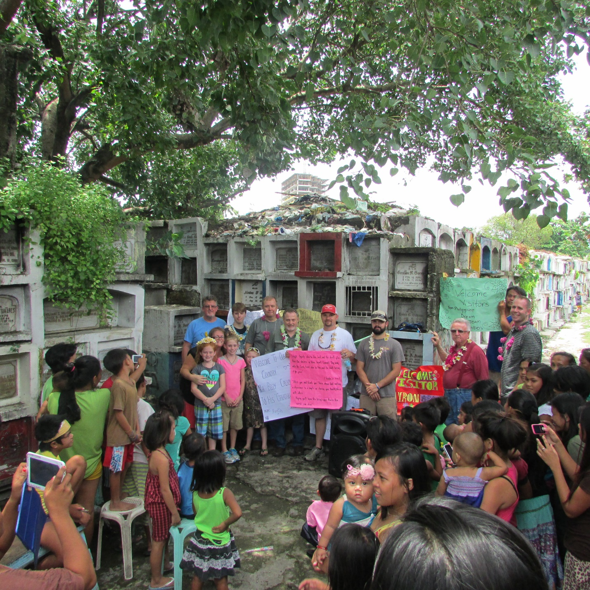

The Gospel was preached and the love of Christ was shown by distributing hundreds of pounds of clothing to a poor, small island’s people.
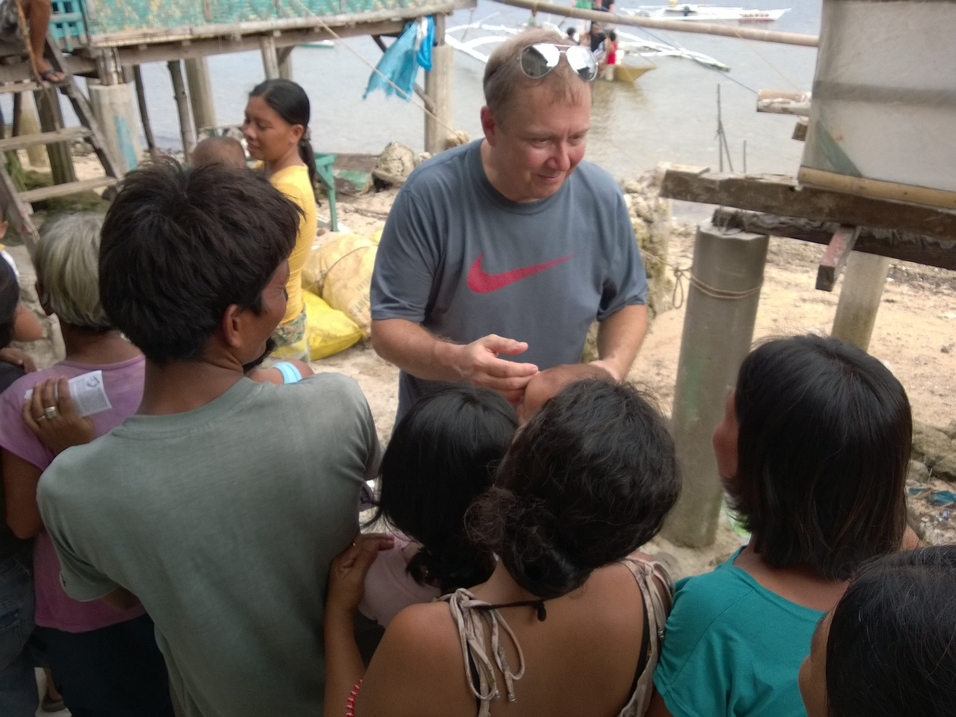

Each box of clothing weighed 90 lbs.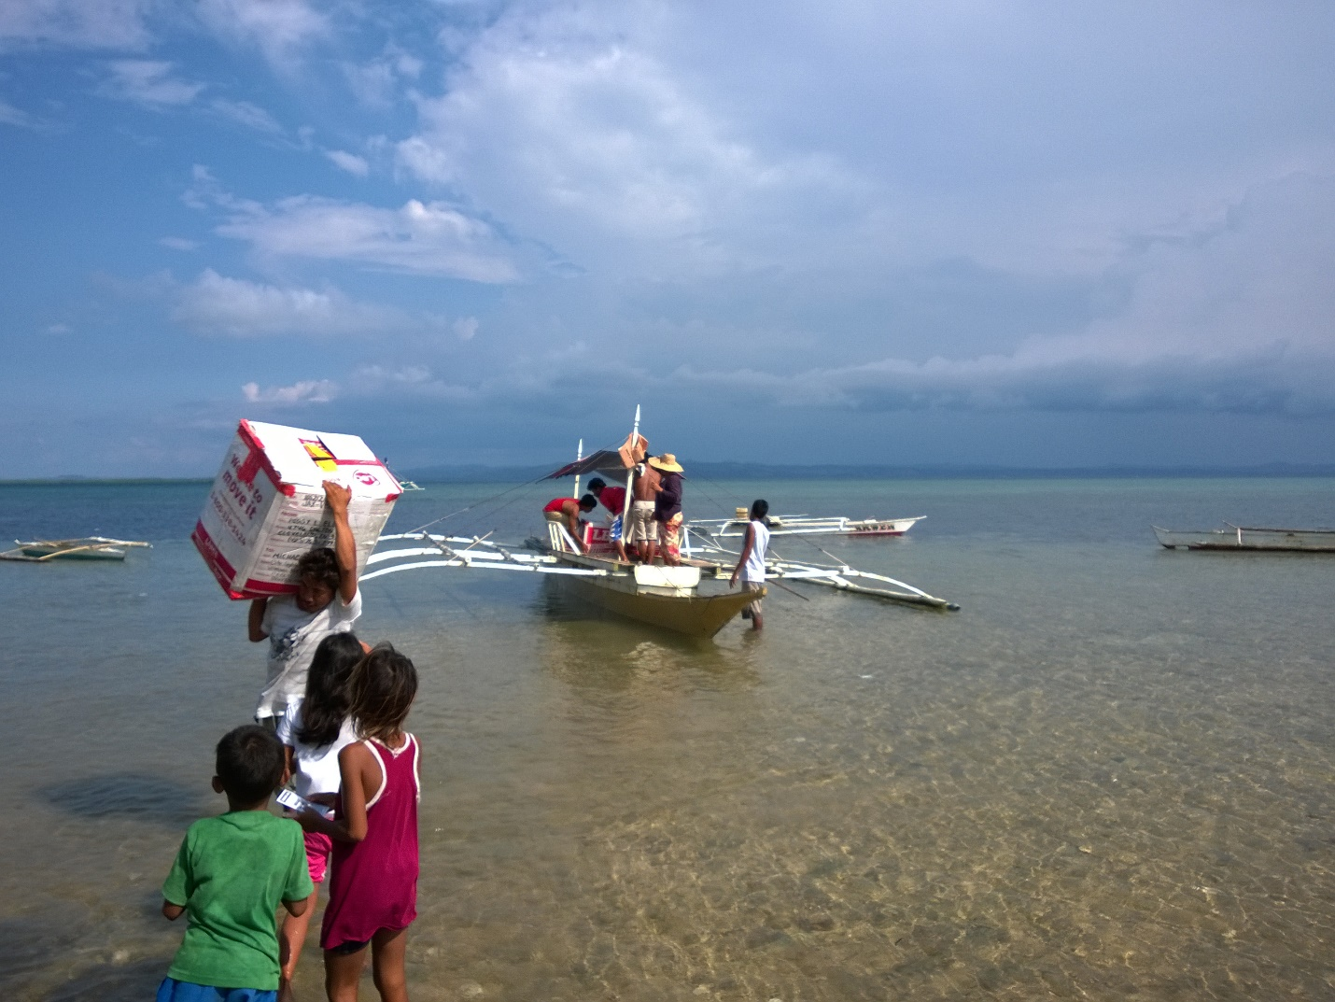

Loving the people
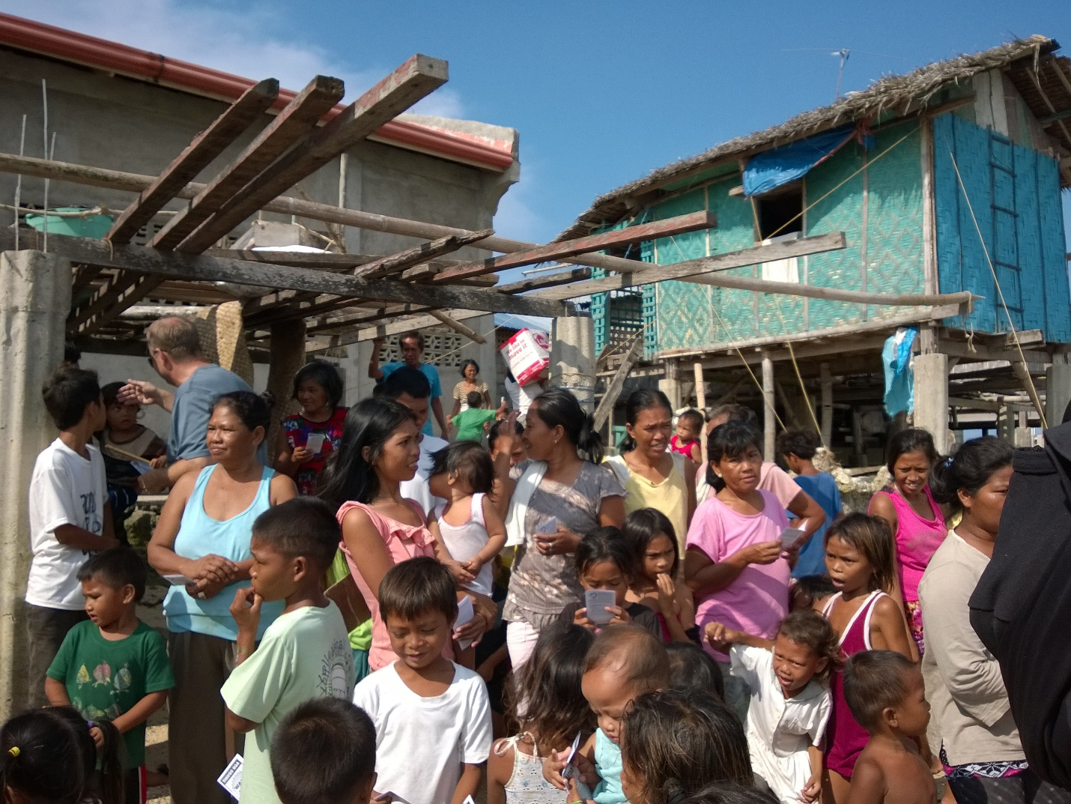
Showing the love of Jesus!