HOW MUCH DO YOU KNOW ABOUT HARRIET TUBMAN?

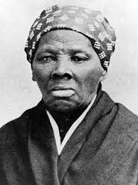
Harriet
Tubman

They Called Her Moses

“There was one of two things I had a right to: liberty or death. If I could not have one, I would take the other, for no man should take me alive. I should
fight for liberty as long as my strength
lasted.”

- What was Harriet Tubman’s given name at birth?
- Explain the problem presented in the state of Maryland, during the time Harriet was born.
- Why was Harriet given the nickname Moses?
- What was another name/title given to Harriet Tubman?
- What was the Fugitive Slave Act of 1850?
- Name at least three jobs/role Harriet had.
- How many children did Harriet have?
- Ms. Tubman had vivid dreams that she felt guided her. What did she attribute these dreams to?
- In 2016 Jack Lew, the Treasury Secretary under the Obama administration acknowledged Tubman as “a role model for leadership and participation in our democracy.” What announcement did he make at that time?
- Why was Harriet Tubman’s Home for the Aged established and where is it located?

“Lord, I’m going to hold steady on to You and You’ve got to see me through.”
Harriet Tubman

HOLLIS AVENUE CONGREGATIONAL CHURCH
Rev. Jerry Greene, Senior Pastor
Rev. Marian Buckman, Associate Pastor

Continuing the Celebration - Honoring African Americans
November 2019

THEME: THE SPIRIT OF THE WOMAN – HARRIET TUBMAN
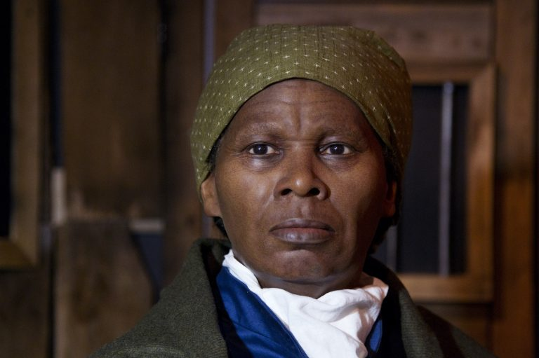

A picture of the wax likeness of Harriet Tubman unveiled at the President’s Gallery in Washington, DC (February 7, 2012)

The recent release of the movie Harriet in theaters across the country has evoked discussion and controversy. Aside from the exchange of dialogue one might expect about the story of a Black historical figure in American history, there has been talk in the Black community to boycott this film. African Americans have different reasons for not spending their dollars on this movie. Some of the concerns expressed have been, the actress (Cynthia Erivo) selected to portray the role of the lead character should have been an African American and not a British of Nigerian descent. Up for discussion is also what has been said about Ms. Erivo’s alleged view of African Americans as “ghetto” or “angry” people. Maybe it is because Comcast (owned by Universal – the studio that filmed the movie) has been accused of racism. Whatever the reason some Blacks will decide not to see the movie. The focus on the person playing the character instead of the “real” Harriet Tubman has shifted.
The discussions will continue (as they should), but the accomplishments of the movie Harriet and the Black slave Harriet should be uplifted. There will always be “forces” that distract us from celebrating our achievements. For example, in an industry where a film about an African American who contributed to the history of this country is seldom told and the director and writer of this movie are Black, are rare in Hollywood and these successes should not be overlooked. Also, what one woman born into slavery was able to accomplish must be remembered and celebrated. Hopefully in the Black community when we discuss the movie Harriet, we will remain focused on the spirit of the woman. The woman who worked for the freedom of so many enslaved people. The accomplishments of Harriet Tubman tell us about the SPIRIT of the Woman and that should be included in our conversations.
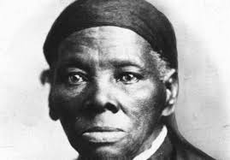

Use a word or words from the list below to describe an action/accomplishment by Harriett Tubman.

Fearless Determined Brave Activist Leader
Courageous Resilient Supportive Encouraging
Abolitionist Tenacious

- Served in the Union Army as a cook, nurse and a spy.
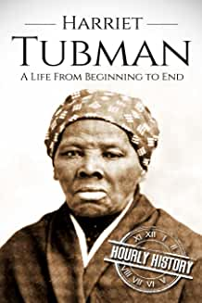
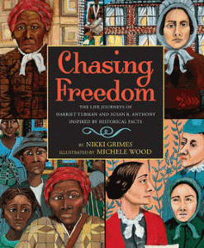
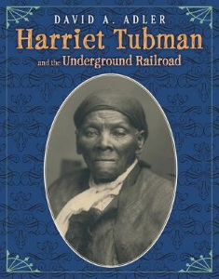
- Led hundreds of slaves to freedom (there is no record of an exact number of slaves rescued).
- Ushered slaves through the underground railroad when there was a reward posted for her.
- Was active in the women's suffrage movement.
- Plowed the fields, did forest work, drove oxen, and hauled logs.
- Continued to help slaves escape after the U.S. Congress passed the Fugitive Slave Law of 1850.
- “If you hear the dogs, keep going. If you see the torches in the woods, keep going. If there’s shouting after you, keep going. Don’t ever stop. Keep going. If you want a taste of freedom, keep going.”
Harriet Tubman

BOOKS ABOUT HARRIET TUBMAN
TITLE | AUTHOR
YOUNG ADULT/ADULT
- Harriet Tubman: The Road to Freedom | Catherine Clinton
- Harriet Tubman: The Moses of Her People | Sarah Bradford
- Bound for the Promised Land: Harriet Tubman, Portrait of an American Hero | Kate Clifford Larson
- Harriet Tubman: The Life and The Stories | Jean Humez
- Harriet Tubman: Negro Soldier and Abolitionist | Earl Conrad
- Harriet Tubman: Myth, Memory and History | Milton C. Sernett
CHILDREN
- A Picture Book of Harriet Tubman | David A. Adler
- Before She Was Harriet | Lesa Cline-Ransome
- I Am Harriet Tubman (Ordinary People Change the World) | Brad Meltzer
- Which Way to Freedom and Other Questions About the Underground Railroad | Mary Kay Carson
- Chasing Freedom: The Life Journeys of Harriet Tubman and Susan B. Anthony | Nikki Grimes
- Harriet and the Promise Land | Picture Book-Artist Jacob Lawrence
- Minty: A Story of Young Harriet Tubman | Alan Schroeder
- Aunt Harriet’s Underground Railroad in the Sky | Faith Ringgold

