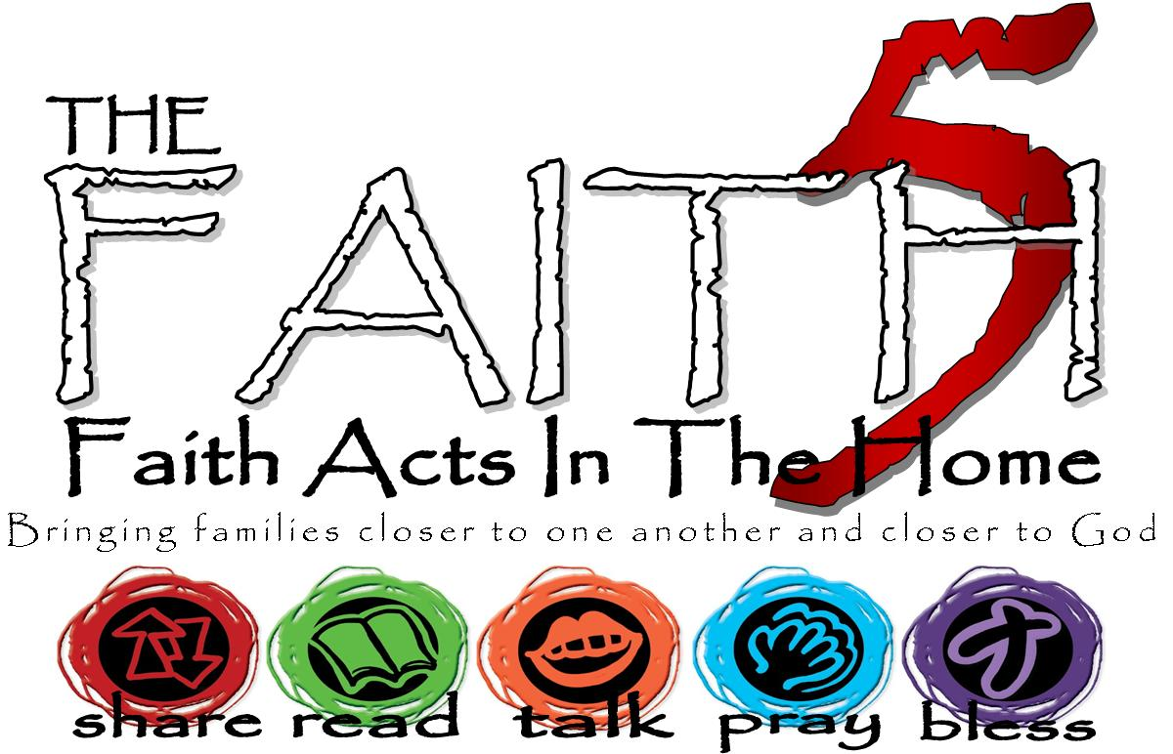
St. Daniel’s Lutheran
Fall 2017
Grow In Faith Together
GIFT
Week #2
Sunday | 24-Sep | Week 2 Word Alone. The bible is a gift from God and is the sole source of our faith and practice.
Monday | 25-Sep |  | 2 Timothy 3:16
Tuesday | 26-Sep |  | Genesis 22
Wednesday | 27-Sep
Thursday | 28-Sep |  | Psalm 46
Friday | 29-Sep |  | Chopstick Race MTWI | Cereal in one central large bowl. Each player using only chopsticks (or 2 pencils) pick cereal piece one at a time and put into smaller bowl in front of each player. Most in bowl wins.
Saturday | 30-Sep |  | 2 Timothy 3:10-17
MTWI – Minute-To-Win-It… a silly game, meant to be played for 1 minute. Have a great time! Play more than once.

A reading that I/we connected with was… because…

