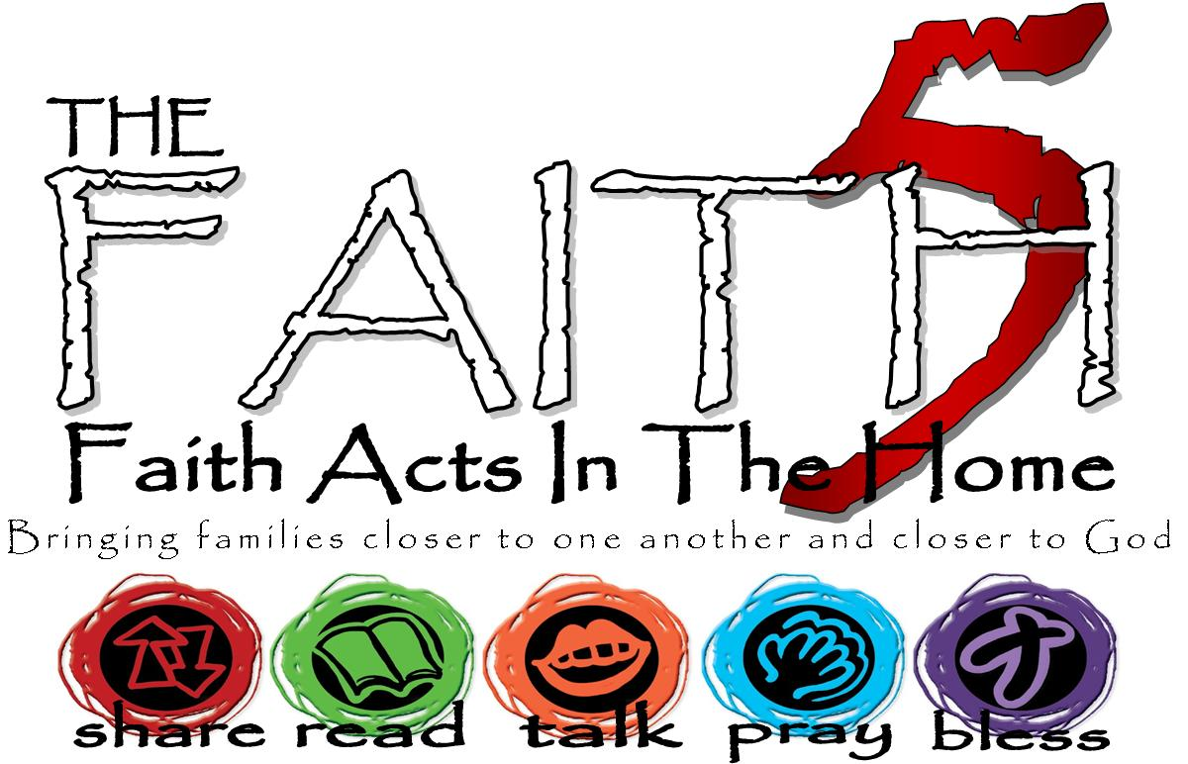
St. Daniel’s Lutheran
Fall 2017
Grow In Faith Together
GIFT
Week #5
Sunday | 15-Oct | Week 5: Priesthood of All Believers. All are called by God to serve God & neighbor.
Monday | 16-Oct |  | 1 Peter 2:9
Tuesday | 17-Oct |  | John 13:31-35
Wednesday | 18-Oct
Thursday | 19-Oct |  | Exodus 40:12-16
Friday | 20-Oct |  | Shoe Fly Shoe MTWI | Start Pile of shoes on floor next to table. Sling the shoe onto the table using only your foot. Challenge: go for quantity!
Saturday | 21-Oct |  | 1 Peter 2:1-11
Write some of your highs and lows from the week here…

