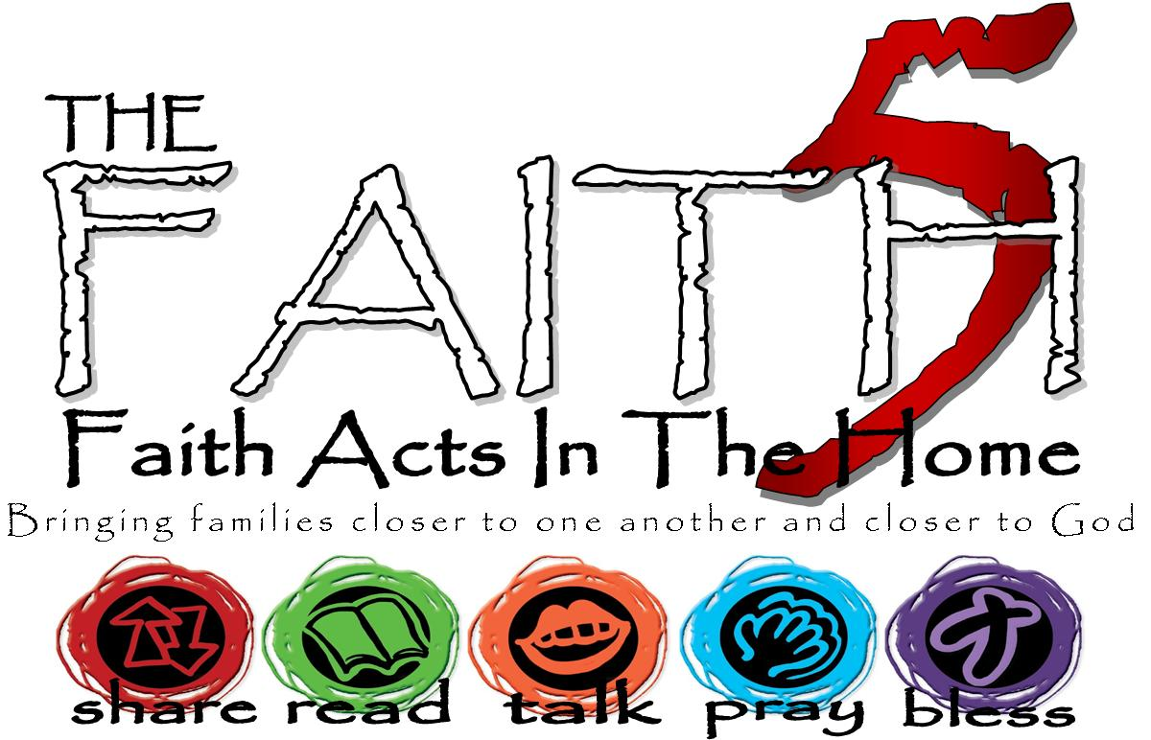
St. Daniel’s Lutheran
Fall 2017
Grow In Faith Together
GIFT
Week #3
Sunday | 1-Oct | Week 3: Faith Alone. Following God brings joy to our hearts, because God’s yoke is easy and the burden light.
Monday | 2-Oct |  | Matthew 11:29-30
Tuesday | 3-Oct |  | Romans 3:21-30
Wednesday | 4-Oct
Thursday | 5-Oct |  | Psalm 118
Friday | 6-Oct |  | Scoop MTWI | In 60 sec., transfer 6 ping-pong balls/cotton balls from one bowl to another by holding the spoon in your mouth.
Saturday | 7-Oct |  | Matthew 11:29-30
MTWI – Minute-To-Win-It… a silly game, meant to be played for 1 minute. Who has won week #1-3?
Write some of your highs and lows from the week here…

