Hopewell Baptist Church
Jerry Heslinga, Guest Pastor
“Reckless Love”
Oct. 21, 2018

Notes:

Our Calendar This Week:
Today: 9:45 a.m. Sunday School 11:00 a.m. Worship . 7:00 p.m. Discipleship Training
Oct. 23 10:15 a.m.-12:30 p.m. Women’s Bible Study
Oct. 24 5:30 p.m. Dinner, Soup
6:30 p.m. Bible Study
7:30 p.m. Choir Practice

Our Calendar Looking Ahead:
Sept. 23, 8 Sundays 5:30-8 p.m. Divorce Recovery Workshop,
Richmond’s First Baptist Church
See flyer on bulletin board
Oct. 27 5 p.m.-8 p.m. Fall Festival
Nov. 4 Pastor Jeremy Smith preaches
Nov. 11 Church Council

Hopewell
Baptist Church
5061 Hopewell Road, New Kent, VA 23124

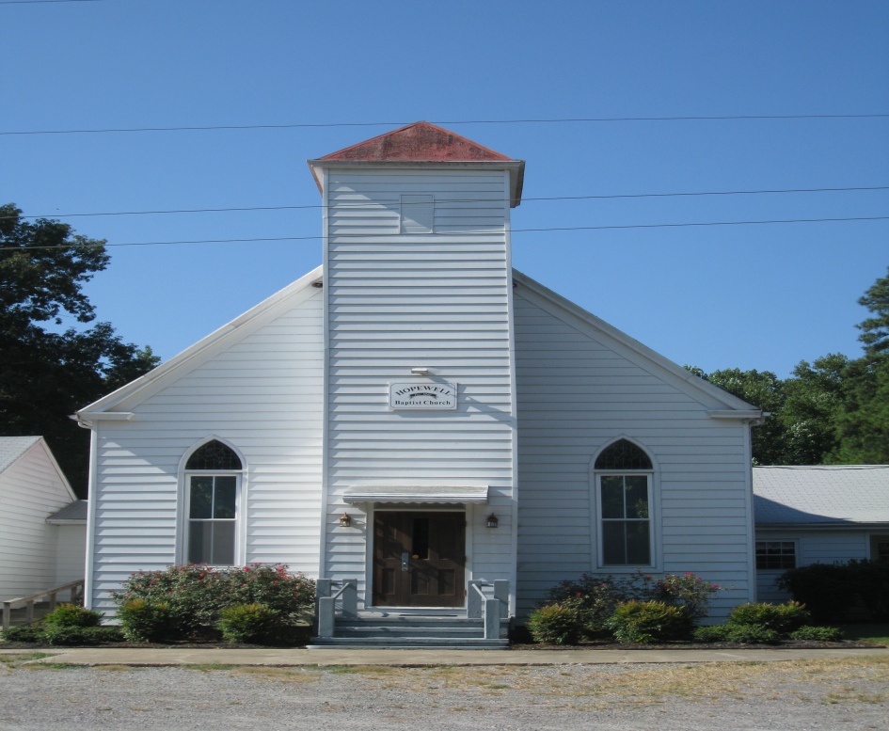
Be Still and Know That I Am God Psalm 46:10
Timmy Douglas Steve Simmons
David Fox * Tim Tuck
Jack Hastings Ben Williams
Dan Horton John Williamson
Taylor Moore Bob Yates
* indicates Deacon of the Month

