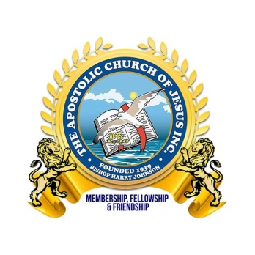The Apostolic Church of Jesus, Incorporated  
____________________General Headquarters/Executive Staff  
**Chief Apostle Jimmy Hicks, Jr., Presiding Bishop  
Apostle Samuel Hunt, Sr., Assistant Presiding Bishop**   
Sunday School Staff:  
*Minister Tiffarney Lee, General Superintendent  
Minister Cynthia Barrett, Assistant General Superintendent  
Elder Deanna Callands, Sunshine Band Supervisor**Sister Janay Johnson, Assistant Sunshine Band Supervisor**Elder Darius Hay, AYPU President  
Sister Kimberly Huggins-Simpson, Assistant AYPU President*

**Honor Roll Recognition**: Due Friday, July 11, 2025  
*Please include a copy of the most current report card showing honor roll status*  
Submit to: [theacojsundayschool@gmail.com](mailto:theacojsundayschool@gmail.com)

|  |  |  |
| --- | --- | --- |
| Names: Last, First | Grade: | Report Card R’cvd |
|  |  |  |
|  |  |  |
|  |  |  |
|  |  |  |
|  |  |  |
|  |  |  |
|  |  |  |
|  |  |  |
|  |  |  |
|  |  |  |
|  |  |  |

The Apostolic Church of Jesus, Incorporated  
___________________General Headquarters/Executive Staff  
**Chief Apostle Jimmy Hicks, Jr., Presiding Bishop  
Apostle Samuel Hunt, Sr., Assistant Presiding Bishop**   
Sunday School Staff:  
*Minister Tiffarney Lee, General Superintendent  
Minister Cynthia Barrett, Assistant General Superintendent  
Elder Deanna Callands, Sunshine Band Supervisor  
Sister Janay Johnson, Assistant Sunshine Band Supervisor**Elder Darius Hay, AYPU President  
Sister Kimberly Huggins-Simpson, Assistant AYPU President*

**Dean List Recognition**: Due Friday, July 11, 2025

*Please include a copy of the most current report card showing Dean status*  
Submit to: [theacojsundayschool@gmail.com](mailto:theacojsundayschool@gmail.com)

|  |  |  |
| --- | --- | --- |
| Names: Last, First | Grade: | Report Card R’cvd |
|  |  |  |
|  |  |  |
|  |  |  |
|  |  |  |
|  |  |  |
|  |  |  |
|  |  |  |
|  |  |  |
|  |  |  |

The Apostolic Church of Jesus, Incorporated  
____________________General Headquarters/Executive Staff **Chief Apostle Jimmy Hicks, Jr., Presiding Bishop  
Apostle Samuel Hunt, Sr., Assistant Presiding Bishop**   
Sunday School Staff:  
*Minister Tiffarney Lee, General Superintendent  
Minister Cynthia Barrett, Assistant General Superintendent  
Elder Deanna Callands, Sunshine Band Supervisor  
Sister Janay Johnson, Assistant Sunshine Band Supervisor**Elder Darius Hay, AYPU President  
Sister Kimberly Huggins-Simpson, Assistant AYPU President*

**2025 Senior High School Graduates**: Due Friday, July 11, 2025  
Submit to: [theacojsundayschool@gmail.com](mailto:theacojsundayschool@gmail.com)

|  |  |
| --- | --- |
| Names: Last, First | Name of School |
|  |  |
|  |  |
|  |  |
|  |  |
|  |  |
| **2025 College Graduates**: | |
|  |  |
|  |  |
|  |  |
| General Education Development Honorees | |
|  |  |
|  |  |