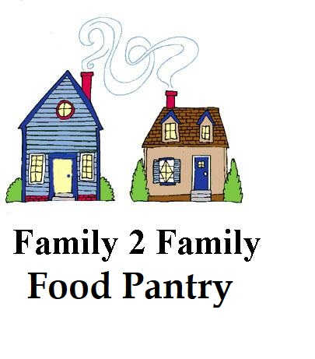
School Supplies Needed for
Bell Elementary Students

Feel free to choose certain items or gather a quantity of each. Bring to the church and place in collection boxes in the sanctuary foyer
by August 21st.

Boxes of 24-count Crayola crayons
Boxes of 10-count Crayola markers
Boxes of colored pencils
Boxes of quart-sized Ziploc-type baggies
Boxes of gallon-sized Ziploc-type baggies
Pencils (yellow #2) Dixon Ticonderoga preferred
Wide-ruled, one-subject spiral notebooks
Clorox wipes
Hand sanitizer
Kleenex
Total of 20 backpacks

