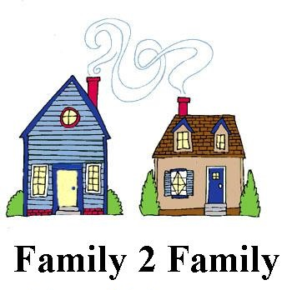

July 2022 Update
Over the last 2½ years, the following ministries have been provided through the Family2Family Ministry:

- Christmas gifts for Bell Elementary students
- Poundings for Bell Elementary staff (supplies)
- Clothing & shoes for Bell students
- School supplies for Bell students
- Food Pantry for East Asheville families
- B.E.A.R. Closet (baby equipment & resources) available via phone requests
- Welcome Table free meals for homeless
- Reading Buddies program for Bell students
- Outreach to middle and high school students
- MANNA backpack deliveries to the schools

School Support – Current Opportunities
- Collecting supplies for the students; delivery requested to schools by Aug. 22.
  - See List of School Supplies
- Ingles gift cards – churches providing funds for $25 gift cards for Bell staff to have on hand for student families needing food or gas.
- Superintendent Tony Baldwin retired in June; please pray the new superintendent will be receptive to continuing the F2F ministry relationship with Bell Elementary.

Food Pantry Update – June 2022
- 73 families served/139 individuals (10 were children)
- Asheville Terrace Apts makes 2 trips for residents; they are very appreciative
- MANNA has difficulty getting some food; Pantry purchased meat in May and June.
- With lack of food sources and volunteers, some area pantries may be forced to close. BHBC food pantry shared some unused emergency food boxes with “the Place” at a church in Fairview, and welcomed their clients to our pantry if needed.

Welcome Table Update
During the pandemic, they were able to take meals to the homeless, but have now reopened for a free meal on Thursdays for anyone. Located at Groce UMC, 5:00-6:30 pm. Meals are free; donations accepted.

Reading Buddies Program
To learn more about this opportunity or get involved, contact Rev. Gerald Davis at Groce UMC, 298-7647.

