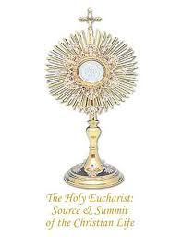
You are Invited to
JOIN US FOR A HOLY HOUR
And spend time with the Lord

Mondays from 6:30-7:30 p.m.
Holy Eucharist Church

Miraculous Medal Novena
The Rosary
Benediction of the Blessed Sacrament

Bring your family and friends
Whatever amount of time you can spend with us is welcome

