CERTIFICATION EMPHASIZES PROFESSIONALISM, EXPERTISE, AND VALUE.
Achieving a certification verifies a service provider has met specific requirements to showcase the credential.
Dr. Tré Sina E. Steger-Smith
Owner / Founder / Consultant of TE Enterprises Consulting, LLC.,
is congratulated and acknowledged as a ProfilingPro Associate who has added the Certified DISCstyles™ Communication Consultant (CDCC) credential to her impressive list of professional accomplishments.
The Certified DISCstyles Communication Consultant designation distinguishes Tré Sina as an Authorized DISC Administrator and Behavioral Consultant who received the specific CDCC education, met specific requirements, and passed the certification exam.
Tré Sina has demonstrated her knowledge in the powerful DISCstyle concept and language. She has proven her ability to provide valuable insight in understanding communication preferences and expertise in enhancing interactions and communication.
We recognize and support the fact that strengthening one’s credibility is a benefit for those having the desire to add a new dimension to their business and to the success of their clients.
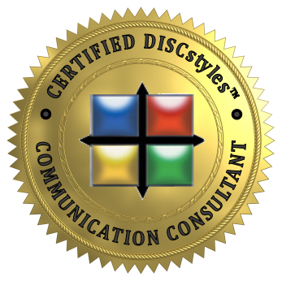
Tré Sina’s CDCC designation reinforces that her professional services in using the DISCstyles assessments will meet and exceed her clients’ expectations.
Certified individuals, in good standing, with ProfilingPro use the official CDCC logo as an identifier of their accomplishment and demonstration of their achievement.
Tre` retired from the Department of Navy in 2014 and is proud to have a combined total 20 years of experience in both federal and private industry human resources and financial management. She also holds a Certificate in Strategic Workforce Planning (SWP) from the Human Capital Institute; a Certificate in Human Resources Management from Columbia Southern University; a Presentation Certificate from The University of New Mexico, and a Certificate in Financial Management from the Graduate School USDA. She has a Level I certificate from the Graduate School USA in Human Resources. She is a Certified Federal Job Search Trainer (CFJST) and Certified Federal Career Counselor (CFCC) through the Federal Career Training Institute located in Baltimore, MD.
Congratulations, Dr. Tré!
We are proud of your success.
Jane, the ProfilingPro staff and Dr. Tony

