The Healing Place Presents …
A Pilgrimage to the Land Where It All Began
Egypt, Jordon and Israel
March 7 – 21, 2021

15 days and 12 nights

Cost $4,835.00
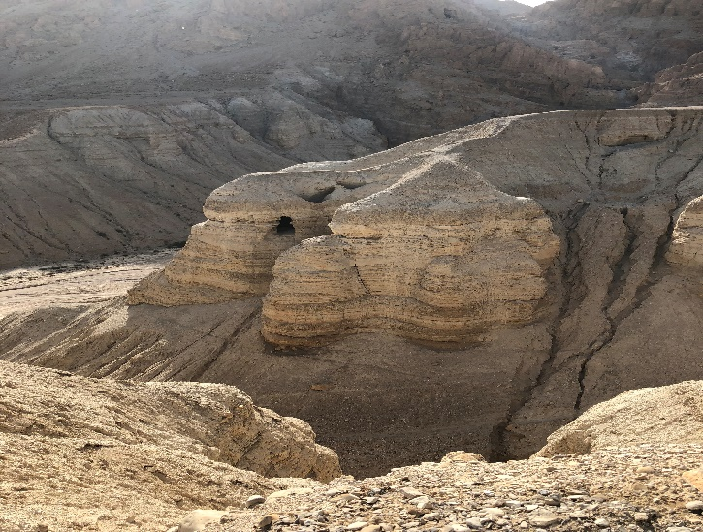
- Roundtrip airfare from Washington, DC or Detroit, MI
- 4-star hotel accommodations (double room occupancy)
- Transfers from airports to hotels
- Buffet breakfast and dinner daily
- Deluxe air-conditioned transportation
- Tours of Pyramids, Mt. Sinai, Land of Goshen, Red Sea
- Time to reflect as we visit sites in the life of Jesus and ministry of the Apostles including
  - Bethlehem
  - Nazareth
  - Galilee
  - Capernaum
  - Magdala
  - Garden of Gethsemane
  - Upper Room
  - Jerusalem
DEPOSIT OF $350.00 DUE NOVEMBER 30, 2019 (non-refundable after Dec. 15, 2019)
Payments may be made by check/credit card to:
The Healing Place 8150 Walnut Grove Rd. Mechanicsville, VA 23111
For More Information Contact: Dr. Emily A. Pardue revladyem@yahoo.com or (313) 378-1084

