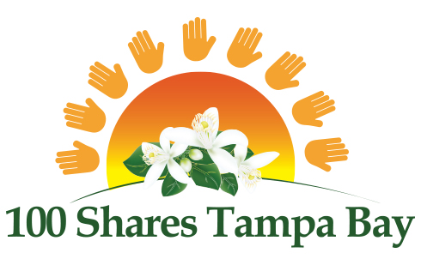

2021 GRANT APPLICATION

Grant applications may be submitted for any amount between $25,000 and $100,000.

Name of organization:
Street Address (no P.O. Box):
City, State, Zip:
Contact Name, Title:
Contact Email: Contact Phone:
Executive Director (if different from above):
E.D. Email: E.D. Phone:
Website:
Effective Date of 501(c)3: Tax ID:

Grant Amount Requested: $ Total Project Cost: $
Total Current Operating Budget: $

Purpose of Grant (75 words or less):
Ministry Mission Statement (75 words or less):

ORGANIZATION INFORMATION

- Brief summary of organization’s history (200 words or less):
- Description of ministry’s current programs and accomplishments (200 words or less):
- Statement of ministry’s vision (200 words or less):
- Describe how the ministry is actively engaged in evangelism and discipleship (200 words or less):
- Statement of Faith (may be attached separately):
- Number of people served annually:
- Description of the population you serve:
- Describe your collaboration with other ministries/organizations in the community:
- How did you find out about 100 Shares Tampa Bay?

PURPOSE OF GRANT AND DESCRIPTION OF YOUR SPECIFIC PROJECT

Our heart is to significantly propel a ministry forward, help a ministry expand, or fund a project with this grant. That is part of the benefit and goal of collective giving vs. individual gifts of potentially smaller size. Please keep the mission of 100 Shares Tampa Bay in mind when answering the following questions.

- Explain the specific project for this grant, description of target population, and benefits the project will render (200 words or less):

- Explain the specific ways that this grant will help you to expand significantly or propel your ministry forward (200 words or less):

- Provide measurable project goals and methods of evaluation - how will this project measurably expand an existing initiative or establish a new initiative?

- How will key staff and/or volunteers engage in this project?

- Timetable for implementation of the project:

- What is the long-term strategy for funding the project?

By signing below, I acknowledge that I have read the 100 Shares Grant Application requirements in their entirety and attest to the truthfulness and accuracy of this application and supporting documentation.

____________________________________ ______________
Signature of Executive Director Date Signed

____________________________________ ______________
Signature of Board Chair Date Signed

ADDITIONAL GRANT REQUIREMENTS

The following items are required and must be submitted along with the completed grant application (both in hard copy and electronically).

- Detailed Grant Budget (Must download and use Excel spreadsheet on the GRANTS web page)
- Provide an itemized Grant Budget clearly stating how the grant monies will be used, giving actual costs where available and detailing items and services to be purchased.
- Grant budget request amount must not exceed half of the applicant’s current operating budget.
- Grant budget request for advertising, marketing, consultant fees, and salaries in total must not exceed 20% of the grant amount.
- Grant budget request must not include ongoing operating expenses, rent, or endowments, nor be used for fundraising or new construction.

- Detailed organization budget for the current year (include all sources of funding) along with year to date spending.

- Comparative financial statements (audited is preferred, if available) for the most recent two-year period. For example, if you are applying for a grant in 2020, we require comparative financial statements for the years 2018 and 2019. These statements should include a Balance Sheet (a statement of Assets and Liabilities) and Profit and Loss Statement.

- Ministry’s current 990 tax return.

- Provide a list of your other grant funding sources.

- Copy of 501(c)3 IRS letter approving your tax-exempt status.

- Current list of Board of Directors, their professions, and whether they support the ministry financially.

- Current list of staff and their positions.

- An electronic (jpg.) version of your organization’s logo (on flash drive only).

- 6 high resolution photos of your ministry “in action” (on flash drive only).

GRANT SUBMISSION INFORMATION

The deadline to apply for the 2021 Grant is August 28, 2020. Submission requirements must be followed exactly. Incomplete or late applications will not be considered. Remember to start well before the grant deadline date to prepare your grant application and gather all required documentation to submit on or before the grant application deadline.

Once a grant application has been submitted, the applicant is not allowed to make revisions of any kind.

If your ministry has NOT received a grant from 100 Shares Tampa Bay, you will be able to apply again every year.
If your non-profit DID receive a grant, you can re-apply for another grant after waiting two years. For example, if your ministry was awarded a grant in 2019, you can re-apply to receive another grant in 2022.

SUBMISSION REQUIREMENTS:
- 1 hard copy of grant application and all supporting documentation, except for the logo and photos. (Please see ADDITIONAL GRANT REQUIREMENTS above);
- A USB flash drive with all required documents and items loaded onto it;
- Package MUST be postmarked by FRIDAY AUGUST 28, 2020;
- Package should be mailed to:
TRICIA COLLINS, 100 SHARES TAMPA BAY GRANTS CHAIR
C/O NATIONAL CHRISTIAN FOUNDATION TAMPA BAY
1901 ULMERTON ROAD, SUITE 400
CLEARWATER, FL 33762

All questions should be submitted in advance of the deadline to Tricia Collins at: Grants100STB@gmail.com.

