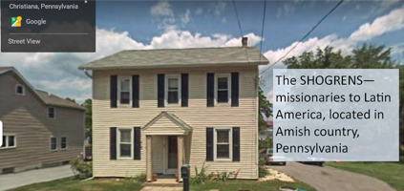

Karen: "I will never look at kazoos the same way again!"
Perhaps a bit of background on that one!
March and April were extremely busy for my ministry. One conferences after another, presenting material on all sorts of subjects and age level. .
When that combined with the involved spiritual warfare, travel, lack of time to regroup between events - and most of our belongings still in boxes - it was an extraordinarily stressful time that left me feeling isolated, exhausted and disoriented.
Then came my last event, the spring women’s retreat of Woodlyn Baptist Church at Camp Sankanak. I didn’t have much to do except to give a very short ministry update and to be a small group leader. The 4 of us in our group enjoyed lively discussions comparing Bible passages in various translations and applying them to our lives. Soon we all felt so comfortable together that one woman shared some personal concerns. The rest of us rallied around her with prayers and offers of help and it was a special time of ministry. It wasn’t until later that it dawned on each of us how perfectly suited that particular group of women had been to help our sister. It was a group so perfectly put together that only God could have done it. And that got us thinking.
Usually small groups are pre-organized. But this time it had been different: each small group leader was given a differently colored kazoo ahead of time (my kazoo was red).

During our first large group meeting everybody else picked a kazoo from a large bag without looking or understanding the significance of the different colors. The colored kazoos assigned us to groups. But obviously, it was God who grouped us together. So God used a bag full of kazoos to make sure we were all in the right place at the right time to be his voice and arms so he could love and help one of his precious daughters.
We will never look at kazoos the same way again. We will never look at God the same way again. Praise him!
Welcome to new newsletter friends from: Faith BFC Harleysville women’s retreat
Woodlyn Baptist Church women’s retreat
North Chester Baptist Church
Upcoming Presentation:
June 12—Tasker Street Missionary Baptist Church morning service, 9am at 2010 Tasker Street, Philadelphia, PA, or online https://www.facebook.com /TSMBC2
Prayer Requests
- "Household focus: Finish and move into Karen’s home office, finish unpacking and organizing
- "Karen’s ministry focus: website and social media presence for recruiting new students
- "Gary’s ministry focus: doing the final edit of the SUN Old Testament for the deaf non-reader; giving ESEPA courses.
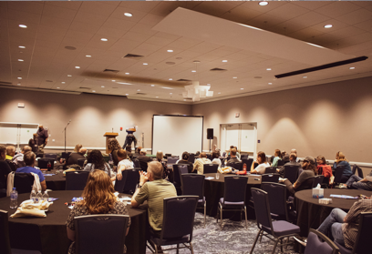
In April, all of the WorldVenture missionaries from the Americas got together in Orlando. A milestone, after years of COVID!

Blessings,

