STATE OF MARYLAND
Department of Assessments and Taxation

I, HEIDI DUDDERAR OF THE STATE DEPARTMENT OF ASSESSMENTS AND TAXATION OF THE STATE OF MARYLAND, DO HEREBY CERTIFY THAT THE DEPARTMENT, BY LAWS OF THE STATE, IS THE CUSTODIAN OF THE RECORDS OF THIS STATE RELATING TO LIMITED LIABILITY COMPANIES , OR THE RIGHTS OF LIMITED LIABILITY COMPANIES TO
TRANSACT BUSINESS IN THIS STATE, AND THAT I AM THE PROPER OFFICER TO EXECUTE THIS CERTIFICATE.

I FURTHER CERTIFY THAT TRINITY INTERNATIONAL THEOLOGICAL SEMINARY, LLC , REGISTERED AUGUST 28, 2015, IS A LIMITED LIABILITY COMPANY EXISTING UNDER AND BY VIRTUE OF THE LAWS OF THE STATE OF MARYLAND, AND THAT THE LIMITED LIABILITY COMPANY IS AT THE TIME OF THIS CERTIFICATE IN GOOD STANDING TO TRANSACT BUSINESS.

IN WITNESS WHEREOF, I HAVE HEREUNTO SUBSCRIBED MY SIGNATURE AND AFFIXED THE SEAL OF THE STATE DEPARTMENT OF ASSESSMENTS AND TAXATION OF MARYLAND AT BALTIMORE ON THIS OCTOBER 30, 2015.

Heidi Dudderar Associate Director

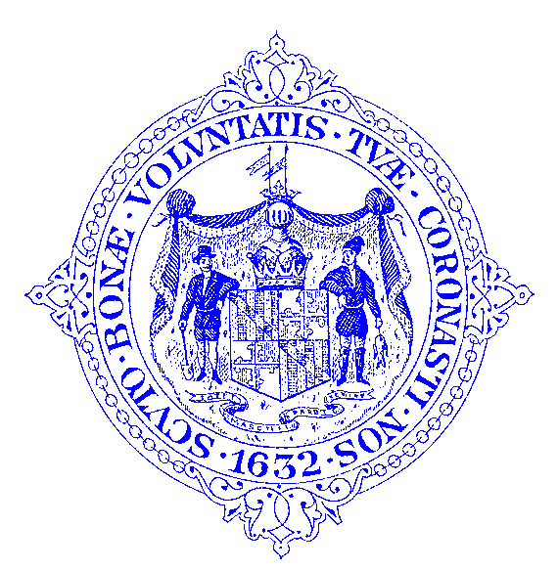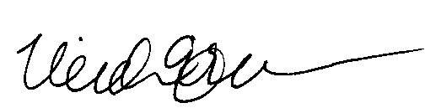

crblnk
301 West Preston Street, Baltimore, Maryland 21201
Telephone Balto. Metro (410) 767-1340 / Outside Balto. Metro (888) 246-5941 MRS (Maryland Relay Service) (800) 735-2258 TT/Voice
Fax (410) 333-7097

R0009879840

