TRINITY INTERNATIONAL THEOLOGICAL SEMINARY
P.O. Box 1591, Owings Mills, Maryland, 21117, USA
Phone: 443-854 9832
E-mail: info@titseminary.org
Website: www.titseminary.org

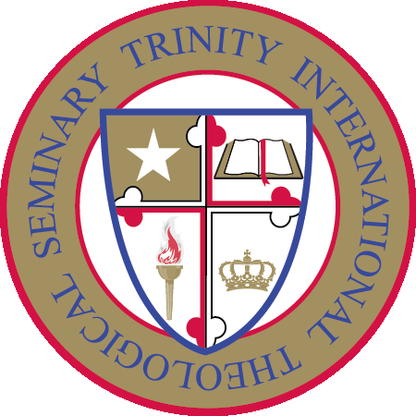

Online Diploma in Leadership Program

BROCHURE

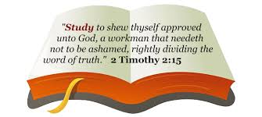

THE DIPLOMA IN LEADERSHIP (ONLINE)
Don’t take the leadership journey alone. Making a decision to enroll is this program could be one of the best decision you will make as a leader. You will receive valuable resources that will help you rise to new levels of leadership and increase your capacity to make greater impact in your sphere of influence.
The Diploma in Leadership Program
*Is self-paced
*Not structured in semesters, quarters or terms;
*Can be completed 100% online;
*Uses email and easy file transfers to send coursework;
*Is designed to allow the student to begin at any time of the year.
PROGRAM ENTRANCE REQUIREMENTS
The applicant must meet the following minimum requirements.
Be not less than 18 years of age.
Have earned a High School Diploma or equivalent qualification, or the Seminary’s Certificate in Church Leadership or any other equivalent qualification from an acceptable institution.

Diploma in Leadership - Curriculum

LEAD 101 - The Leader's Guide to Organizational Transformation
Book: Change Your Culture Change Everything

LEAD 102 - Shaping Today's Ministry for Tomorrow's Opportunities
Book: Future Faith

LEAD 103 - Making Decisions In Times of Transition
Book: Your Next Bold Move

LEAD 104 - Selecting, Developing, and Inspiring Your Team
Book: Ladder Holders

LEAD 105 - 7 Steps and 8 Challenges Every Leader Faces
Book: Journey to Destiny

LEAD 106 - Leading While You'd Rather Be Leaving
Book: Growing Pains

LEAD 107 - Leadership Succession That Works
Book: Exit Right

LEAD 108 - Tackling 15 Hazards in Organizational Growth
Book: Leader Slips

LEAD 109 - Setting and Maintaining Organizational Direction
Book: First Focus

LEAD 110 - Creating Systems and Structures To Turn Vision Into Reality
Book: Built To Grow

LEAD 111 - Dealing with What Keeps Leaders up At Night
Book: Stress in Success

LEAD 112 - Indispensable Tools for Effective Influence
Book: Leadership Essentials

Completion of a course will lead to a Certificate of Achievement. Upon successful Completion of the 12 courses, you will be awarded a Diploma in Leadership.

REGISTRATION PROCESS – ONLINE DIPLOMA IN LEADERSHIP PROGRAM
Simply print and fill the Registration Form, to begin your journey into the Diploma in Leadership program.
Registration Procedures: There are only 5 steps for you to take to enroll in our courses.
5-Step process
Print and fill-out the Registration Form. Enclose your $20 one-time registration fee and $30 per course fee by check, money order or bank draft drawn on a U. S. bank, payable to Trinity International Theological Seminary. Mail to Trinity International Theological Seminary, P. O. Box 1591, Owings Mills, Maryland 21117, USA. You may also email your Form to: info@titseminary.org, and payments can be made by credit or debit card or PayPal on our website. We will accept a discounted fee of $300 if you are paying for the entire 12 courses in the program instead of $360.
Receive Course Material and Assignment by email.
Start reviewing your Course Material and complete the assignments.
Email or mail your completed assignment to the Seminary.
Completion of a course will earn you a Certificate of Achievement.
Upon successful completion of all academic and financial requirements, you will receive your Diploma in Leadership (within four weeks).
TUITION FEE
One time Registration fee: $20
$30 per course
$360 for the full Diploma program tuition fee. We will accept a discounted tuition fee of $300 if you pay for the entire 12 courses at the time of registration Text book in pdf format will be provided. No other text book is required.
There is a $35 fee per check which is returned unpaid.
Please send your fees to: Trinity International Theological Seminary, P.O. 1591, Owings Mills, Maryland 21117, U.S.A. All checks and money order must be made payable to "Trinity International Theological Seminary" in U.S. funds. Registration form will not be processed without the required fees.
Payments can also be made on our website by credit or debit card. Click on the "BUY NOW" button to make payments by credit or debit card. Select either "Pay with my PayPal account" or Don't have a PayPal account? – Pay with a debit or credit card." Complete the card information and indicate the purpose of your payment.

