TRINITY INTERNATIONAL THEOLOGICAL SEMINARY
P.O. Box 1591, Owings Mills, Maryland, 21117, USA
Phone: 443-854 9832
E-mail: info@titseminary.org
Website: www.titseminary.org

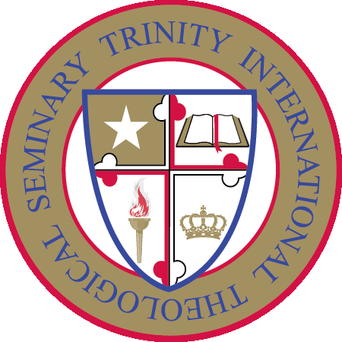

Online Certificate in Church Leadership Program

BROCHURE

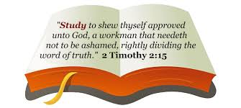

Certificate in Church Leadership Program
For those who are interested in gaining knowledge as a Christian leader, the Certificate Program in Church Leadership is designed to move students from their entry point of study into a progression of in-depth studies.
This leadership program is designed to help identify some of the most basic principles of church leadership. These characteristics should be found in all churches, but unfortunately, many of our church leaders lack true leadership skills. The lack of true leadership prevents the church from moving forward.

Most of our churches are not moving forward at all. They seem to be more self-centered and are totally ineffective in reaching others for Christ. They may have a great pastor, one who has the skill, charisma, and the drive to preach the gospel but lack the support or leadership needed from others to accomplish any vision or outreach in their community.

It is lazy and egotistical for any believer to think that the success or failure of any church should rest solely upon the shoulders of their pastor. The true measure of success or failure is in the hands of its leadership. What type of leaders does the church have? Do they have a vision? Does that vision match up to the one that the pastor has? Are the leaders willing to learn or are they bound by fears of inadequacy? We truly believe that everyone can learn a few basic skills that can make them more effective leaders.

So, what makes a good leader? This program tries to answer that question by examining some of the characteristics, qualities, and examples of what makes a good leader. Leaders provide direction. But unfortunately, too many of our churches have become poor examples of what Christianity is all about. Every church should have quality people: those who lead, encourage, and direct others to become even greater and more effective Christians.

People in every community are looking for something real and genuine. They want a real church with real people who really care! This leadership program is designed to help your church leaders to understand the importance of true leadership and discover ways to make your church even more effective. We pray that this program will help you and your church to move forward in becoming a true and viable force in your community.

Program Outline
Introduction
Leadership – Moving Forward

Part 1
Definition of Leadership

Part 2

A Leader Must Lead

Part 3

A Leader Must Lead By Example

Part 4

A Leader Has a Positive Attitude

Part 5

A Christian Leader Must Have Discernment

Part 6
A Leader Must Educate and Encourage Others

Part 7
A True Leader Seeks Righteousness

Part 8
A True Leader has a Heart of Servant-hood

Part 9
It’s All About His Will / Not Our Will

Part 10
A True Leader Has Integrity

Part 11
A True Leader Will Persevere

Summary
Teamwork and Unity

General Information
The Certificate in Church Leadership Program is presented by Seminary faculty with earned doctorates in theology and related disciplines.

The online program includes a Test when you have completed the course manual. The tests are "open book" format. This means you are allowed to read the manual as often as necessary to arrive at your answers for the questions. You will be provided with a course manual, no other text book is required. The Bible will be used for information.
Trinity International Theological Seminary will evaluate your Test. This qualifies you to receive the Certificate in Church Leadership. Graduates of this program are eligible to apply for the Ministerial License of the Trinity Ministerial Fellowship.

A WORD ABOUT THE IMPORTANCE OF EARNING A CERTIFICATE - Certificate programs are the latest trend in adult higher education. To meet the rising demand, U.S. institutions of higher learning are expected to greatly increase the number of certificate programs currently offered. Not surprisingly, the value and prestige of earning a certificate is beginning to rival that of the associate degree, and in some cases even the baccalaureate degree. Certificates are an ideal way to gain competency quickly and less expensively. They are also considered a more reasonable stepping stone toward earning a degree if that is the ultimate goal.

REGISTRATION PROCESS - ONLINE CERTIFICATE IN CHURCH LEADERSHIP
Simply print and fill the Registration Form, to begin your journey into Church Leadership.
Registration Procedures: There are only 6 steps for you to take to enroll in our courses.
6-Step process
- Print and fill-out the Registration Form. Enclose one-time registration fee of $20 and $100 program fee, (Total $120) by check, money order or bank draft drawn on a U. S. bank, payable to Trinity International Theological Seminary. Mail to Trinity International Theological Seminary, P. O. Box 1591, Owings Mills, Maryland 21117, USA. You can email your form to: info@titseminary.org. Payments can also be made by credit or debit card.
- Receive Course Manual by email.
- Start reading your manual.
- Request for your test by email.
- Take your test (open book), and pass with at least 75%. You are able to resubmit assessments as many times as you need to satisfactorily complete your course. Each time you will receive feedback from us or what outcome you may have not satisfied and how you should go about improving your resubmission in order to achieve a pass grade.

- Receive your Certificate (within four weeks of program completion.)
EDUCATIONAL REQUIREMENTS: Any person who has accepted our Lord Jesus Christ as his or her Savior may enroll as a student with Trinity International Theological Seminary. Regardless of one's educational background he or she may become a student.
COSTS:
$20 one-time non-refundable registration fee.
$100 program tuition fee. Course Manual which will be provided. No other text book is required.
There is a $35 fee per check which is returned unpaid.
Trinity International Theological Seminary's cost effective tuition is among the lowest tuition compared to other online Seminaries and traditional Seminaries. Trinity is committed to keeping our tuition as low as possible, recognizing that many of our students are motivated by a desire to serve the Church.
Trinity International Theological Seminary having one of the lowest tuition does not mean that we have sacrificed on the quality of the education or the services to the students. Trinity truly believes that quality education can be delivered at affordable prices. Our students cannot believe that this type of education is being offered at this low price. It is our belief that where God guides, He provides!

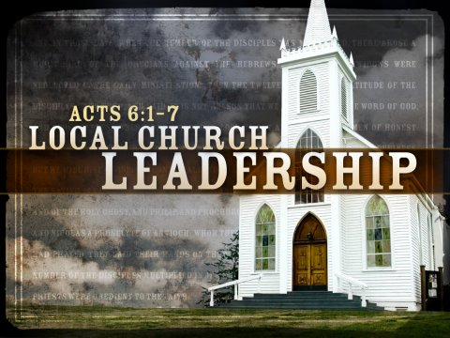

TRINITY INTERNATIONAL THEOLOGICAL SEMINARY
P.O. Box 1591
Owings Mills, Maryland 21117
Email: info@titseminary.org

Registration Form – Certificate in Church Leadership Program
A $20.00 non-refundable registration fee and $100 program fee (Total $120), must accompany this Registration Form. Complete the credit/debit card payment portion located at the end of the application, if applicable. Applicants must be at least 18 years of age. Please review our Withdrawal / Refund Policy on our website and catalog.

Student Information

First Name:_______________________________________________________________

Middle Name:_____________________________________________________________

Last or Family Name:_______________________________________________________

Trinity Student ID Number if applicable:_______________________________________

Gender: Male_________________________ Female_____________________________

Mailing Address:___________________________________________________________

_________________________________________________________________________

Date of Birth:______________________________________________________________

Email:____________________________________________________________________

Phone Number:_____________________________________________________________

Do you have a High School Diploma or equivalent?

Yes_____________________________________ No_______________________________

Are you a Trinity Graduate or a returning student? Yes_____________ No______________

Employer Information

Current Employer (if applicable):________________________________________________

Position:____________________________________________________________________

College/University Name (if applicable) and Dates Attended:

__________________________________________________________________________

__________________________________________________________________________

__________________________________________________________________________

Graduated: Yes______________________________ No___________________________

Highest Qualifications Earned:__________________________________________________

*How did you hear about Trinity? _______________________________________________

Payment Information

Name on Credit Card:__________________________________________________________

Credit Card Number:___________________________________________________________

Card Name:______________________________

Expiration (mm/yy):____________________________________________________________

Card Verification Code (CVV) (Located at the back of the card):_________________________

Card Address:______________________________________________________

Payment can also be made on our website by credit or debit card. Click on the “BUY NOW” button to make payments by credit or debit card. Select either “Pay with my Paypal account” or “Don’t have a Paypal account? – Pay with a debit or credit card.” Complete the card information and indicate the purpose of your payment.

Certification

By entering my name below, I certify that I am at least 18 years of age and to the best of my knowledge the information provided in this application is accurate and complete. I hereby apply for registration for the course listed on this registration form. I am enclosing a non-refundable registration fee of $20.00 and the program tuition fee of $100 (Total $120).
I have read this agreement and reviewed the information on the website of TRINITY INTERNATIONAL THEOLOGICAL SEMINARY and I understand all aspects of the agreement. All of the information supplied on my registration form and written work is true and accurate. All work submitted to TRINITY INTERNATIONAL THEOLOGICAL SEMINARY is my own. I understand and accept that if at any time it is demonstrated that I have misrepresented myself or my work, I may be dismissed from TRINITY INTERNATIONAL THEOLOGICAL SEMINARY and no refund of fees paid, and any certificate or diploma (s) awarded may be rescinded.
Signature:______________________________Date:__________________________________

Make sure you have entered your credit card information correctly - it should be only numbers; no dashes or spaces.
Confirm that there are verifiable funds in the account.
Email this form to info@titseminary.org . You can also send the Registration Form by mail to: Trinity International Theological Seminary, P.O. 1591, Owings Mills, Maryland 21117, U.S.A. All checks and money order must be made payable to “Trinity International Theological Seminary” in U.S. funds. Registration form will not be processed without the required fees.

