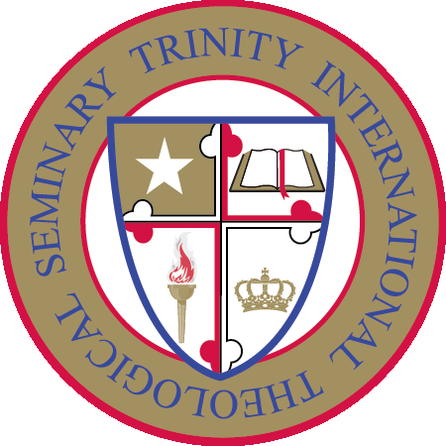

TRINITY INTERNATIONAL THEOLOGICAL SEMINARY
P.O. Box 1591
Owings Mills, Maryland 21117, USA
Phone: 443-854 9832
Email: info@titseminary.org
Website: www.titseminary.org

BROCHURE

Online Certificate in Biblical Counseling Program

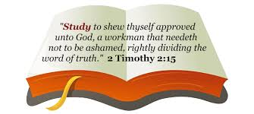

Certificate in Biblical Counseling Program
For those who are interested in gaining knowledge as a Christian Counselor, the Certificate Program in Biblical Counseling is designed to move students from their entry point of study into a progression of in-depth studies. The sole purpose for offering this program is to better equip the servants of God in helping their fellow men and women.
As part of the Trinity International Theological Seminary curriculum, this program is designed to assist the student to achieve the following objectives of this curriculum:
a. Verbalize a general knowledge of the Bible, including a systematic understanding of the major books.
b. Evidence an understanding of the historical development of theology, and an ability to support their theological views and apply them to contemporary issues.
c. Evidence an understanding of the educational program of the local church and an awareness of the worldwide mission of the church.
d. Lead a local church or other group by means of biblical exposition, leadership skill, evangelism, and service.
e. Develop a biblical framework for common counseling problems.
f. Interact with and critique standard counseling approaches to common problems.
g. Provide counseling intervention for common life struggles.
Program Outline
Part I: Foundations of Biblical Counseling
Psychology and Christian Counseling
General Principles of Biblical Counseling
Theology and Biblical Counseling1
The Doctrine of Sanctification and Biblical Counseling

Counseling in a Postmodern World
The Tenderness Trap
Part II: Common Counseling Issues
Peacemaking
Who is a Murderer?
Conflict Resolution and Communication
Church Discipline
Learning from King David's Mid Life Failure
Temptation
Confess Your Sins
Rejoice in God's Forgiveness
Forgiving Others
In Whom Do You Trust?
Obedience to God
Integrity
Worry
Financial Freedom
The Disease of Materialism
Dealing with Abuse
The Pain of Porn
Substance Abuse
Peer Pressure: Not Just for Teens

Knowing God's Will: Part 1
Knowing God's Will: Part 2
Serve God in Your Vocation
A Change of Clothes and a Change of Mind. Ephesians 4:17-24
Turn Natural Vices into Supernatural Virtues. Ephesians 4:25-30
Walk in Love. Eph. 4:29-5:2
When Good Kids Make Bad Choices
Helping Families with Twixters
Abortion and the Philosophy Behind It
Part III: Counseling Helps for the Biblical Counselor
General Information
The Certificate in Biblical Counseling Program is presented by Seminary faculty with earned doctorates in theology and related disciplines.
The online program includes a Test when you have completed the course manual. The tests are "open book" format. This means you are allowed to read the manual as often as necessary to arrive at your answers for the questions. You will be provided with a course manual, no other text book is required. The Bible will be used for information.
Trinity International Theological Seminary will evaluate your Test. This qualifies you to receive the Certificate in Biblical Counseling.

A WORD ABOUT THE IMPORTANCE OF EARNING A CERTIFICATE - Certificate programs are the latest trend in adult higher education. To meet the rising demand, U.S. institutions of higher learning are expected to greatly increase the number of certificate programs currently offered. Not surprisingly, the value and prestige of earning a certificate is beginning to rival that of the associate degree, and in some cases even the baccalaureate degree. Certificates are an ideal way to gain competency quickly and less expensively. They are also considered a more reasonable stepping stone toward earning a degree if that is the ultimate goal.

REGISTRATION PROCESS - ONLINE CERTIFICATE IN BIBLICAL COUNSELING
Simply print and fill the Registration Form, to begin your journey into Biblical Counseling.
Registration Procedures: There are only 6 steps for you to take to enroll in our courses.
6-Step process
- Print and fill-out the Registration form. Enclose one-time registration fee of $20 and $100 program fee, (Total $120) by check, money order or bank draft drawn on a U. S. bank, payable to Trinity International Theological Seminary. You can also pay by credit or debit card. Mail to Trinity International Theological Seminary, P. O. Box 1591, Owings Mills, Maryland 21117, USA. You can email your Registration form to: info@titseminary.org
- Receive Course Manual by email.
- Start reading your manual.
- Request for your test by email.
- Take your test (open book), and pass with at least 75%. You are able to resubmit assessments as many times as you need to satisfactorily complete your course. Each time you will receive feedback from us or what outcome you may have not satisfied and how you should go about improving your resubmission in order to achieve a pass grade
- Receive your Certificate (within four weeks of program completion.)
EDUCATIONAL REQUIREMENTS: Any person who has accepted our Lord Jesus Christ as his or her Savior may enroll as a student with Trinity International Theological Seminary. Regardless of one's educational background he or she may become a student.
COSTS:
$20 one-time non-refundable registration fee.
$100 program tuition fee. Course Manual will be provided and it is included in the tuition fee. No other text book is required.
There is a $35 fee per check which is returned unpaid.
Trinity International Theological Seminary's cost effective tuition is among the lowest tuition compared to other online Seminary and traditional Seminary. Trinity is committed to keeping our tuition as low as possible, recognizing that many of our students are motivated by a desire to serve the Church.
Trinity International Theological Seminary having one of the lowest tuition does not mean that we have sacrificed on the quality of the education or the services to the students. Trinity truly believes that quality education can be delivered at affordable prices. Our students cannot believe that this type of education is being offered at this low price. It is our belief that where God guides, He provides!

