TRINITY INTERNATIONAL THEOLOGICAL SEMINARY
P.O. Box 1591
Owings Mills, Maryland 21117
Email: info@titseminary.org
Website: www.titseminary.org

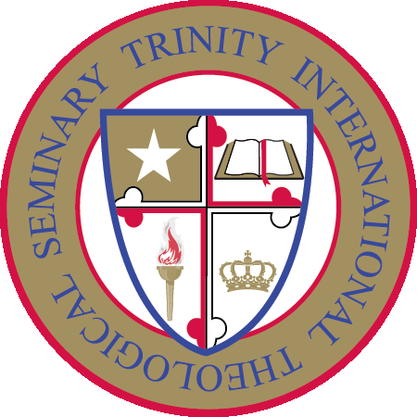

Registration Form – Certificate in Biblical Counseling Program
A $20.00 non-refundable registration fee and $100 program fee (Total $120), must accompany this Registration Form. Applicants must be at least 18 years of age. Please review our Withdrawal and Refund Policy.

Student Information

First Name:_______________________________________________________________

Middle Name:_____________________________________________________________

Last or Family Name:_______________________________________________________

Maiden Name:_____________________________________________________________

Gender: Male_________________________ Female_____________________________

Mailing Address:___________________________________________________________

_________________________________________________________________________

Date of Birth:______________________________________________________________

Email:____________________________________________________________________

Phone Number:_____________________________________________________________

Do you have a High School Diploma or equivalent?

Yes_____________________________________ No_______________________________

Are you a Trinity Graduate or a returning student? Yes_____________ No______________

Employer Information

Current Employer (if applicable):________________________________________________

Position:____________________________________________________________________

College/University Name (if applicable) and Dates Attended:

__________________________________________________________________________

__________________________________________________________________________

__________________________________________________________________________

Graduated: Yes______________________________ No___________________________

Highest Qualifications Earned:__________________________________________________

*How did you hear about Trinity? _______________________________________________

Payment Information

Payments can be made on our website by credit or debit card. Click on the “BUY NOW” button to make payment by credit or debit card. Select either “Pay with my PayPal account” or “Don’t have a PayPal account? – Pay with a debit or credit card”. Complete the card information and indicate the purpose of your payment.

Checks or Money Order must be made payable to Trinity International Theological Seminary in U.S. funds only. No request will be processed without the required fees.
Certification

By entering my name below, I certify that I am at least 18 years of age and to the best of my knowledge the information provided in this application is accurate and complete. I hereby apply for registration for the course listed on this registration form. I am enclosing a non-refundable registration fee of $20.00 and the program tuition fee of $100 (Total $120).
I have read this agreement and reviewed the information on the website of TRINITY INTERNATIONAL THEOLOGICAL SEMINARY and I understand all aspects of the agreement. All of the information supplied on my registration form and written work is true and accurate.
Signature:______________________________Date:__________________________________

Email this form to info@titseminary.org. You can also send the Registration Form by mail to: Trinity International Theological Seminary, P.O. 1591, Owings Mills, Maryland 21117, U.S.A.

