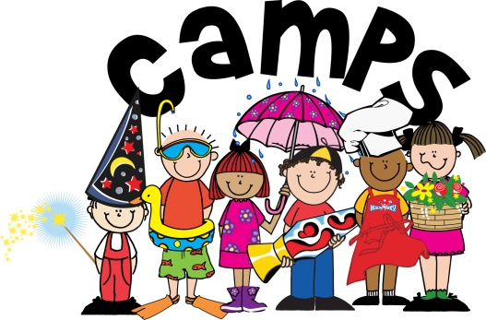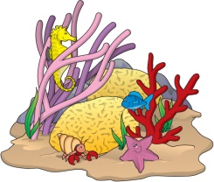

**SPACE LIMITED**

**Register Now!**

Penny Lane Schools

Administration Office

10255 Ridgeland Ave.

Chicago Ridge, IL 60415

www.PennyLaneSchools.com

4527 Southwest Highway

708-424-1335

#### Oak Lawn

10255 S. Ridgeland Ave

708-425-4233

#### Chicago Ridge

**JULY SESSION**

**Stars & Stripes**

**Planes, Trains &**

**Automobiles**

**Olympic Games**

**Everyday Games**

**Under The Sea**

**Waterworks**

**Nature Detectives**

**Starry Nights**

**AUGUST SESSION**

**JUNE SESSION**

**How Does Your Garden Grow**

**Weather Watch**

**Animal Safari/ Tails & Scales**

**Treasure Hunt**

**Wild N’ Wacky Wrap Up Weeks**

**Aug 20-Sept 3**

Monthly **FIELD TRIPS-** children will visit local places of interest ( Pre-k through Kindergarten)

Weekly **PICNIC IN THE** **PARK**- organized games, free play and lunch at the park.

Weekly **WATER FUN**- a variety of sprinkler fun, including squirt toys, water tables & visits to local water pads.

**2018**

**Preschool &**

**Kindergarten**

Super Summer Intro Week

June 11-15

Session III

July 30-Aug 17

Session II

July 9-27

Session I

June 18-July 6

Session IV

Aug 20-24

**Wacky Wrap Up Week-**

You don’t want to miss our final week!

- Jungle Breakfast in the Park

- Talent Show

-Photo Scavenger Hunt

- .10 cent Flea Market

- Costume Pizza Party

- Silly Olympics

-Beach Towel Volleyball

-Field Trip and MORE!

**Kids In The Kitchen**- Get your chef’s hat on and find your flair in the kitchen. Learn to make edible fruit arrangements, candy confections and more!

**Xtreme Sports Outdoors**- For the sports lover! Softball, football, baseball, etc.

**Creative Crafters**- Learn beginning sewing, crochet and loom weaving techniques to create bracelets, headbands and more!

**NERF Wars**- Form your teams, plan your strategy for this extreme competition using NERF toys.

**Photography**- Learn to use a digital camera and explore perspective photography. Then make a T-Shirt collage of your photos.

**Game Show Superstar**- Form your teams then compete with other teams in our version of real TV Game Shows!

**LEGO Animation**- Set up your LEGO scene, shoot a frame, adjust and repeat. Once you’re done string together all the frames into a movie.

**Passport Around The World**- An international adventure! We will make our own passports and venture into other countries through cooking, games, music, art and literature.

**Water Wars**- Extreme water fun competition using water balloons, launchers, squirt toys and more!

**Advanced Art** - Introduction to advanced art techniques including sculpture, tile design and more! Design and paint your own personalized tile piece to be installed permanently on the walls in the hallway.

**Fashion Frenzy**- Do you have a passion for fashion? Learn the newest hair and nail trends, how to create beautiful jewelry and design your own fashion portfolio.

**Gamer’s Club**- You become the game pieces in this LIFE SIZE version of your favorite games including Jenga, Hungry, Hungry Hippo, Chess and more!

**Game Show Superstar**- Form your teams then compete with other teams in our version of real TV Game Shows!

**CSI**- Experience detective work first hand. From dusting for fingerprints to analyzing handwriting. Collect clues throughout the school to solve your very own “Clue” case!

**Atcher Island**

**Gizmos**

**Medieval Times**

**Laser Quest**

**Haunted Trails**

**Art Clay World**

**Deep River Water Park**

**WC Thunderbolts**

**Hollywood Park**

**Bears Training Camp**

**Bowling & Plush Horse**

**Santa’s Village Azoosment Park**

Field Trips

**Master Chef**- Advanced Kid’s In The Kitchen

**Xtreme Sports Outdoors**- For the sports lover! Softball, football, baseball, etc.

**Art**- Are you creative? This is the club for you. Arts and crafts galore.

**Wii Dance**- Learn the latest dance moves, be fit and have fun at the same time.

**Vines Superstar**- Work in teams to create your own Vines. Then post them to the Penny Lane YouTube Channel.

**Gamer’s Club**- You become the game pieces in this LIFE SIZE version of your favorite games including Jenga, Hungry, Hungry Hippo, Chess and more!

**NERF Wars**- Form your teams, plan your strategy for this extreme competition using NERF toys.

**Daily Morning SPORTS CAMP**...Kickball, Softball, Basketball, Dodgeball, Football, Volleyball and more!

**Afternoon INSTRUCTIONAL SWIMMING**...Fun in the sun 4 days a week. Learn to swim or perfect your stroke.

**Weekly FIELD TRIPS**...Every THURSDAY the children will attend field trips at various sites (occasionally held on a different day).

**Weekly PICNIC IN THE PARK**...The children go on a picnic every WEDNESDAY to enjoy organized games, free play and lunch at the park.

**DAILY CLUBS**...Children choose a special club each session to participate in 4 days a week. See sessions below.

**Have fun making new friends, organizing your personal camp cubby, swimming at the pool, and testing out our various sports activities. Explore exciting learning centers including art, LEGOS, computers, board games and more! Then choose your daily clubs and plan your own amazing summer camp experience.**