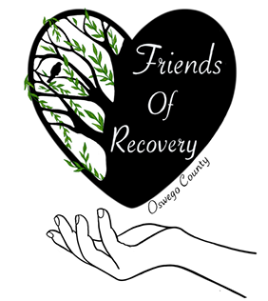
Friends of Recovery Oswego County
Board of Directors Application

Personal Information
- Full Name: Click or tap here to enter text.
- Phone Number: Click or tap here to enter text.
- Email Address: Click or tap here to enter text.
Professional Information
- Current Job Title: Click or tap here to enter text.
- Organization/Company Name: Click or tap here to enter text.
- Work Phone: Click or tap here to enter text.
- Work Email: Click or tap here to enter text.

Statement of Interest
Please provide a brief statement explaining why you are interested in joining the board of directors for Friends of Recovery Oswego County. Describe how your skills, experience, and personal values align with the organization’s mission.
Click or tap here to enter text.

Relevant Experience & Skills
Please outline your professional background, key skills, and any relevant volunteer work or board experience. Consider including:
- Previous Board Experience (if any) Click or tap here to enter text.
- Leadership or Management Roles Click or tap here to enter text.
- Relevant Skills/Expertise (e.g., finance, marketing, legal, human resources, grant writing, business administration, fundraising) Click or tap here to enter text.
- Volunteer or Community Involvement (specific roles that align with the nonprofit’s mission) Click or tap here to enter text.

Knowledge of the Organization
Describe your understanding of Friends of Recovery Oswego County’s goals, and programs. How do you see your role contributing to the success of the organization? Click or tap here to enter text.

Availability and Commitment
Board members are expected to make a significant time commitment. Please indicate the following:
- Time Available for Board Meetings: Click or tap here to enter text.
(e.g., Once per quarter, monthly meetings)
- Committees or Projects You Are Interested in:
(e.g., Fundraising, Governance, Marketing) Click or tap here to enter text.
- Additional Time for Special Events or Fundraising:
(e.g., Availability for fundraising events, conferences, etc.)
Click or tap here to enter text.

Additional Information (Optional)
Is there anything else you would like to share that would be helpful for us to know about you? Click or tap here to enter text.

Signature
By signing below, I affirm that the information provided in this application is accurate to the best of my knowledge, and I am interested in serving on the Board of Directors for Friends of Recovery Oswego County.
Signature: Click or tap here to enter text.
Date: Click or tap to enter a date.

