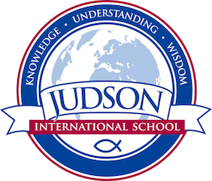 World Literature

Course Description: World Literature focuses on literary analysis through the study of world literature. Our focus will be on discussion, critical reading and thinking and honing our writing skills in essays and research papers.

Prerequisite: English 11

Texts:
Wordly Wise 21
Pocket Style Manual

Macbeth by William Shakespeare
Midsummer Night’s Dream by Shakespeare

1984 by George Orwell
Night by Elie Wiesel
Tale of Two Cities by Charles Dickens
A Modest Proposal by Jonathan Swift
The Count of Monte Cristo by Alexander Dumas
Things Fall Apart by Chinua Achebe
Stories of Anton Chekhov by Anton Chekhov
or Leo Tolstoy’s 20 Greatest Short Stories
or Great Short Stories of the World

Evaluations: Students are evaluated by a variety of means including homework, quizzes, tests, essays, annotations, creative writing and a research paper.
1610 East Elizabeth St I Pasadena I CA 91104 I 626.398.2476 I info@judsonschool.org I www.judsonschool.org

