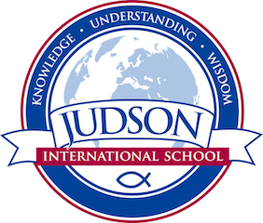 Judson International School
World History 2

Course Description: World History 2 begins with the Middle Ages, moves through the Renaissance, Reformation, Enlightenment, Exploration and Colonization and ends in 19th century Europe.

Topics by unit:

- 1) Church of the East; the Byzantine Empire, the church and monasticism, the rise of Islam, Charlemagne, Barbarian migration and Viking expansion
- 2) Feudal system, Kings and the Church, the East/West Schism, Francis of Assisi, the Crusades, the rise of science, the Black Death, the Magna Cara and the breakdown of feudalism.
- 3) Great Papal Schism, the 100 Years War, Joan of Arc, Genghis Khan, Marco Polo, the Silk Road, the Ottoman Turks, the Fall of Constantinople, Tamerlane, China under the Mongols, India, Shoguns of Japan and Korea.
- 4) Early African and American civilizations, the age of exploration, the conquistadors, the Renaissance including innovations in the arts, science and technology.
- 5) Pre-Reformation, the Reformation, Elizabethan England, the Age of Reason, the Enlightenment, the Agricultural Revolution and the Industrial Revolution
- 6) Native peoples of North America; colonization of the Americas, Africa and Asia; the French Revolution, Napoleonic wars and Imperialism

Prerequisites: World History 1

Field Trips: The Getty Museum, the Natural History Museum, And Medieval Times.

Texts:
Civilizations: Ten Thousand Years of Ancient History
Religions of the Silk Road by Richard Folz
How the Irish Saved Civilization by Thomas Cahill
Mysteries of the Middle Ages by Thomas Cahill
Holy Bible
Encyclopedia of World Religions
Source texts provided by instructor (e.g .Magna Carta, selections from Dante’s Divine Comedy, selections from Summa Theologica, Declaration of Independence)

Evaluations: Students are evaluated based on their historical timeline, tests, quizzes, poster projects, oral reports, mapping projects, and a historical research paper.
1610 East Elizabeth St I Pasadena I CA 91104 I 626.398.2476 I info@judsonschool.org I www.judsonschool.org

