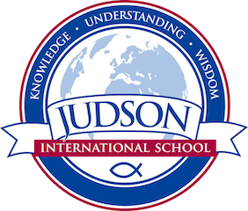 Judson International School

World History 1

Course Description: This course covers the first half of world history and cultures from Mesopotamia to the barbarian invasions and the decline of Rome. We will study the history of ancient cultures including Mesopotamia, Babylon, Egypt, Middle East, China, India, Greece and Rome. We will also cover ancient world religions and geography . We discuss the impact of historical events on our world today. This course includes field trips to the Asia-Pacific Museum, the Natural History Museum and the Getty Villa for on-site learning.

Texts:
Civilizations: Ten Thousand Years of Ancient History
The Pharaohs of Ancient Egypt
Holy Bible
Encyclopedia of World Religions
Wisdom of the Buddha
Tao Te Ching
Bhagavad-Gita
The Odyssey
Greek Mythology
Bulfinch’s Greek and Roman Mythology
Encyclopedia of the Roman World
Source texts provided by instructor

Evaluations: Students are evaluated based on their historical timeline, tests, quizzes, poster projects, oral reports, mapping projects and a variety of other assignments.
1610 East Elizabeth St I Pasadena I CA 91104 I 626.398.2476 I info@judsonschool.org I www.judsonschool.org

