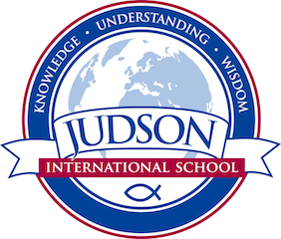 Judson International School

Theology: Jesus and the Gospels

Course Description:
This course covers the major themes and narrative development of each Gospel on its own terms. Major focuses of the class include the following: the reliability of the Gospel record, epistemology and miracles, the kingdom of God, basic orthodox doctrines found in the gospels, and what the gospels teach about discipleship. Additionally, this class will encourage students to integrate what they are learning cognitively about the faith with a developing relationship with the living Christ.

Prerequisites: None

Texts:
Holy Bible

Other sources provided by the instructor

Evaluations: Students are evaluated based on their projects (such as a biblical timeline and power points) quizzes, tests, discussions and oral reports
1610 East Elizabeth St I Pasadena I CA 91104 I 626.398.2476 I info@judsonschool.org I www.judsonschool.org

