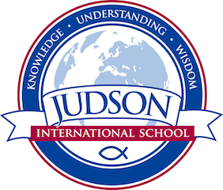 Judson International School

Scientific Literacy

Course Description:

This course will examine historic and recent advances in science and the implications for human societies. This course will require considerable reading and reflection. We will address controversial topics from a Christian perspective.

Texts:
The reading list for this course will include:
Hazen and Trefil, Science Matters
Larson, Summer for the Gods

Evaluations:

All grades are based on exams only. I do not assign homework, but students are welcome to take textbooks home if they wish. In will contact parents if there is to be an exception to this policy.

1610 East Elizabeth St I Pasadena I CA 91104 I 626.398.2476 I info@judsonschool.org I www.judsonschool.org

