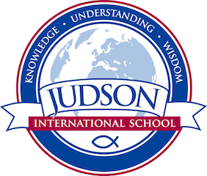 Judson International School

Physics
Course Description: This course is a standards-based study of fundamental physics concepts such as measurement, calculation, and graphing in kinematics and dynamics, propagation and conservation of energy and momentum, gravitation and orbital mechanics, heat and thermodynamics, waves, optics, electromagnetic phenomena, and relativity and quantum physics. Emphasis is placed on the utilization of mathematical, analytical, data acquisition, graphical, and communication skills as well as interdisciplinary approaches to discovery. Concepts and skills are reinforced by a strong emphasis on hands-on laboratory experiences and the integration of other branches of science. Applications to society, individuals, and the utilization of technology are included.
Prerequisites: Algebra I
Texts:

Physics Principles and Problems. Columbus, OH: Glencoe/Mcgraw-Hill, 2002. Print.

Evaluations: Course grades will be based on homework, labs, projects, quizzes, tests, and participation.

1610 East Elizabeth St I Pasadena I CA 91104 I 626.398.2476 I info@judsonschool.org I www.judsonschool.org

