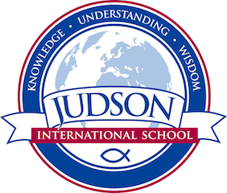 Judson International School

Journalism:

Course Description: The purpose of this course is to provide practical journalism experience in writing, editing, photography, layout, production and design with the goal of producing school newsletter and yearbook. The course will also provide hands-on experience in desktop publishing. Copy editors and Photo editors will be responsible for supervising these activities and keeping production on schedule. The class adviser will provide support, advice and instruction as needed.

Prerequisites: None

Resources: School Annual Online

Evaluations: Students are evaluated fulfilling project assigned for the completion of newspaper editions and the yearbook.

1610 East Elizabeth St I Pasadena I CA 91104 I 626.398.2476 I info@judsonschool.org I www.judsonschool.org

