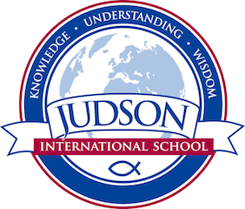 Judson International School

English 9

Course Description: English 9 builds skills in language arts needed for high school and beyond: grammar, essay writing, timed essays, annotations, poetry, the novel, literary analysis, Socratic circles, drama, research papers, creative writing, grammar and vocabulary. All students will participate in the Poetry Out Loud contest and the winner will represent Judson at the Los Angeles County competition.

Field Trip: Shakespearience

Texts:
Wordly Wise 9
Pocket Style Manual
Mara Daughter of the Nile by Eloise Jarvis
The Good Earth by Pearl Buck
The World’s Best Short Stories
Antigone by Sophocles
Medea by Seneca
Until We Have Faces by C.S. Lewis
The Chosen by Chaim Potok
Apostle by John Pollock

Evaluations: Students are evaluated by a variety of means including homework, quizzes, tests, essays, annotations, creative writing and a research paper.
1610 East Elizabeth St I Pasadena I CA 91104 I 626.398.2476 I info@judsonschool.org I www.judsonschool.org

