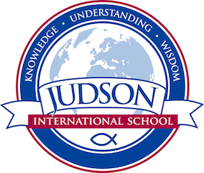 Judson International School

ELL History
Course Description: This course covers the first half of world history and cultures from Ancient Mesopotamia to Ancient Rome. These lessons include historical connection that ties back to the Bible. Students study the history of ancient cultures including Mesopotamia, Egypt, China, India, Greece, and Rome. We will cover ancient world religions and geography as well as the daily life of these cultures. Students are encouraged to engage in world event discussions to practice their skills in listening and speaking. This course is heavily vocabulary based, thus students will learn how to cope with intense reading in order to build up their vocabulary skills. This course includes field trips to the Asia-Pacific Museum and the Natural History Museum for on-site learning.
Texts:
Lister, Robin. The Odyssey. New York: Larousse, 1994. Print
Billings, Henry. History of our World: People, Places, and Ideas. Austin: Harcourt Supplemental, 2004

Evaluations: Tests and poster presentations.

1610 East Elizabeth St I Pasadena I CA 91104 I 626.398.2476 I info@judsonschool.org I www.judsonschool.org

