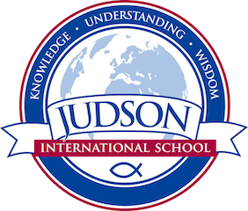 Judson International School

ELL English
Course Description: Over the course of two-semesters, ELL students build basic English skills in language arts needed for high school and beyond in the areas of reading, writing, grammar, vocabulary building, listening, and speaking. The students will write research papers, annotations, journals, and a variety of essays to demonstrate their ability and comprehension to reproduce the language. The students get to participate in the Poetry Out Loud competition. This class prepares students for the regular 9th grade English.

Texts:
Penguin Readers
The Heinle Picture Dictionary
Oxford Picture Dictionary, 2nd Edition
Hampton-Brown. Edge: Reading, Writing & Language. Monterey: National Geographic Learning, 2014. Print.
Hampton-Brown. Edge: Grammar & Writing Practice Book. Monterey: National Geographic Learning, 2014. Print.
Gaiman, Neil. Coraline. New York: HarperCollins, 2002. Print.

Evaluations: Grammar test, timed writing assignments, vocabulary test, essays and research paper, online audio listening clips and responding to speaking prompts.

1610 East Elizabeth St I Pasadena I CA 91104 I 626.398.2476 I info@judsonschool.org I www.judsonschool.org

