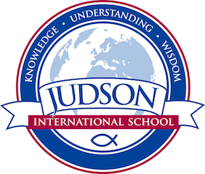 Judson International School

ELL Bible
Course Description: This course is taught in a story telling method for students to listen and have open-ended discussions. This course covers all the major events and characters in the Bible. The creation story begins with God creating the earth, to the fall of man to the birth and death of Christ. The characters mentioned in the creation story are Adam & Eve, Cain & Abel, Noah, Abraham, Isaac, Jacob, Joseph, Moses, etc. This story telling method allows students to reproduce the stories in their own words through making a presentation based on their listening and comprehension skills in front of their peers. In addition, students are exposed to Scripture by memorizing verses to reproduce and use in the real world.

Texts:

The Holy Bible.

Evaluations: Poster Presentations, re-telling the Bible stories, and reproducing Bible verses.

1610 East Elizabeth St I Pasadena I CA 91104 I 626.398.2476 I info@judsonschool.org I www.judsonschool.org

