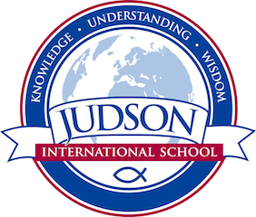 Judson International School

Speech and Drama

Course Description:

Speech: The first semester will focus on speech as a performance art. Students will have a variety of public and classroom presentations and performances in order to gain confidence in their speaking skills, communication and listening skills. Students will strengthen their vocal instrument, gain poise and confidence by conquering stage fright through exercises and performance, improve communication and listening skills. A variety of speech forms will be explored including storytelling, spoken word, personal presentation, poetry and oral interpretation, and characterization techniques using theatrical plays and scripts.

Drama: The second semester will introduce basic acting skills such as analyzing and developing a character, trusting one’s instincts and risk-taking on stage, improvisation, vocal flexibility, stage movement and body control, monologue and scene work, theater forms, stagecraft, and makeup application for a character.

The culmination of the students’ emerging and maturing skills will be affirmed through the creation and rehearsal of an evening of professional scenes and monologues performed in a theatrical setting. Students will serve the role of actor and supporting stage crew roles for their show as well.

1610 East Elizabeth St I Pasadena I CA 91104 I 626.398.2476 I info@judsonschool.org I www.judsonschool.org

