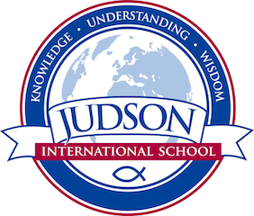 Judson International School
Chemistry

Course Description: This class explores the fundamental principles of chemistry, which characterize the properties of matter and how it reacts. Topics include, but are not limited to: measurement, atomic structure, electron configuration, the periodic table bonding, gas laws, properties of liquids and solids, solutions, stoichiometry, reactions, kinetics, equilibrium, acids and bases, and nuclear chemistry . Chemistry labs are used used to obtain, organize and analyze data. Conclusions are developed using both qualitative and quantitative procedures.
Text:
Chemistry , a Natural Approach – Lab-Aids, 2010
Introduction to Chemistry;

Evaluations: Course grades will be based on labs, homework, quizzes and tests.

1610 East Elizabeth St I Pasadena I CA 91104 I 626.398.2476 I info@judsonschool.org I www.judsonschool.org

