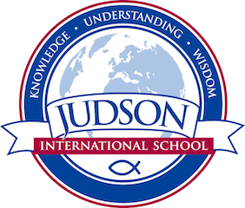 Judson International School

Biology 1
Course Description: Biology I is a one-year class, which covers the three main areas of biology: botany, zoology, and human anatomy/physiology. The class meets once each week for 2 ½ hours of lecture and lab. The labs include microscope work, experiments, and dissections.
Texts:
Main texts:
Biology, God’s Living Creation, ABeka Publishing
God’s Living Creation -Field and Laboratory Manual, ABeka Publishing

Supplemental texts:
Buchsbaum, Ralph; Buchsbaum Mildred; Pearse, John; Pearse, Vicki, Animals
Without Backbones – Third Edition, The University of Chicago, 1987.
Coulombe, Deborah, The Seaside Naturalist, Simon & Schuster, 1992.
Elson, Lawrence, The Zoology Coloring Book, Coloring Concepts, Inc., 1982.
Johnson, George B., Biology – Visualizing Life, Holt, Reinhart and Winston,
Inc., 1994.
Snyderman, Marty, Ocean Life, Publications Interational, LTD., 1991.
Sumich, James L., An Introduction to the Biology of Marine Life – Sixth
Edition, Wm. C. Brown Publishers, 1996.

Other sources provided by the instructor

Evaluations: The labs include microscope work, experiments, and dissections. Four days of homework are given each week. Weekly quizzes, written tests (about every 6 – 8 weeks), and quarterly practicums (lab tests) are given. Out-of-class projects are also assigned. Members of the class will go on one working field trip to the Long Beach Aquarium of the Pacific.
1610 East Elizabeth St I Pasadena I CA 91104 I 626.398.2476 I info@judsonschool.org I www.judsonschool.org

