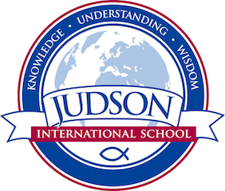 Judson International School
Art 1 and 2

Course Description:

Art 1: Our introductory art course focuses on The Elements of Art such as line, shape, and value, while building the foundations of art techniques using a variety of dry mediums that include graphite, charcoal, and soft pastel.

Art 2: Art 2 builds on Art 1 by focusing on the Principles of Design which include balance, harmony, and color to name a few. This area of study allows students to delve deeper into various styles of art and to develop their own identity as an artist.

The objectives of our art classes are:

- Enhancing students’ God-given creativity
- Introducing a variety of art media
- Studying and understanding the elements of color and design
- Improving individual drawing and painting skills
- Strengthening intelligent analysis of art based on foundational elements
- Fostering an appreciation of art within history

Field Trip: Norton Simon Museum of Art

Evaluation: Class projects build on one another. Students keep a personal folder of their works. Student projects are evaluated on effort shown, used of time, correct use of materials, evidence of listening and evidence of understanding the assignment.
1610 East Elizabeth St I Pasadena I CA 91104 I 626.398.2476 I info@judsonschool.org I www.judsonschool.org

