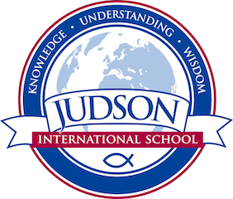

American Literature

Course Description: American Literature uses the techniques learned in English 9 and 10 to analyze American literature. Our focus will be on discussion, critical reading and thinking and honing our writing skills in essays and research papers.

Prerequisite: English 10

Texts:
Wordly Wise 11
Pocket Style Manual
English from the Roots Up
SAT Official Study Guide

The Scarlet Letter by Nathaniel Hawthorne
Drums Along the Mohawk
Red Badge of Courage by Stephen Crane
My Antonia by Willa Cather
Huckleberry Finn by Mark Twain
Our Town by Thorton Wilder
Death of a Salesman by Arthur Miller
Grapes of Wrath by John Steinbeck
To Kill A Mockingbird by Harper Lee
Selected American Poetry

Evaluations: Students are evaluated by a variety of means including homework, quizzes, tests, essays, annotations, creative writing and a research paper.
1610 East Elizabeth St I Pasadena I CA 91104 I 626.398.2476 I info@judsonschool.org I www.judsonschool.org

