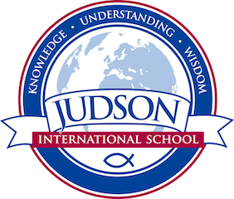 Judson International School

American History

Course Description: This course focuses on American History including: indigenous peoples of North America, colonial development, the American Revolution, foundations of the American government and nation, Westward Expansion, innovations and inventions, early reform movements, Civil War, Reconstruction, Industrialization and Immigration, the Great Depression ,World War I and II, the Cold War, the rights revolutions, the Vietnam War and its aftermath, contemporary America.

Prerequisites: World History 1 and 2

Texts:
A People’s History of the United States by Howard Zin
A History of Christianity in the United States and Canada by Mark A. Noll
The Patriot Chiefs by Alvin M. Josephy, Hr.
The Federalist Papers
Bury My Heart At Wounded Knee by Dee Brown
Abraham Lincoln by James McPherson

Other sources provided by instructor

Evaluations: Students are evaluated based on their historical timeline, tests, quizzes, poster projects, oral reports, mapping projects, and a historical research paper.
1610 East Elizabeth St I Pasadena I CA 91104 I 626.398.2476 I info@judsonschool.org I www.judsonschool.org

